INTERNAL MEDICINE OSCE GUIDE v24.1018

[Latest Version Here](https://moses245.github.io/internal_med_downloads/)

A. Fundamentals 3

A.01 Reference Ranges**** 3

A.02 Grading/Classification/Scoring Systems**** 3

A.03 Blood Gases**** 4

A.04 Fluid Management (IPC Rotation)**** 5

B. Blue Book 6

B.01 DKA vs HONKC**** 6

B.02 Hypoglycaemia 7

B.03 Hypertension**** 8

B.04 Acute Coronary Syndrome**** 9

B.05 Acute Anaphylaxis**** 10

B.06 Thyroid Storm 11

B.07 Acute Asthma**** 12

B.08 Acute Pulmonary Embolism 14

B.09 Pneumothorax 16

B.10 Acute Adrenal Insufficiency 17

B.11 Metabolic Emergencies 18

K+ Summary**** 18

Na+ Summary 23

Ca2+ Summary 26

1. Neurology 29

Tracts 29

Spinal Cord Lesions 35

Weakness 39

Speech & Higher Centres**** 43

Stroke* 44

Approach to a 'Young Stroke' 47

Chronic Venous Sinus Thrombosis 48

Guillain-Barre Syndrome**** 49

Myasthenia Gravis 51

Transverse Myelitis**** 52

Muscle Weakness Localization 53

2. Cardiology 55

2.0 Heart Failure 55

2.1 Infective Endocarditis 56

2.2 Rheumatic Heart Disease 61

2.3 Dilated Cardiomyopathy 63

2.4 Valvulopathies**** 66

2.5 Afib, A-Flutter Emergency Management 69

2.6 Heart Failure 70

2.6.1 CHATGPT Heart Failure (GeekyMedic) 74

2.7 Cor Pulmonale 77

2.8 Venous Thromboembolic Disease (DVT & PE) 78

3. Respiratory 80

3.1 Pulmonary Hypertension**** 80

3.2 Pneumonia **** 81

3.3 Pleural Effusion**** 83

3.4 Interstitial Lung Disease 85

3.5 Suppurative Lung Disease 87

3.6 Empyema 89

3.7 Lung Abscess 90

3.8 COPD 92

4. GIT 94

4.0 General GIT 94

4.0.1 Approach to Portal Hypertension 96

4.0.2 Approach to Clubbing 96

4.0.3 Virchow’s Node (Left supraclavicular lymph node) 96

4.1 Ascites*** 97

4.2 Hepatomegaly 98

4.3 Splenomegaly 99

4.4 Jaundice 101

4.5 Acute Liver Failure (fulminant liver failure) 102

4.6 Chronic Liver Disease (Cirrhosis) 103

4.7 Hepatocellular Carcinoma 104

4.8 Crohn’s Disease 105

5. Rheumatology 106

5.1 Rheumatoid Arthritis 106

5.2 Systemic Lupus Erythematosus 108

5.3 Gout 109

6. Haematology/Oncology 110

6.0.1 Haematological Malignancies 110

6.1 Leukaemia 110

6.2 Chronic Myeloid Leukaemia 111

6.3 Generalised Lymphadenopathy 112

6.4.1 Hodgkin’s Lymphoma**** 113

6.4.2 Non-Hodgkin’s Lymphoma**** 114

6.5 Kaposi Sarcoma**** 115

#Clinical Exams 116

Cardiovascular examination | Checklist 116

#Trauma Manual (Trauma Rotation) 118

T.03 Trauma Induced Coagulopathy 118

T.04 ABCs of Trauma Resuscitation 120

T.05 Damage Control Resuscitation and IV Fluids in Trauma 122

T.06 Emergency Room Thoracotomy & REBOA 124

T.07 Radiology in Trauma 125

T.08 Analgesia in Trauma 126

T.09 Traumatic Brain Injury 127

T.22 Burns 131

# A. Fundamentals

## A.01 Reference Ranges****

|  |  |  |  |  |  |  |  |  |  |  |  |  |  |  |  |  |  |  |  |  |  |  |  |  |  |  |  |  |  |  |  |  |  |  |  |  |  |  |  |  |  |  |  |  |  |  |  |  |  |  |  |  |  |  |  |  |  |  |  |  |  |  |  |  |  |  |  |  |  |  |  |  |  |  |  |  |  |  |  |  |  |  |  |  |  |  |  |  |  |  |  |  |  |  |  |  |  |  |  |  |  |  |
| --- | --- | --- | --- | --- | --- | --- | --- | --- | --- | --- | --- | --- | --- | --- | --- | --- | --- | --- | --- | --- | --- | --- | --- | --- | --- | --- | --- | --- | --- | --- | --- | --- | --- | --- | --- | --- | --- | --- | --- | --- | --- | --- | --- | --- | --- | --- | --- | --- | --- | --- | --- | --- | --- | --- | --- | --- | --- | --- | --- | --- | --- | --- | --- | --- | --- | --- | --- | --- | --- | --- | --- | --- | --- | --- | --- | --- | --- | --- | --- | --- | --- | --- | --- | --- | --- | --- | --- | --- | --- | --- | --- | --- | --- | --- | --- | --- | --- | --- | --- | --- | --- | --- |
| |  |  |  | | --- | --- | --- | | **FBC + Diff** | **Male** | **Female** | | Haemoglobin (g/L) | 135 – 180 | 115 – 160 | | WBC (x10⁹/L) | 4.00 – 11.00 | 4.00 – 11.00 | | Platelets (x10⁹/L) | 150 – 400 | 150 – 400 | | MCV (fL) | 78 – 100 | 78 – 100 | | PCV | 0.40 – 0.52 | 0.37 – 0.47 | | RBC (x10¹²/L) | 4.5 – 6.5 | 3.8 – 5.8 | | MCH (pg) | 27.0 – 32.0 | 27.0 – 32.0 | | MCHC (g/L) | 310 – 370 | 310 – 370 | | RDW (%) | 11.5 – 15.0 | 11.5 – 15.0 | | Neutrophils (x10⁹/L) | 2.0 – 7.5 | 2.0 – 7.5 | | Lymphocytes (x10⁹/L) | 1.0 – 4.0 | 1.0 – 4.0 | | Monocytes (x10⁹/L) | 0.2 – 0.8 | 0.2 – 0.8 | | Eosinophils (x10⁹/L) | 0.04 – 0.40 | 0.04 – 0.40 | | Basophils (x10⁹/L) | < 0.1 | < 0.1 | | |  |  |  | | --- | --- | --- | | **Blood Gas** | **ABG** | **VBG** | | pH | 7.35 – 7.45 | 7.31 – 7.41 | | pCO₂ | 35 – 45 mmHg (4.6-5.9 kPa) | 41 – 51 mmHg (5.4-6.7 kPa) | | pO₂ (Room air) | 80 – 100 mmHg (10.5-13.1 kPa) | 35 – 42 mmHg (4.6-5.5 kPa) | | HCO₃ | 22 – 26 mEq/L | 25 – 29 mEq/L | | TCO₂ | 23 – 30 mmol/L | 23 – 30 mmol/L | | Base Excess | -2 to +2 | -2 to +2 | | Standard HCO₃ | 20 – 25 mmol/L | 20 – 25 mmol/L | | O₂ Saturation | 95 – 98% | 68 – 77% | | Glucose | 3.3-6.1 mmol/L |  | | Lactate | 0.5-2.2 mmol/L |  | | |  |  | | --- | --- | | **Urea & Electrolytes** | **Reference Range** | | Sodium | 135 – 146 mmol/L | | Potassium | 3.5 – 5.3 mmol/L | | Chloride | 95 – 106 mmol/L | | Bicarbonate | 22 – 29 mmol/L | | Urea | 2.5 – 7.8 mmol/L | | Creatinine | 60 – 120 µmol/L | | Calcium | 2.2 – 2.6 mmol/L | | Magnesium | 0.7 – 1.0 mmol/L | | Phosphate | 0.8 – 1.5 mmol/L | | eGFR | > 60 mL/min/1.73m² | |

## A.02 Grading/Classification/Scoring Systems****

|  |  |
| --- | --- |
| Pathology | Grading/Classification/Scoring |
| Lymphomas | Ann-Arbor |
| Ascites | Mild, Moderate, Severe |
| Acute Pulmonary Embolism | Modified Well’s Score |
| Rheumatic Heart Disease | Jone’s Criteria |
| Infective Endocarditis | Modified Duke’s Criteria |
| Heart failure | NYHA |
| Pleural Effusion | Light’s Criteria |
|  |  |
|  |  |

## A.03 Blood Gases****

Notes

* Lactate raised contributes to metabolic acidosis. Lactic acidosis follows organ hypoperfusion (e.g.cardiac arrest)
* ++K+ secondary to cell death and secondary to acidosis (pushes K+ extracellularly exchanged with H+)
  + Requires IV calcium (stabilize myocardium) and insulin/dextrose infusion (see notes)
  + Intracellular shifts of K+ in setting of alkalosis 🡪 hypokalaemia
* ACE-I predispose to AKI in the setting of dehydration

|  |  |
| --- | --- |
| **PH < 7.35** | **PH > 7.45** |
| **Respiratory acidosis**  Respiratory acidosis is caused by **inadequate alveolar ventilation** leading to **CO₂ retention**.  A **respiratory acidosis** would have the following **characteristics** on an ABG:   * ↓ pH, ↑ CO₂   **Causes of respiratory acidosis** include:   * Respiratory depression (e.g. opiates) * Guillain-Barre: paralysis leads to an inability to adequately ventilate * Asthma * Chronic obstructive pulmonary disease (COPD) * Iatrogenic (incorrect mechanical ventilation settings) | **Respiratory alkalosis**  Respiratory alkalosis is caused by **excessive alveolar ventilation** (hyperventilation) resulting in more CO₂ than normal being exhaled. As a result, PaCO₂ is reduced and pH increases causing alkalosis.  A **respiratory alkalosis** would have the following **characteristics** on an ABG:   * ↑ pH, ↓ CO₂   **Causes of respiratory alkalosis** include:   * Anxiety (i.e. panic attack) * Asthma exacerbation * Severe anaemia * Aspirin toxicity (precedes a met. Acidosis) * Pain: causing a ++respiratory rate * Hypoxia: resulting in ++alveolar ventilation to compensate. * Pulmonary embolism, * Pregnancy * Pneumothorax * Iatrogenic (e.g. excessive mechanical ventilation) |
| **Metabolic acidosis**  Metabolic acidosis can occur because of either:   * Increased acid production or acid ingestion. * Decreased acid excretion or increased rate of GI and renal HCO₃⁻ loss.   A **metabolic acidosis** would have the following **characteristics** on an ABG:   * ↓ pH, ↓ HCO₃⁻, ↓ BE   **Anion gap formula**: Na⁺ - (Cl⁻ + HCO₃⁻)  The **anion gap (AG):** primarily used for metabolic acidosis to determine the presence of **unmeasured anions** (e.g. albumin is the main unmeasured anion). The normal AG = [**4 -12] mmol/L**.   |  |  | | --- | --- | | **Normal AG metabolic acidosis** (typically due to loss of HCO3 which is subsequently replaced by Cl in the plasma, resulting in a stable overall anion concentration):   * GI loss of HCO₃⁻ (e.g. diarrhoea, ileostomy, proximal colostomy) * Renal tubular acidosis (normal eGFR) * Addison’s disease | **High AG metabolic acidosis** (typically relate to ++production/ingestion or reduced excretion of H⁺ by the kidneys):   * Diabetic ketoacidosis * Lactic acidosis * Toxins (e.g. aspirin, methanol and ethylene glycol) * Renal failure (deranged eGFR) * Blood loss   + ++lactate (hypoperfusion)   + -–Hb (blood loss),   + ++K+ (acidosis🡪 shift) | | **Metabolic alkalosis**  Metabolic alkalosis occurs as a result of **decreased H+ ion concentration**, leading to **increased HCO3**, or alternatively a direct result of increased bicarbonate concentrations.  A **metabolic alkalosis** would have the following **characteristics** on an ABG:   * ↑ pH, ↑ HCO₃⁻, ↑ BE   **Causes of metabolic alkalosis** include:   * GI loss of Cl-, H⁺ ions (e.g. vomiting, diarrhoea) * Renal loss of H⁺ ions (e.g. loop and thiazide diuretics, heart failure, nephrotic syndrome, cirrhosis, Conn’s syndrome) * Iatrogenic (e.g. addition of excess alkali such as milk-alkali syndrome) |
| **Mixed respiratory and metabolic acidosis**  A **mixed respiratory and metabolic acidosis** would have the following **characteristics** on an ABG:   * ↓ pH, ↑ CO₂, ↓ HCO₃⁻   **Causes of mixed respiratory and metabolic acidosis** include:   * Cardiac arrest * Multi-organ failure | **Mixed respiratory and metabolic alkalosis**  A **mixed respiratory and metabolic alkalosis** would have the following **characteristics** on an ABG:   * ↑ pH, ↓ CO₂, ↑ HCO₃⁻   **Causes of mixed respiratory and metabolic alkalosis**:   * Liver cirrhosis in addition to diuretic use * Hyperemesis gravidarum * Excessive ventilation in COPD |

## A.04 Fluid Management (IPC Rotation)****

|  |  |  |  |  |  |  |  |  |  |  |  |  |  |  |  |  |  |  |  |  |  |  |  |  |  |  |  |  |  |  |  |  |  |  |  |  |  |  |  |  |  |  |  |  |  |  |  |  |  |  |
| --- | --- | --- | --- | --- | --- | --- | --- | --- | --- | --- | --- | --- | --- | --- | --- | --- | --- | --- | --- | --- | --- | --- | --- | --- | --- | --- | --- | --- | --- | --- | --- | --- | --- | --- | --- | --- | --- | --- | --- | --- | --- | --- | --- | --- | --- | --- | --- | --- | --- | --- |
| **Introduction**   * Correct fluid prescription depends on the indication and individual patient. * Fluids are drugs (4Ds): Drug, Dose, Duration, De-escalation.   **Assessment of Fluid Status**   * **Clinical parameters**:   + **Fluid depleted patients**: Dry mucous membranes, reduced skin turgor, decreased urine output (<0.5 ml/Kg/hr), orthostatic hypotension, shock symptoms.   + **Fluid balance patients**: No signs of depletion or overload.   + **Fluid overloaded patients**: ↑JVP, peripheral/sacral oedema, pulmonary oedema. * **Lab parameters**: Hct, Urea/Creat ratio, Serum Lactate, base deficit (ABG).   **Fluid Management: Types of Fluids**   * **Crystalloids**: Small molecular weight solutes (e.g., 0.9% NaCl, Ringers Lactate). * **Colloids**: Larger molecular weight solutes (e.g., Albumin 5%, Voluven, Gelofusine). * **Blood products**: Packed RBCs, FFP, Platelets.   **Crystalloids**   * Hypertonic: 3% NaCl. * Isotonic: 0.9% NaCl. * Hypotonic: 5% dextrose, 0.45% NaCl. * Mixed crystalloid solutions: 5% dextrose in 0.9% NaCl, 5% dextrose in 0.45% NaCl.   **Colloids**   * Natural (albumin) or Artificial (Voluven, Gelofusine). Use is controversial due to risks (anaphylaxis, renal failure). | |  |  |  |  |  |  | | --- | --- | --- | --- | --- | --- | |  | Plasma | 0.9% NaCl | Ringer’s Lactate | 5% Dextrose | Gelofusine | | Na+ | 142 | 154 | 131 | 0 | 154 | | Cl- | 103 | 154 | 111 | 0 | 125 | | K+ | 4 | 0 | 5 | 0 | <0.5 | | Ca2+ | 2.4 | 0 | 2 | 0 | <0.5 | | Glucose | 0.9-1.1 | 0 | 0 | 50 | 0 | | HCO3- | 26 | 0 | 0 | 0 | 0 | | Osm | 280-310 | 308 | 280 | 250 | 274 |   **Indications**   * Fluid resuscitation, replacement of fluid losses, maintenance, correction of electrolyte imbalances, IV medication delivery.   **Prescribing IV Fluids**   * **4 Ds of fluid prescription**: Drug, Dose, Duration, De-escalation. * **4 Dynamic phases of IV fluid treatment**:   + Patient rescue phase (minutes).   + Organ rescue phase (hours).   + Organ support phase (days).   + Organ recovery phase (days to weeks).   **Fluid Resuscitation**   * **Indications**: Hypovolemic shock, initial treatment in other types of shock, severe hypovolemia without frank shock. * **Fluids**: Isotonic crystalloid solution (0.9% NaCl, RL). * **Monitoring**: HR, BP, CVP, lactate, and urine output.   **Replacement of Ongoing Fluid Loss**   * **Conditions**: Burns, pancreatitis, vomiting, diarrhea, surgical drainage. * **Fluid regimen**: Match volume/composition of replacement fluid to the lost fluid. | **Maintenance Fluid Therapy**   * For patients who cannot meet their daily requirements enterally. * **Daily requirements (NICE guidelines)**: Water (25 mL/kg/day), Na+ (1 mmol/kg/day), K+ (1 mmol/kg/day), Glucose (50g/day). * **Maintenance fluid rates** vary for neonates, children, and adults.   **Special Patient Groups**   * **Edematous states**: 40-60% of calculated maintenance. * **Oliguric/anuric states**: 25% of calculated maintenance. * **Solute diuresis (DKA, adrenal insufficiency)**: ≥120% of calculated maintenance.   **Monitoring and Evaluation**   * Baseline and frequent assessments: Clinical (Pulse, BP, Cap refill time, JVP) and diagnostic (biomarkers, imaging). * **Fluid balance monitoring**: Intake (enteral/parenteral fluids) and output (GI/urinary losses).   **Complications**   * **Fluid overload**: Common in elderly, pediatric, CKD, iatrogenic causes. * **Hyperchloremic metabolic acidosis**: Excessive use of chloride-containing solutions. * **Electrolyte imbalances**: Hypo/hypernatremia. |

# B. Blue Book

## B.01 DKA vs HONKC****

|  |  |  |
| --- | --- | --- |
| Feature | DKA | Hyperosmolar non-ketotic coma (HONKC) |
| History | Previous history of DM, poor compliance with Rx, infection | 50% will have no history of DM. Infection, trauma, drug-induced |
| Age | **Younger** | **Elderly** |
| Onset | Hours to days | Several days |
| Symptoms | Polyuria, polydipsia, anorexia, nausea, abdominal pain, vomiting, stupor | Severe polyuria, polydipsia, increasing somnolence |
| Signs | Moderate dehydration, acidotic breathing, confusion → coma | Profound dehydration, stuporosed-comatosed, focal neurological signs |
| Blood glucose | **Elevated (up to ± 40 mmol/l)** | **Markedly elevated (>40 mmol/l)** |
| Blood and urine ketones | **Strongly positive** | Usually absent or weakly positive |
| Serum sodium | **Usually decreased** | Normal/increased/decreased |
| Serum potassium | Normal/increased/decreased | Normal/increased/decreased |
| Serum bicarbonate | **Very low** | Normal/slightly decreased |
| Anion gap | **Increased** | Normal/slightly increased |
| Blood pH | **Markedly decreased** | Normal/slightly decreased |
| Serum urea | Slightly elevated | **Markedly elevated** |
| Serum Osmolality | <330 mosmol/kg | **>350 mosmol/kg** |

**Serum osmolality** = 2 (Na⁺ + K⁺) + urea + glucose

**Need** **KCL, K2PO4, Insulin, NaHCO3, Ringers, DW**

|  |  |  |
| --- | --- | --- |
|  | **DKA** | **HONKC** |
| **FLUIDS** |  | |
| Primary Consideration | insulin delivery along with dextrose if euglycaemic, until the acidosis resolves | too rapid a reduction in osmolality (cerebral oedema) |
| Administer crystalloid | 150mls/hr x 2 hours **Ringers Lactate** or Balsol, avoid saline (worsens acidosis)  Maximum =4L over 24h | |
| Thiamine if malnourished | 100mg IMI if malnourished/alcoholic | |
| Rise in Na+>150mmol/l **or**  glucose drop<15mmol/l | Change to 5% **Dextrose water**. (Indication typically hypernatremia, hypoglycaemia) Run at 100 ml/hr, monitor glucose hourly  **Aim**: urine output > 0.5 ml/kg/hr (provided renal function is normal). | |
| **CORRECT K+ w/ KCL** |  | |
| Replace K+ according to [K+] done hourly Check K⁺ every 30 mins  Max **KCL** = 40mmol KCL/h IV | K+ > 3.5mmol 🡪 insulin  K⁺ < 3.0 mmol/l – 40 mmol **KCl** /L of fluid  K⁺ < 3.0 – 4.0 mmol/l – 30 mmol **KCl** /L of fluid  K⁺ < 4.0 – 5.0 mmol/l – 20 mmol **KCl** /L of fluid  K⁺ < 5.0 – 5.5 mmol/l – 10 mmol **KCl** /L of fluid  K⁺ > 5.5 mmol/l or ecg changes that may reflect hyperk+– **NO KCl** | |
| **CORRECT PO4-** |  | |
| replace phosphate as K2PO4 when supplementing K⁺ initially. | Infuse 20 mmol/l of **K2PO4** IV over 1 hour Mg2+, Ca2+, Mg2+ may need to be replaced as well |  |
| **INSULIN** |  | |
| Insulin if K+>3.5mmol/L | 10 u regular insulin IV stat, then  10 u IV (0.1 u/kg) hourly as a bolus or constant IV | |
| Aim | Lower glucose by 5mmol/h | |
| When BG controlled (<15mmol/L) but acidosis present and AG still elevated | 5% or 10% Dextrose water plus  KCl together with  hourly insulin as above  **until** HCO3 > 15, blood glucose < 15 mmol/l, pH > 7.3. | |
| **ACIDOSIS** | Essential to measure AG (Na⁺ – {Cl⁻ + HCO₃⁻}). Persistent acidosis is frequently due to ++CL- following administration of normal saline (hyperchloraemic acidosis). | |
| If ph<7.0 & K+>4.0mmol/L | Add 25 – 50 ml of 8.5% **NaHCO3** to  200 ml of 0.45% Saline or sterile water, + 10 mmol KCl, run over 1 hour.  **Repeat infusion until pH > 7.0** | |

**Supportive Treatment**

1. Record data on a Flow Chart
2. Look for and treat precipitating causes, such as infection, infarction, ischaemia, ignorance, intoxication, implantation (pregnancy). Also consider infections such as emphysematous pyelonephritis or cholecystitis, mucormycosis of the sinuses (especially DKA).
3. Antibiotics only if CRP elevated.
4. Consider prophylactic heparin with hyperosmolar comas
5. Cardiorespiratory support as indicated
6. Nasogastric tube if gastric dilatation or gastroparesis is present  
   (Where there is uncertainty in a comatosed patient, i.e. hyperglycaemic vs hypoglycaemic coma, treatment should be as for hypoglycaemic coma – see below)

|  |  |  |  |  |  |  |  |
| --- | --- | --- | --- | --- | --- | --- | --- |
| Characteristic | Normal plasma | 0.9% saline (a.k.a. “normal saline”) | 0.45% saline (a.k.a. ½ NS) | 3% saline | D5 ½NS + 20 mEq KCL | D5W | Lactated Ringer’s (LR) / Hartmann’s solution |
| Na⁺ mEq/L | ~140 | 154 | 77 | 513 | 77 | 0 | 130 |
| Cl⁻ mEq/L | ~100 | 154 | 77 | 513 | 97 | 0 | 109 |
| K⁺ mEq/L | ~4 | 0 | 0 | 0 | 20 | 0 | 4 |
| Ca²⁺ mEq/L | ~2.4 | 0 | 0 | 0 | 0 | 0 | 3 |
| Glucose g/L | ~0.85 | 0 | 0 | 0 | 50 | 50 | 0 |
| Buffer | HCO₃⁻ ~24 mEq/L | 0 | 0 | 0 | 0 | 0 | Lactate 28 mEq/L |
| Osmolarity mOsm/L | ~290 | 308 | 154 | 1026 | 446 | 252 | 273 |
| Tonicity | N/A | "Isotonic" | Hypotonic | Hypertonic | Hypertonic → Hypotonic | Hypotonic | Isotonic |
| Typical Indication | N/A | Resuscitation | Maintenance | Severe Hyponatremia | Maintenance | Hypernatremia, Hypoglycemia | Resuscitation |

## B.02 Hypoglycaemia

**Clinical features**

* **Adrenergic Activation:**
  + tremor, tachycardia, palpitations, sweating, faintness, anxiety, hunger
* **Neuroglycopaenia:**
  + Weakness, headache, disturbed intellectual function, amnesia, motor incoordination or paralysis, seizures, coma

**Diagnosis**

* **Blood glucose < 3.0 mmol/l**. Send blood for glucose to laboratory.
* **Take blood for insulin, C-peptide and cortisol levels** where cause not obvious.

**Therapy**

* Free flowing drip, slow IV bolus of **50 ml 50% glucose** (preferably diluted), and repeated as necessary until blood glucose 5 – 10 mmol/l.
  + **Follow the 50% IV bolus 🡪 with continuous IV infusion of 10% dextrose water** until the next meal. Monitor glucose hourly; keep blood glucose <15 mmol/l.
  + Give Thiamine 100 mg IM and/or Vit B Complex, particularly if patient is alcoholic or malnourished.
* **Out of the hospital setting**: **1 mg Glucagon may be injected SC or IM** before access to IV therapy is obtained. Once consciousness regained🡪 carbohydrate snack.
* Search for the cause (e.g., insulin, oral hypoglycaemics, alcohol, endocrine, tumour, liver disease).
* If hypoglycaemic due to sulphonylureas, prolonged IV glucose administration may be necessary. Do not use Glucagon.
* If the patient has not regained consciousness after 30 min with a normal blood glucose, look for another cause for coma.

## B.03 Hypertension****

In most instances, the blood pressure should be reduced gradually with oral therapy.

|  |  |  |  |  |  |  |  |  |  |  |  |  |  |  |  |  |  |  |  |  |  |  |  |  |  |  |  |  |  |  |  |  |  |  |  |  |  |  |  |  |  |  |  |  |  |  |  |  |  |  |  |  |  |  |  |  |  |  |  |  |  |  |  |  |  |  |
| --- | --- | --- | --- | --- | --- | --- | --- | --- | --- | --- | --- | --- | --- | --- | --- | --- | --- | --- | --- | --- | --- | --- | --- | --- | --- | --- | --- | --- | --- | --- | --- | --- | --- | --- | --- | --- | --- | --- | --- | --- | --- | --- | --- | --- | --- | --- | --- | --- | --- | --- | --- | --- | --- | --- | --- | --- | --- | --- | --- | --- | --- | --- | --- | --- | --- | --- |
| **SEVERE HYPERTENSION**  Stage 3 Hypertension SBP > 180/110mmHg  **Asymptomatic +/- TOD**   * 5mg tablet diazepam **sublingually**, measure BP after rest 1h. * If still elevated🡪two drugs, one = low-dose thiazide-like diuretic. * Follow-up and refer as needed.  |  |  | | --- | --- | | Stage 3 Hypertension SBP > 180/110mmHg **Asymptomatic** **+/- TOD** | | | **Aim:** BP <140/90 | | | **Diazepam (1h)** | 5mg tablet SL | | Diuretics:  **Thiazide: HCTZ** 🡪**Furosemide** if renal failure | 25mg 40mg dly | | **CCB**: **Amlodipine** | 10mg dly | | No hyponatremia **ACE-I: Enalapril** **ARB: Losartan** | 5mg bd PO 50 mg dly | | No Brady  **BB**: **Carvedilol** | 12.5mg bd🡪 25mg bd | | Follow-up and refer as needed. |  | | **HYPERTENSIVE URGENCY**  **w/ TOD, non-life immediate threatening HTN** or grade III/IV retinopathy (malignant / accelerated hypertension).   * **w/ TOD**🡪Admit      |  |  | | --- | --- | | Stage 3 Hypertension SBP > 180/110mmHg+ **TOD+ but not immediate life threatening🡪Admit** | | | **Aim**: DBP < 100mmHg over 48-72h (<140/90 eventually) | | | **Diazepam (1h)** | 5mg tablet subl. | | 🡪 Diuretic +1 orals < DBP100 | | | Diuretics: **Thiazide: HCTZ  Furosemide** if renal failure | 25mg 40mg dly | | Long acting CCB: **Amlodipine** | 10mg dly | | No hyponatremia **ACE-I: Enalapril** **ARB: Losartan** | 5mg bd PO 50 mg dly | | No Brady  **BB**: **Carvedilol** | 12.5mg bd 🡪 25mg bd | |  |  | | **HTN w/ Thrombotic (Ischaemic) Stroke or ICH** | **BP> 220/120 mmHg** | | Aim to reduce BP by 10-15% to < 185/110 | | | **Labetalol** | 10 – 20 mg IVI over 1 to 2 minutes followed by 2 – 4 mg/min infusion | | Initiate 2 oral agents (as above) at the same time | | | Avoid Ace-I & Nefidipine sublingual | | | **HYPERTENSIVE EMERGENCY**  Rare life-threatening situations requiring immediate lowering of BP usually with parenteral therapy   * **The life-threatening complications include:**   + Hypertensive encephalopathy (severe headache, visual disturbances, confusion, seizures, coma).   + Unstable angina / myocardial infarction.   + Acute left ventricular failure with severe pulmonary oedema   + Eclampsia and severe pre-eclampsia.   + Acute aortic dissection. * **General Management**   + If ICU not available attempt to lower the BP over 24 hours <160/100 mmHg often achievable with orals  |  |  | | --- | --- | | Stage 3 Hypertension SBP > 180/110mmHg+ **TOD + life threatening Requires IV therapy 🡪Admit ICU/High Care** | | | **Aim**: <140/90 with 3 or 4 orals, slowly | | | **IV Labetalol** | 10-20mg bolus repeat 10 min, 🡪 infuse 0.5mg/min 🡪 2mg/min.  Initiate oral therapy simultaneously. Use with caution with COPD, asthma, bradycardia. | | **IV Furosemide** | 10 – 20mg IV (++ if overloaded) | | **IV Nitro-glycerine** if MI | 5 – 10μg/min | | **2 Oral agents** | added to regime as in under “Hypertensive Urgency”, or used alone if IV agents are not available | | **Diuretic: Furosemide** | 40mg oral | | Long actingCCB: **Amlodipine** | 10mg dly | | No hyponatremia **ACE-I: Enalapril** **ARB: Losartan** | 5mg bd PO 50 mg dly | | No Brady  **BB**: **Carvedilol** | 12.5mg bd 🡪 25mg bd | |

## B.04 Acute Coronary Syndrome****

|  |  |
| --- | --- |
| **UA/NSTEMI (**MONA-BASC)  Angina associated with typical rise/fall of cardiac biomarkers and ST-segment depression or T-wave inversion.   * Admit to high care, bloods cardiac markers & Troponin T/I (has prognostic value) * Treat aggravating factors (e.g. uncontrolled hypertension, cardiac failure, arrhythmias, infection, anaemia).   **Risk Stratify the Patient**  **TIMI Risk Score** UA/NSTEMI: **(0 – 2 = Low Risk) 3 – 4 = Medium Risk 5 – 7 = High Risk**   1. Age ≥ 65 years 2. ≥ 3 coronary artery risk factors 3. Known coronary artery stenosis ≥ 50% 4. Aspirin use in the last 7 days 5. Elevated cardiac biomarkers 6. Severe angina (> 2 episodes in prior 24 hours) 7. ST-depression or elevation > 0.5mm   Alternative validated score is the GRACE score. | **STEMI (**MONA-BASC-AR)  **1. CONFIRM DIAGNOSIS**   * Clinically: Distant heart sounds, S3 gallop, atypical precordial impulse, appearance or accentuation of murmurs with chest pain * ECG changes (12-lead ECG, or preferably 16-lead ECG including V4R) * Elevated cardiac biomarkers   **2. EXCLUDE OTHER LIFE-THREATENING CAUSES OF CHEST PAIN**   * Pericarditis / Cardiac tamponade, Dissecting aortic aneurysm * Pulmonary embolus, Tension pneumothorax   **3. RISK STRATIFY THE PATIENT**  **TIMI Risk Score STEMI (0 – 2 = Low Risk 3 – 4 = Medium Risk 5 – 7 = High Risk)**   1. Age > 75 years 2. Age 65-74 3. Diabetes Mellitus or Hypertension or Angina 4. SBP < 100mmHg 5. HR > 100/min 6. Killip Class II to IV 7. Weight < 67 kg, Anterior STEMI or LBBB, Time to reperfusion > 4 hours |
| |  |  |  | | --- | --- | --- | | Morphine | If pain persists after nitrate administration and the patient is not hypotensive or hypovolaemic | Dilute 15mg with 10ml water. Administer 2 – 4mg slowly IV. Repeat every 5 – 15 minutes intervals, just until pain relief is obtained or S/E (hypotension, nausea, vomiting, respiratory depression) appear. | | Oxygen | Stabilize patient (ACLS) if hypoxemic (SaO2 < 90%) |  | | Nitrates | Pain control, SL or IV. **C/I** SBP<90mmHg. Brady or tachy **Aim**: decrease **sBP** <10% (if normotensive) or 30% (if hypertensive). | **SL Nitroglycerine** 0.5mg tab or  **IV**: 10ug/min, increasing by 10ug/min every 3 – 5 minutes if necessary🡪 max 200ug/min | | Aspirin | 300mg stat | 100mg dly  Caution bleeding ds. Or asthma | | Beta Blocker |  |  | | |  |  |  | | --- | --- | --- | | Anti-coagulate | IV UF Heparin or LMWH for > 48h | Either unfractionated heparin IV (keep PTT 2x normal) or LMWH subcu Enoxaparin 1mg/kg bd | | Clopidogrel | 300-600mg stat | 75mg dly | | Statin | A-statin 80mg  R-statin 40mg |  | | ACE-I | within 24 hours of infarction, is beneficial in --mortality, especially in large infarcts. Administer only once haemodynamically stable. | **Enalapril** 5mg bd PO | | Reperfusion | Fibrinolytics within 6/12h chest p. | **Tenecteplase** 40mg IV bolus **Streptokinase**: 1.5 million Units IV over 60 minutes | |  | Cardiogenic shock: **Dobutamine** | 10ug/kg/min: ++contractility in severe hypotension (or dec. urine output) |   **PROPHYLACTIC ANTI-ARRHYTHMICS:** shown to decrease the incidence of sustained ventricular fibrillation but do not improve overall survival. Reserve for patients with life-threatening arrhythmias or haemodynamic compromising arrhythmias. |

## B.05 Acute Anaphylaxis****

**Definition**: Acute severe hypersensitivity reaction after antigen exposure.

**Common causes**: antibiotics, aspirin, NSAIDS (IM/IV), contrast media, latex, insect stings, nuts, wheat etc.

**The following develops**

* **Acute Resp difficulty**
  + Hypoxemia, cyanosis, swelling of soft tissues, hoarseness, stridor, wheezing, dyspnoea, distress
* **Signs of shock**
  + sBP < 90 mmHg, incontinence
* **Involvement of skin/mucosa**
  + Pale, flushed, pruritic, urticaria, rhinitis (early sign)
* **Gastrointestinal**
  + Crampy abdo pain, nausea vomiting diarrhoea

|  |  |  |  |  |  |  |  |  |  |  |  |  |  |  |  |  |  |  |  |  |  |  |  |  |  |  |  |  |  |
| --- | --- | --- | --- | --- | --- | --- | --- | --- | --- | --- | --- | --- | --- | --- | --- | --- | --- | --- | --- | --- | --- | --- | --- | --- | --- | --- | --- | --- | --- |
| **MANAGEMENT OF ANAPHYLAXIS**   * **Remove or stop the precipitating agent immediately.** * **IM Adrenaline:**   + Inject 0.3 - 0.5 ml of adrenaline (1:1000) IM   + Anterolateral aspect of the thigh if the patient   + Repeat every 5 – 15 minutes if no improvement * **Oxygen:** High flow oxygen via rebreather mask. * **Maintain a Patent Airway:**   + Position patient semi-Fowler’s (unless hypotensive) to assist breathing. Monitor respiratory parameters and vital signs (BP, Sats, and ECG) continuously.   + Beware that progressive airway obstruction may occur, necessitating emergency intubation or even cricothyrotomy. * **Establish IV Access**   + Rapidly infuse 1 – 2 liters of crystalloid (Ringers or other balanced salt solution) **if hypotensive or unresponsive to IM adrenaline.**   + Repeat the IV infusion if necessary, as large amounts may be required.   + Aim: Keep SBP > 90mmHg. * **IV Adrenaline:**   + IV adrenaline is potentially hazardous in anaphylaxis and only considered if     - life-threatening hypotension persists despite the administration of IM adrenaline &     - aggressive fluid resuscitation.   + **Dilute** **1mg adrenaline in 200ml normal saline, and slowly infuse at 1ml/minute** (5ug/min) with continuous ECG monitoring.   + Titrate the adrenaline infusion (0.1 – 1ug/kg/min) in accordance with the patient’s response. * **Antihistamine:**   + Administer an antihistamine such as **promethazine 25mg IM or slowly IV**. * **Nebulized Bronchodilators:**   + Nebulized short-acting B-agonist e.g., Salbutamol (5mg) together with ipratropium (0.5mg) prepared as a unit dose vial should be given every 15 – 20 minutes if bronchospasm is a major feature, and especially if the patient is on beta blockers. * **Corticosteroids:**   + Particularly useful for preventing or shortening protracted reactions.   + Administer hydrocortisone 200mg IM or slowly IV. | * **Glucagon:**   + Administer 1 – 2mg IM or slowly IV every 5 minutes if the patient is unresponsive to adrenaline and fluids, and especially if the patient is on beta blockers.   + Watch out for vomiting and hyperglycaemia. * **H2 Receptor Antagonist:**   + Consider the administration of cimetidine (300mg IM or slowly IV, diluted in 20ml over 2 minutes). * **Admit for Observation:**   + Recurrences may occur, and therefore the patient should be admitted and observed for 8 – 24 hours.   + Antihistamines and oral steroids should be continued for the next 3 days after discharge. * **Prevent Recurrence:**   + Identification of the cause to prevent recurrence is important, and arrange for a “Medic Alert” bracelet for the patient.   + It is essential to prescribe and educate the patient and relevant family members on the use of a self-injectable adrenaline device (e.g., EpiPen). All patients having had a severe reaction should have such a kit on their person at all times.  |  |  | | --- | --- | | **Management Summary** | | | **IM adrenaline** (repeat 5-15 min) | 0.3-0.5ml (1:1000) IM  =0.3-0.5mg | | **Airway** | Maintain patency | | **Breathing: O2** | High flow rebreather mask | | **Circulation: Fluids** (hypotensive, unresponsive to IM) | 1-2L crystalloids (keep SBP>90mmHg) | | **IV adrenaline** (hypotension persists) | 1mg in 200ml saline @ 1ml/min | | **Antihistamine**: promethazine | 25mg IM or IV | | **Neb. Bronchodilator** if bronchospasm | Salbutamol 5mg Ipratropium 0.5mg | | **Corticosteroids**: hydrocortisone | 200mg IM or IV | | **Glucagon** unresponsive to fluids and adrenaline | 1 – 2mg IM | | **H2 receptor antagonist** | Cimetidine 300mg IM | | **Admit** for observation | May recur | | **Antihistamines & oral steroids** for next 3 days | Discharge patient | | **Prevent recurrence** | Epipen, medical alert bracelet | |

## B.06 Thyroid Storm

**THYROTOXIC CRISIS / STORM**

**Clinical Features** Thyrotoxic crisis is a clinical diagnosis defined by the presence of a life-endangering augmentation of thyrotoxic features:

* Exaggerated features of thyrotoxicosis
* Pyrexia with vasodilatation
* Marked tachycardia
* There may be features of cardiovascular dysfunction (in particular) but also of the central nervous and gastro-intestinal systems
* A crisis rarely arises de novo and is usually precipitated by infection, trauma, surgery, pulmonary embolus, I131 or thyroid surgery in a poorly controlled patient

**Laboratory Features** *(these are not invariable)*:

* Anaemia with relative lymphocytosis
* Hypokalaemia
* Hypercalcaemia
* Raised urea
* Abnormal liver function tests

**Definitive Diagnosis** Clinical diagnosis with elevated T3 and T4 levels and suppressed TSH level

**Management**

**Specific therapy**

* **Carbimazole** (neomercazole): 40 – 60 mg daily orally or by NGT.
* **Dexamethasone**: 8 mg 8 hourly IV or orally
* **Lugol’s Iodine**: 10 drops (≃ 60 mg iodine) 8 hourly orally or by NGT one hour *after* initiation
* Carbimazole therapy *(Can use IV contrast media if Lugol’s iodine not available).*

**Supportive therapy**:

* Maintain blood pressure with fluid or inotropic support (e.g. dobutamine)
* Maintain oxygenation (cool humidified O₂)
* Caloric support. Oral nutrition or via NG tube is ideal, and 100 mg Thiamine daily. Be careful of fluid overload with LV dysfunction.
* Tepid sponging and paracetamol for hyperpyrexia
* **Propranolol** – 10 mg 6 hourly (*if NOT* in cardiac failure or hypotensive). Use very
* cautiously. Increase to 40 mg 6 hourly only if no adverse response to the lower dose.
* **Anti-psychotic** if delirious (e.g. Haloperidol 5 mg 8 hourly). If sedated, beware pneumonia.
* Treat any associated infection.

## B.07 Acute Asthma****

**ASSESSMENT OF SEVERITY**

* upper airway obstruction and left ventricular failure should be excluded.
* Asthma is associated with bronchial hyperreactivity, which is due to airway inflammation.
* Treatment: inflammation & bronchoconstriction.
* Appropriate management is difficult without measurement of the degree of airway obstruction.
* Severity of exacerbations is assessed by **PEFR** (Peak Expiratory Flow Ratio):
* PEFR >80% predicted or best = controlled
* 60-80% = uncontrolled
* 40-59% = acute severe
* <40% or <100 l/min = life threatening
* Silent chest, cyanosis, confusion, coma, hypotension, acidosis require immediate intubation & ICU

**TREATMENT OF ASTHMA**

**General**

1. **O2 to keep saturation >92%**, although saturation only declines late in the presentation. pCO2 that is normal is a warning sign of impending respiratory arrest.
2. Antibiotics: if pyrexial or pneumonia on X-ray.
3. Sedatives are contra-indicated.

**Specific**

* Beta-2-agonists and anticholinergic (ipratropium) by inhalation (bronchodilators)
  + If PEFR is >60%, Salbutamol (5 mg) or fenoterol (1 mg) nebules UDV (Unit Dose Vials).
  + If PEFR <60%:
    - use ipratropium bromide (0.5 mg) + Salbutamol (5 mg)
    - Administered continuously (every 20 minutes) until PEFR >60%.
  + UDV’s are pre-diluted and do not require addition of saline.
* Steroids (inflammation)
  + PEFR 60%-80%: All patients managed for acute asthma should be given steroids even if there is a rapid response and the patient is discharged.
    - Prednisone 0.5 mg/kg once daily for 10-14 days
  + PEFR < 60%: hydrocortisone 200 mg IV immediately and then 6 hourly for 24 hrs.
    - Prednisone 0.5 mg/kg once daily for 10-14 days
* MgSO4 (hypoxemia** look up)
  + Administer 2g MgSO4 IVI over 20 minutes. Repeat once if necessary.
* IV Salbutamol
  + IV salbutamol is rarely used except occasionally in ventilated patients. It is given as an initial dose of 0.5 mg IV slowly, followed by a maintenance of 3-20 μg/minute by infusion pump. Watch for hypokalaemia.
* Adrenaline
  + If no IV access is immediately available and patient is moribund,
    - subcutaneous Adrenaline (0.3 ml of 1:1000 solution, and repeated every 20 minutes if no response)
    - Not superior to salbutamol
* Theophylline
  + **No longer recommended** as part of routine therapy. There is no synergy with other bronchodilators.
* Intubation and mechanical ventilation
  + If the patient becomes exhausted. Caution should be exercised that air trapping does not occur.
  + Respiratory rate should be ≤10 to ensure adequate time for exhalation. Avoid PEEP initially. SEEK assistance from an intensivist.
* **Convert to metered dose inhalers** once there is significant improvement of clinical features and peak flow.
  + Continue oral steroids as above for up to 14 days.

**Summary Acute Asthma**

* **Treatment target**: airway inflammation (🡪 bronchial hyperreactivity) & bronchoconstriction
* Severity of exacerbations is assessed by **PEFR** (Peak Expiratory Flow Ratio)
* PEFR >80% predicted or best = controlled
* 60-80% = uncontrolled
* 40-59% = acute severe
* <40% or <100 l/min = life threatening

|  |  |  |
| --- | --- | --- |
| **General** | * **O2 to keep saturation >92% via nasal cannula or mask** * Antibiotics: if pyrexial or pneumonia on X-ray. * Sedatives are contra-indicated. | |
|  | **If PEFR is >60%** | **If PEFR <60%** |
| **Beta-2-agonists and anticholinergic (ipratropium) by inhalation (bronchodilators)- SABA/SAMAs** | * (SABA) Salbutamol (5 mg) – nebulized (nebulizer) | * (SABA) Salbutamol (5 mg)- nebuliized * (SAMA) ipratropium bromide (0.5 mg) * Administered cts. (every 20 minutes) until PEFR >60%. |
| **Steroids (inflammation)** | * Prednisone 0.5 mg/kg once daily for 10-14d | * (oral) Prednisone 0.5 mg/kg once daily for 10-14d * hydrocortisone 200 mg IV immediately and then 6 hourly for 24 hrs. |
| **MgSO4 (hypoxemia** look up)- severe cases** | Administer 2g MgSO4 IVI over 20 minutes (repeat once if necessary).Help with bronchodilation and anti-inflammatory effects (to avoid invasive ventilation) | |
| **Adrenaline** | If no IV access is immediately available and patient is moribund,   * subcutaneous Adrenaline (0.3mg = 0.3 ml of 1:1000 solution, repeated every 20 minutes if no response) * Not superior to salbutamol | |
| **Intubation and mechanical ventilation** | If the patient becomes exhausted. Caution should be exercised that air trapping does not occur | |
| **Convert to metered dose inhalers** | If significant improvement of clinical features & peak flow.   * Continue SABA (salbutamol) * Continue ICS (inhaled corticosteroids) * Continue oral steroids as above for up to 14 days. | |

## B.08 Acute Pulmonary Embolism

**CLINICAL SPECTRUM**

1. Sudden onset of dyspnoea often with unexplained anxiety (most common).
2. Pleuritic chest pain and haemoptysis.
3. Massive embolism: pleuritic chest pain, cyanosis, right heart failure, and shock. Minor emboli or pulmonary infarction may herald massive embolism and must be treated vigorously.
4. Sometimes a source of embolus may be found, e.g. deep vein thrombosis.

**INVESTIGATIONS**

Initially assess the likelihood with a **Well’s score**:

1. **D-Dimer test.** This is very sensitive but not specific. A negative D-Dimer and a low-risk Well’s score excludes the need for further investigation.
2. **Cardiac echocardiography,** especially transoesophageal echocardiography, is very useful in the diagnosis and will show evidence of acute right ventricular dilatation (ratio >0.8) in the case of a significant pulmonary embolus.
3. **Computerised tomographic pulmonary angiogram (CTPA).** A spiral CT scan of the chest may be useful for demonstrating the presence and extent of more proximal pulmonary emboli.
4. **ECG** – may be normal and is not a very reliable test for the diagnosis.
   * Sinus tachycardia (most common finding)
   * Acute right ventricular strain, i.e. right axis shift, S wave in Std. lead I, Q wave + inverted T wave in Std. lead 3 (SI Q3 T3) occurs in a small percentage of cases, but is characteristic.
   * May develop acute bundle branch block (left or right). May simulate an acute myocardial infarct. May develop arrhythmias, e.g. atrial fibrillation.
5. **Chest X-ray**
   * May be normal and is also not very reliable.
   * Diaphragm may be raised on affected side.
   * Atelectasis may occur.
   * Pulmonary infarction causes peripheral wedge-shaped shadow.
   * Pleural effusions may be present.
6. **Arterial Blood Gases**
   * pO2 is decreased <60 mmHg (8 kPa) due to ventilation/perfusion mismatch.
   * pCO2 is decreased due to hyperventilation.
   * pH is increased but may be decreased if the patient is shocked.
7. **Ventilation/Perfusion Scan**
   * Useful to confirm diagnosis in stable patient.
   * The presence of a perfusion defect with normal ventilation not corresponding to an X-ray abnormality is characteristic. However, matched ventilation/perfusion defects may also occur.

**TREATMENT**

1. **General:**
   * Administer O2 – maintain pO2 >60 mmHg (8 kPa); saturation >93%.
   * Treat shock (see section on Shock).
   * Correct abnormalities of electrolytes, acid-base, and arrhythmias.
   * Ventilation may be necessary if the patient is in respiratory failure.
2. **Anticoagulation:**
   * Fractionated heparin such as:
     + Enoxaparin (1 mg/kg subcut bd)
     + Nadroparin (weight adjusted 0.1 ml/10 kg subcut bd)
     + Dalteparin (100 anti-Xa level units/kg subcut bd)
   * Measure anti-Xa levels if possible (should be 0.6–1 anti-Xa units/ml blood).
   * Anticoagulate with fractionated heparin until INR therapeutic × 2 days.
3. **Fibrinolysis:**
   * Indicated in haemodynamically unstable patients with major pulmonary emboli. If certain diagnosis and no contraindication exists, could give rtPA 10 mg IVI over 1 minute then 90 mg IV infusion over 2 hours or Streptokinase 250,000 IU IV infusion over 30 minutes and then 100,000 IU per hour for 24 hours. Fractionated heparin is usually started near the end or immediately following this infusion when partial thromboplastin time or thrombin time falls to twice the normal value or less.
4. **Embolectomy:**
   * **Acute onset:** Only justified if the patient cannot receive fibrinolytic therapy and/or if unable to survive without surgery.
   * **Chronic disease:** Good results have been seen in those patients with large proximal emboli and pulmonary hypertension and no occlusive coronary artery disease.

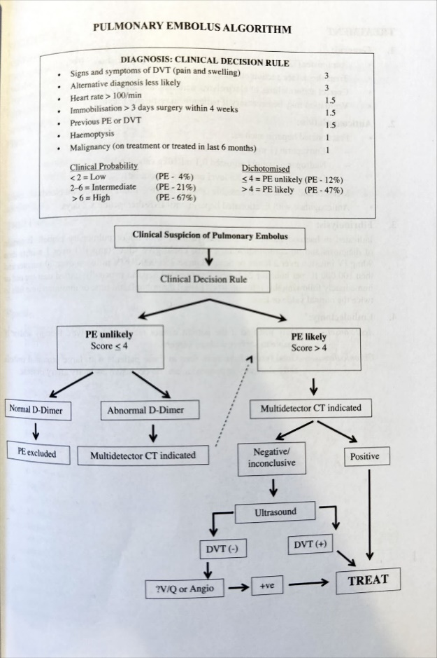

## B.09 Pneumothorax

**TYPES**

* Pneumothorax can be divided into:

1. **Spontaneous pneumothorax**  
   Occurs in tall thin young adult males (due to rupture of a subpleural bleb with normal underlying lung), in smokers and with underlying lung disease (e.g. emphysema, asthma, TB, PCP, interstitial lung disease, etc.).
2. **Traumatic pneumothorax**  
   With open or closed chest wall injuries. Often associated with surgical emphysema.

* Pneumothorax is life-threatening under 3 circumstances:

1. Tension pneumothorax
2. Large haemopneumothorax
3. Simple pneumothorax in the presence of severe underlying lung disease.

**CLINICAL FEATURES**

1. Sudden onset of chest pain, dyspnoea, and cyanosis (If 1-3 above).
2. Resonance on percussion with decreased or absent breath sounds.
3. Mediastinal deviation toward the pneumothorax (simple) and away (tension).
4. Elevated JVP, hypotension (tension).

**EMERGENCY MANAGEMENT OF PNEUMOTHORAX**

1. Examine for injuries, surgical emphysema, deviation of the trachea and/or apex beat, decreased breath sounds, and hyper-resonance.
2. If there is a strong suspicion of a tension pneumothorax, this pressure must be released immediately by insertion of a wide-bore IV cannula through the 2nd intercostal space in the midclavicular line, or the 4th or 5th intercostal space in the anterior axillary line on the affected side. If air rushes out under pressure, a tension pneumothorax was probably present. The needle should be withdrawn, but the cannula retained until an urgent formal intercostal drain has been inserted.
3. Cover penetrating wounds on the chest with a sterile dressing, but watch out for the development of a tension pneumothorax (Tape 3 sides of the dressing, leaving one side untaped).
4. X-ray and insert intercostal drainage tube. It is important to remember that there may be other associated injuries related to trauma.
5. Small pneumothoraxes in an otherwise stable patient may be treated conservatively, i.e. supplemental oxygen (speeds up the resorption of the pneumothorax) and frequent chest X-rays.

## B.10 Acute Adrenal Insufficiency

**SECTION 5.3 ACUTE ADRENAL INSUFFICIENCY**  
**Clinical features**  
Most instances of acute adrenal insufficiency do not arise de novo but occur in patients with underlying hypoadrenalism.

* Antecedent features of long-standing adrenal insufficiency
* Hypotension with or without overt shock
* Prominent gastrointestinal symptoms (anorexia, nausea, vomiting, diarrhea, abdominal pain, weight loss)
* Fever or hypothermia

**Laboratory Findings**

* Hyponatraemia
* Hyperkalaemia (variable)
* Raised urea
* Low bicarbonate
* Low/normal glucose

**Therapy**

* (i) **Specific:**  
  (a) Replace intravascular volume depletion with 5% dextrose in 0.9% saline infusion. (Up to 6 liters may be required during the initial 24 hours).  
  Be cautious in the presence of acute kidney injury as pulmonary edema may be a complication of excess fluid with anuria/oliguria.  
  (b) Hydrocortisone 200 mg IV stat, then 100 mg IV 6 hourly
* (ii) **Supportive:**  
  (a) Monitor serum sodium and potassium  
  (b) Monitor acid-base balance  
  (iii) Maintain oxygenation  
  (iv) Monitor and treat cardiac arrhythmias

## B.11 Metabolic Emergencies

### K+ Summary****

|  |  |
| --- | --- |
| **HYPERKALAEMIA** | **HYPOKALAEMIA** |
| **Clinical Features**   * Fatigue, muscle weakness, decreased tendon reflexes * **Ascending flaccid paralysis**, respiratory paralysis * Cardiac instability, cardiac arrest * Paraesthesia   **ECG Changes (always consider this an emergency)**  (a) **Tall, peaked, symmetrical T-waves (> R wave in 2 or more leads)**    (b) **Prolonged PR interval (1st degree heart block)**; flattened or absent P-waves  (c) **Widened QRS complexes (>0.12s)**; ST segment depression, deep S-wave, merging of S- and T-wave (sine wave pattern), bradycardia.  A graph on a paper  Description automatically generated  (d) Ventricular tachycardia, ventricular fibrillation, pulseless electrical activity or asystole may occur  **Management**  **Base Guideline**   * **Normal range: 3.5-5.3mmol/L** * Check K+ and other electrolytes (1–4 hourly) and monitor ECG * **Emergency** if K+ > 6.5 mmol/l or any increased value with ECG changes or neuromuscular symptoms * Stop K+ supplements / K+-sparing diuretics / ACE inhibitors / NSAIDs / ARBs   **Complete Regimen**   |  |  |  |  | | --- | --- | --- | --- | | 1 | (Remove K+): **Kayexalate** | 30g oral | in 50ml of water 6 hourly (oral) | | 2 | (Remove K+): **Furosemide** | 40mg IV | over 5 min | | 3 | (Shift K+): **Glucose**  (Shift K+): **Insulin** | 50 ml IV | of 50% solution | | 10u regular (rapid-acting) Insulin IV | over 15 min | | 4 | (Remove K+): **Dialysis** (preferably haemodialysis) | |  | | 5 | (Shift K+): Nebulized **Salbutamol** | 20mg | over 15 min | | 6 | (Metabolic acidosis): **NaHCO3** | 50 ml IV | of 8.5% solution over 5 minutes if metabolic acidosis | | 7 | (Stabilize myocardial cell membrane): **Calcium gluconate** | 30 ml IV | of 10% solution over 5 min |  |  |  |  |  |  | | --- | --- | --- | --- | --- | |  | **Mild Elevation (K+ > 5.5 mmol/l)** | **Moderate Elevation (K+ > 6.0 mmol/l)** | **Severe Elevation (K+ > 6.5 mmol/l) w/o ECG changes** | **Severe Elevation (K+ > 6.5 mmol/l) with ECG changes** | | **Aim** | Remove K+ | Remove, Shift K+ | Remove, Shift K+, Avoid acidosis | Remove, Shift K+, avoid acidosis, stabilize myocytes | | **Regimen** | 1,2 | 1,2,3,4 | 1,2,3,4,5,6 | 1,2,3,4,5,6,7 | | **Clinical Features**   * Fatigue, muscle weakness, decreased tendon reflexes * **Ascending paralysis**, respiratory paralysis * Arrhythmias (especially if on Digoxin); VT, VF, asystole * **Leg cramps, constipation, ileus, rhabdomyolysis** * May be associated with hypomagnesaemia, hypocalcaemia or alkalosis (K+ decreases by 0.3 mmol/l for every 0.1 increase in pH)   **ECG Changes**  (a) Flattening/Inverting of the T-waves / widening of the QRS complexes (b) Prominent U-waves (larger than the T-waves) (c) ST segment depression & the T-wave may invert.  (d) Prolonged PR Interval    **Management**  **Principles**   * **Normal range: 3.5-5.3mmol/L** * **Serum K+ < 2.5 mmol/l is life-threatening:** * Check K+ and other electrolytes (1-4 hourly) and monitor ECG * K+ deficiency often associated with Mg deficiency (Mg is required for prevention of renal K+ loss) * Avoid   + dextrose containing fluids as insulin release may shift potassium intracellularly, worsening the hypokalaemia   + **insulin therapy in hyperglycaemia until hypokalaemia is corrected**   **Guideline**   * **Add K+**  |  |  |  | | --- | --- | --- | | No Overload | 20 mmol/L KCL | 1L Saline over 2h | | Overload | 100mls over 2h. Use central line prevent pain/phlebitis |  * **2g MgSO4 diluted in 100 ml of normal saline infused IV over 1 hour**. |

#### B.11.1 Hyperkalaemia****

**SECTION 4.1: HYPERKALAEMIA**

**Clinical Features**

* Paraesthesia, fatigue, muscle weakness, decreased tendon reflexes
* **Ascending flaccid paralysis**, respiratory paralysis
* Cardiac instability, cardiac arrest

**ECG Changes (always consider this an emergency)**

* (a) **Tall, peaked, symmetrical T-waves (> R wave in 2 or more leads)**

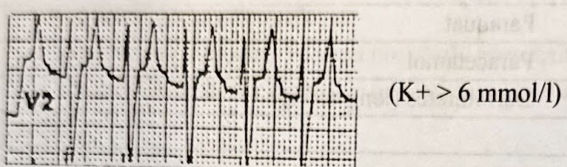

* (b) **Prolonged PR interval (1st degree heart block)**; flattened or absent P-waves
* (c) **Widened QRS complexes (>0.12s)**; ST segment depression, deep S-wave, merging of S- and T-wave (sine wave pattern), bradycardia.

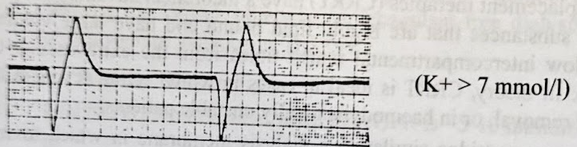

* (d) Ventricular tachycardia, ventricular fibrillation, pulseless electrical activity or asystole may occur
* (e) The cardiotoxic and ECG changes are usually related to:
  + Rate of rise of K+
  + Presence or absence of acidosis
  + Presence of dilutional hyponatraemia
  + Presence of hypocalcaemia

Therefore, a patient with chronic kidney disease could have a K+ > 7-8 with a normal ECG

**Base Guideline**

* **Normal range: 3.5-5.3mmol/L**
* Check K+ and other electrolytes (1–4 hourly) and monitor ECG
* **Emergency** if K+ > 6.5 mmol/l or any increased value with ECG changes or neuromuscular symptoms
* Stop K+ supplements / K+-sparing diuretics / ACE inhibitors / NSAIDs / ARBs

**Complete Regimen**

1. (Remove K+): **Kayexalate** 30g in 50-100ml of water 6 hourly (oral)
2. (Remove K+): **Furosemide** 0.5mg/kg IV over 1-2 min (in hypovolaemic/euvolemic patients, give isotonic saline as needed).
3. (Shift K+): **Glucose** 50 ml of 50% solution with 10u regular (rapid-acting) **Insulin** IV over 15-30 min
4. (Remove K+): **Dialysis** (preferably haemodialysis)
5. (Shift K+): Nebulized **Salbutamol** 20mg over 15 min
6. (Metabolic acidosis): **NaHCO3** 50 ml of 8.5% solution IV over 5 minutes if metabolic acidosis
7. (Stabilize myocardial cell membrane): **Calcium gluconate** 30 ml of 10% solution IV over 2-5 min

|  |  |  |  |  |
| --- | --- | --- | --- | --- |
|  | **Mild Elevation (K+ > 5.5 mmol/l)** | **Moderate Elevation (K+ > 6.0 mmol/l)** | **Severe Elevation (K+ > 6.5 mmol/l) without ECG changes** | **Severe Elevation (K+ > 6.5 mmol/l) with ECG changes** |
| **Aim** | Remove K+ | Remove, Shift K+ | Remove, Shift K+, Avoid acidosis | Remove, Shift K+, avoid acidosis, stabilize myocytes |
| **Regimen** | 1,2 | 1,2,3,4 | 1,2,3,4,5,6 | 1,2,3,4,5,6,7 |

**BLUE BOOK DETAILS**

(a) **Mild Elevation (K+ > 5.5 mmol/l)** – Remove potassium from the body:

* Kayexalate 15-30g in 50-100ml of water 6 hourly orally or by retention enema (Onset within 1-3 hours / Duration of effect 4–6 hours). Newer cation exchangers, if available are preferable to kayexalate.
* Furosemide 40-80mg IV (0.5 - 1mg/kg) over 1-2 min (in hypovolaemic/euvolemic patients, give isotonic saline as needed).

(b) **Moderate Elevation (K+ > 6.0 mmol/l)** – Shift potassium intracellularly:

* Glucose 50-100 ml of 50% solution with 10 u regular (rapid-acting) Insulin IV over 15-30 min. (Onset within 30 min / Duration of effect 4–6 hours). May follow with 10-20 units Insulin + 500 ml 10% D/W over 1 hour. Monitor blood glucose levels hourly for at least 6 hours.
* Kayexalate / Furosemide (as above)
* Dialysis (preferably haemodialysis)

(c) **Severe Elevation (K+ > 6.5 mmol/l) without ECG changes**:

* Nebulized Salbutamol 10-20mg over 15 min. (Beta agonists shift K+ into cells. (Onset within 15 min / Duration of effect 15-90 min). Repeat if necessary.
* Glucose and Insulin (as above)
* Sodium bicarbonate 50 ml of 8.5% solution IV over 5 minutes if metabolic acidosis is present. (Onset within 10 min / Duration of effect 1–2 hours). Repeat after 15 min if necessary, followed by 100-150 ml in 1 litre 5% D/W over 2-4 hours or longer if patient at risk of volume overload.
* Kayexalate / Furosemide / Dialysis (as above)

(d) **Severe Elevation (K+ > 6.5 mmol/l) with ECG changes** – Protect the heart first:

* Calcium gluconate 15-30 ml of 10% solution IV over 2-5 min first to stabilize the myocardial cell membrane (Onset within 1-3 min / Duration of effect 30-60 min). (Calcium chloride 10 ml of 10% solution is an alternative, preferably administered via a central venous line). Calcium must be infused SEPARATELY from sodium bicarbonate to prevent precipitation!
* Sodium bicarbonate (as above)
* Glucose and Insulin (as above)
* Nebulized Salbutamol (as above)
* Kayexalate / Furosemide / Dialysis (as above)

(e) Continuous cardiac monitoring is recommended in patients with severe hyperkalemia or moderate elevation in at-risk patients (e.g. renal failure or rhabdomyolysis) (f) Monitor effectiveness and watch out for recurrent hyperkalaemia and electrolyte abnormalities caused by the therapeutic options above (g) Search for and treat the cause.

**Diagnostic Approach to Hyperkalaemia**

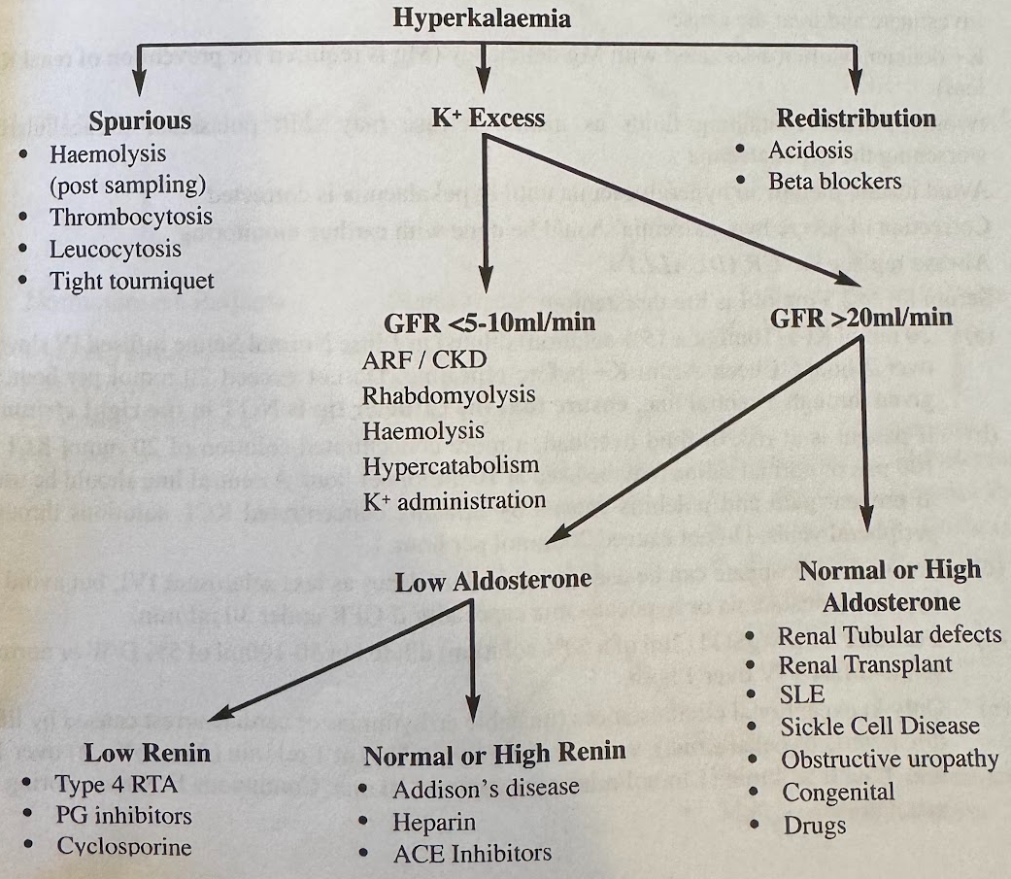

#### B.11.2 Hypokalaemia****

**SECTION 4.2: HYPOKALAEMIA**

**Clinical Features**

* Fatigue, muscle weakness, decreased tendon reflexes
* Leg cramps, constipation, ileus, rhabdomyolysis
* **Ascending paralysis**, respiratory difficulty
* Arrhythmias (especially if on Digoxin), including PEA, VT, VF, asystole
* May be associated with hypomagnesaemia, hypocalcaemia or alkalosis  
  (K+ decreases by 0.3 mmol/l for every 0.1 increase in pH)

**ECG Changes**

(a) Flattening of the T-waves / widening of the QRS complexes  
(b) Prominent U-waves (larger than the T-waves)  
(c) ST segment may be depressed, and the T-wave may invert.

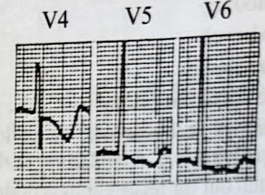

**Principles**

* **Normal range: 3.5-5.3mmol/L**
* **Serum K+ < 2.5 mmol/l is life-threatening:**
* Check K+ and other electrolytes (1-4 hourly) and monitor ECG
* K+ deficiency often associated with Mg deficiency (Mg is required for prevention of renal K+ loss)
* Avoid
  + dextrose containing fluids as insulin release may shift potassium intracellularly, worsening the hypokalaemia
  + **insulin therapy in hyperglycaemia until hypokalaemia is corrected**

**Management**

* **20 mmol** **KCl** **diluted in 1 litre Normal Saline infused IV slowly over 2 hours**.
  + Do not exceed 20 mmol per hour.
  + If given through a central line, **ensure that the catheter tip is NOT in the right atrium**.
* If fluid overload: **20 mmol KCl in 100 mls of normal saline at 10 mmol per hour**.
  + Use central line to prevent pain and phlebitis caused by KCl through peripheral veins.
* **1-2g MgSO4 diluted in 50-100 ml of normal saline infused IV over 1 hour**.

**\*\*\*\*BLUE BOOK\*\*\*\*\*\***

**Therapy**

* **Normal range: 3.5-5.3mmol/L**
* **Serum K+ < 2.5 mmol/l is life-threatening:**
* Check K+ and other electrolytes (1-4 hourly) and monitor ECG
* Oral K+ preferable for serum K+ value > 3.0 mmol/l and patient asymptomatic
* Investigate and treat the cause
* K+ deficiency often associated with Mg deficiency (Mg is required for prevention of renal K+ loss)
* Avoid
  + dextrose containing fluids as insulin release may shift potassium intracellularly, worsening the hypokalaemia
  + **insulin therapy in hyperglycaemia until hypokalaemia is corrected**
* Correction of severe hypokalaemia should be done with **cardiac monitoring**
* Always replace K+ **GRADUALLY**

(a) 20 mmol KCl (10 ml of a 15% solution) diluted in 1 litre Normal Saline infused **IV slowly** over 2 hours. Check serum K+ before repeating. Do not exceed 20 mmol per hour. If given through a central line, **ensure that the catheter tip is NOT in the right atrium**.

(b) If patient is at risk of fluid overload, a more concentrated solution of 20 mmol KCl in 100 mls of normal saline may be used at 10 mmol per hour. A central line should be used to prevent pain and phlebitis caused by infusing concentrated KCl solutions through peripheral veins. Do not exceed 20 mmol per hour.

(c) Potassium phosphate can be used in equivalent doses as less sclerosing IVI, but avoid in hyperphosphataemia or hypocalcaemia especially if GFR under 30 ml/min.

(d) Consider 1-2g MgSO4 (2 ml of a 50% solution) diluted in 50-100 ml of 5% D/W or normal saline infused IV over 1 hour.

(e) Only in exceptional circumstances (unstable arrhythmias or cardiac arrest caused by life-threatening hypokalaemia), very carefully infuse KCl at 1 ml/min (2 mmol/min) over 10 min, then 0.5 ml/min (1 mmol/min) over the next 10 min. Continuous ECG monitoring is mandatory.

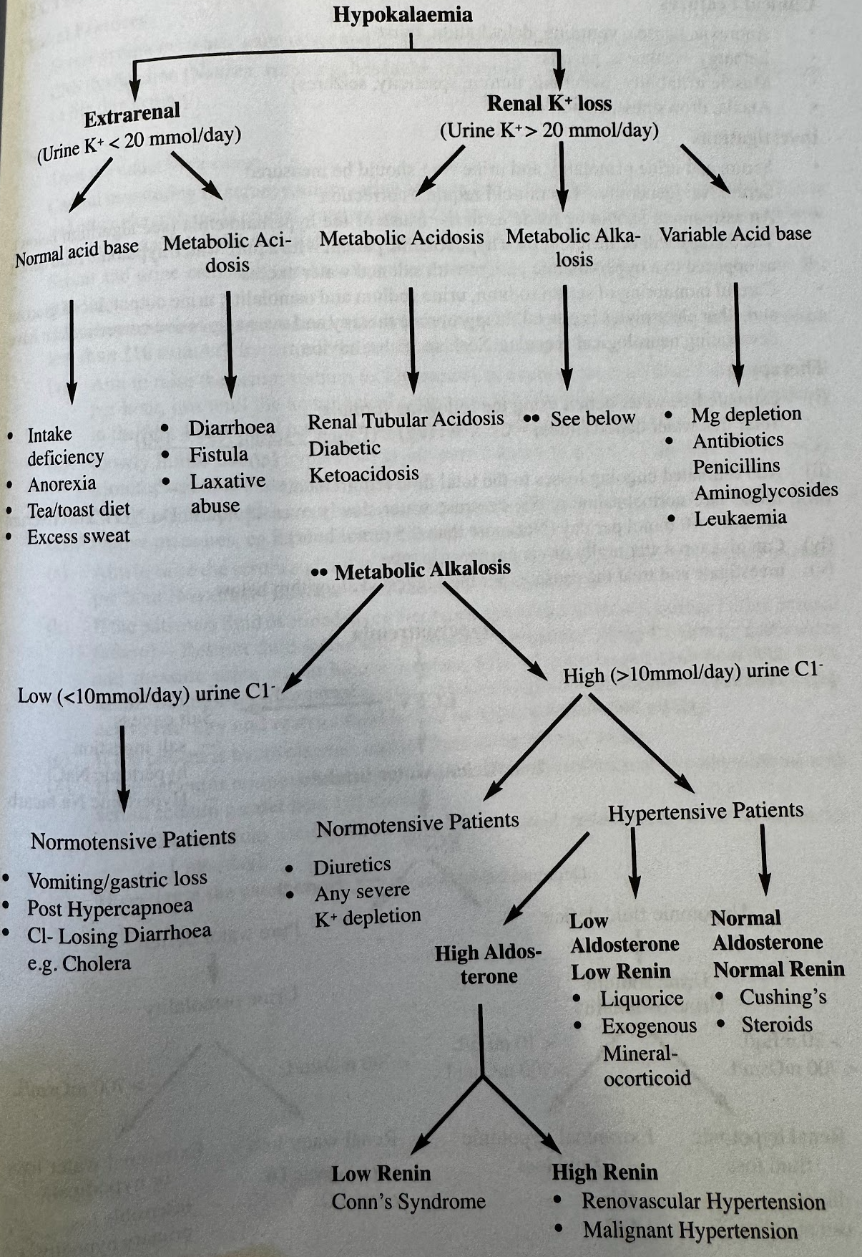

### Na+ Summary

#### B.11.3 Hypernatremia

**SECTION 4.3 HYPERNATRAEMIA**

**Clinical Features**

* Anorexia, nausea, vomiting, dehydration (commonest), thirst
* Lethargy, weakness, paresis
* Muscle irritability (twitching, tremor, spasticity, seizures)
* Ataxia, drowsiness, stupor, coma

**Investigations**

* Serum and urine osmolality and serum/urine Na+ should be measured
* **Serum Na+ generally >150 mmol/l requires correction**
* An assessment should be made as to the cause of the hypernatremia.
* The therapy will be different for a hypovolemic patient with a pure water/hypotonic fluid deficit as opposed to a hypervolemic patient with salt and water excess
* Careful monitoring of serum sodium, urine sodium and osmolality, urine output, blood glucose and other electrolytes is crucial. Inappropriate therapy and over-aggressive correction can have devastating neurological sequelae. Seek specialist advice

**Therapy**

(i) Estimate free water deficit using the following formula:

Total free water deficit (litres) = 0.5 x Wt (kg) x (serum [Na+] – 140) / 140

(ii) Add estimated ongoing losses to the total fluid requirements

(iii) Infuse half-normal saline or 5% dextrose water slowly over 48 hours. Do NOT lower serum sodium > 10 mmol per day (Not more than 0,5 mmol/hour)

(iv) Can give tap water orally or via nasogastric tube

(v) Investigate and treat the cause as per the suggested algorithm below

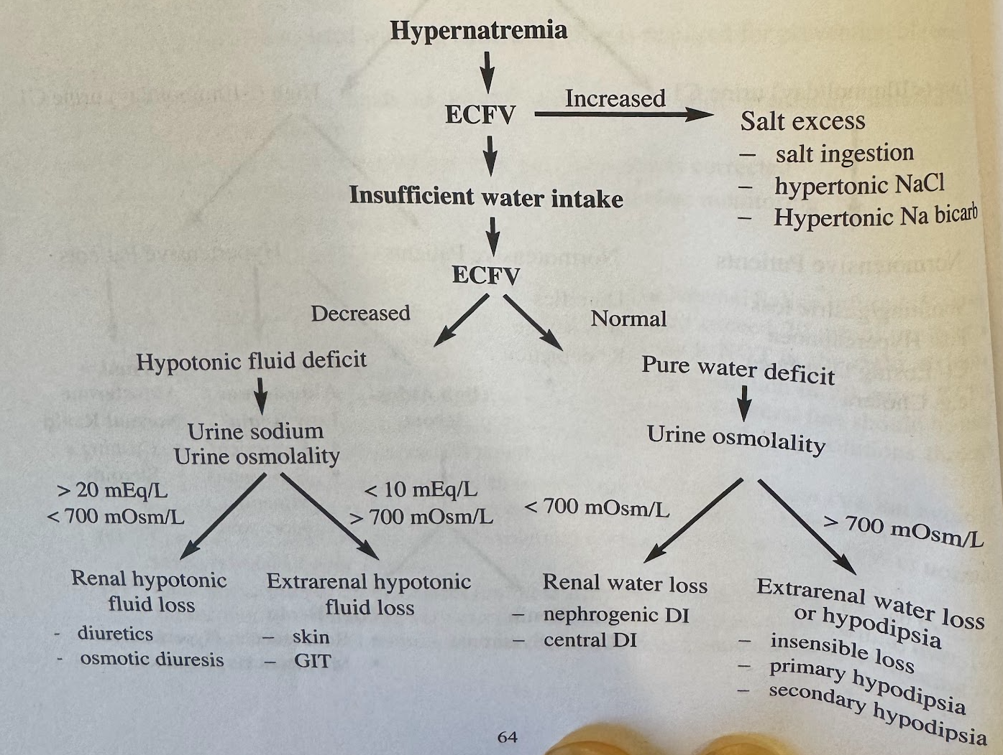

#### B.11.4 Hyponatraemia

**SECTION 4.4 HYPONATRAEMIA**

**Clinical Features**

* Severe symptoms when acute onset and/or severe (serum sodium < 120 mmol/l)
* CNS dysfunction (Nausea, vomiting, headache, irritability, lethargy, seizures, coma, death) can be life-threatening.

**Therapy**

* Treat the underlying cause
* Careful monitoring of serum sodium, urine sodium and osmolality, urine output, blood glucose and other electrolytes is crucial. Inappropriate therapy and over-aggressive correction can have devastating neurological sequelae. Seek specialist advice.
* Serum and urine osmolality and urine sodium should be measured to determine the aetiology.
* When hyponatremia is associated with pronounced CNS dysfunction (usually **serum sodium less than 110 mmol/l**), hypertonic saline should be administered:
  + (a) Aim to raise the serum sodium to 120 mmol/l at a rate of no more than 1 mmol increase per hour, just until the neurological symptoms subside (Maximum increase of 4 mmol/l in the first 4 hours and total increase less than 10 mmol/l in 24 hours).
  + (b) Slowly infuse 200 ml hypertonic saline over 6 hours (e.g 0,5 – 1 ml/min of 3% NaCl). Monitor serum sodium every 1-2 hours
* If CNS signs and symptoms are not present, hypertonic saline should not be used. More conservative measures, eg fluid restriction should be used:
  + (a) Aim to raise the serum sodium to 120 mmol/l at a rate of no more than 0,5 mmol increase per hour (Maximum increase of <10 mmol/l over 24 hours)
  + (b) If the patient is fluid overloaded (eg Nephrotic syndrome, cirrhosis, cardiac failure or renal failure) – Restrict fluid intake and administer furosemide 40mg IV slowly. Catheterize and measure urine output hourly. Replace 50% of urine output each hour with 0.9% saline. Monitor serum sodium every 1-2 hours. **Once serum sodium >120mmol/l**, stop active therapy and restrict fluid intake to approximately 500 ml/day.
  + (c) If the patient is hypovolemic, replace fluid using Normal Saline.
  + (d) If the patient is normovolaemic (eg SIADH, adrenal insufficiency, hypothyroidism) with serum sodium greater than 110 mmol/l:
    - Restrict fluid intake to 50-60% of estimated maintenance fluid requirements (±1 litre/day).
  + (e) Investigate the cause as per the algorithm below.

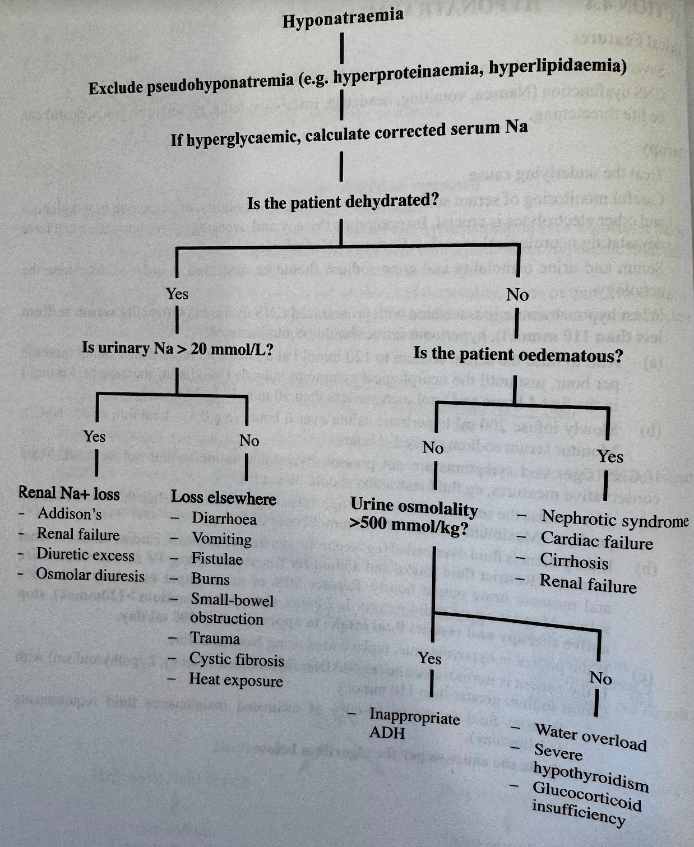

### Ca2+ Summary

#### B.11.5 Hypercalcemia

**SECTION 4.5: HYPERCALCAEMIA**

* **Clinical Features:**
* "Moans, groans, bones, stones and psychological overtones":
  + Constipation, dysphagia, abdominal pain, peptic ulceration, pancreatitis
  + Muscle weakness, hypotonia, bone pain
  + Polyuria, polydipsia, dehydration, renal stones
  + Depression, disorientation, confusion, hallucinations, seizures, coma
  + Arrhythmias, cardiac arrest
* **ECG Changes:**
* Shortened QT interval, AV block
* Prolonged PR or QRS intervals, flattened T-waves

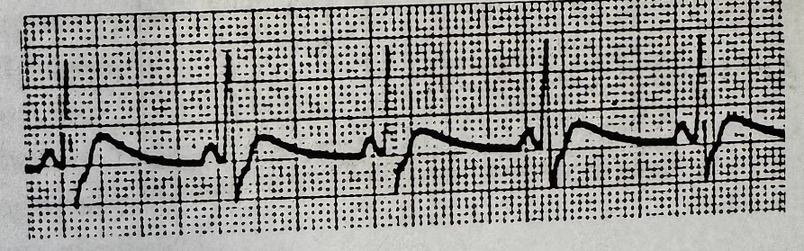

* **Causes:**
* Hyperparathyroidism, malignancy (90% of cases)
* Malignancy
* Pulmonary (TB, sarcoidosis, histoplasmosis, coccidiomycosis, berylliosis, ARDS)
* Drugs (Ca²⁺, Thiazides, oestrogen, lithium, vitamin A or vitamin D excess)
* Endocrine (Hyperthyroidism, adrenal insufficiency, phaeochromocytoma, acromegaly)
* Miscellaneous (Immobilization, Paget’s disease, Milk-alkali syndrome)
* **Investigations:**
* FBC, U&E, ESR, LFTs, Ca/Mg/PO4, **PTH**
* If Ca²⁺ is only slightly elevated, repeat test with uncuffed blood specimen
* Albumin, alkaline phosphatase, protein electrophoresis
* Chest X-ray
* NB – Corrected calcium = measured serum calcium + 0.02 x (40 – Albumin)
* **Therapy:**
* Serum calcium > 2.6 mmol/l with CNS symptoms is an emergency: (a) Normal Saline infusion – 200-300ml/hour (provided patient not in heart or renal failure) until diuresis occurs (urine output > 100-150ml/hour), then decrease infusion to 100-200ml/hour (b) Monitor and replace K⁺ and Mg as necessary (c) Once patient has been rehydrated (or if in heart failure), administer furosemide 1mg/kg if Bisphosphonates unavailable. (d) Consider dialysis with calcium-free dialysate if patient at risk of fluid overload. (e) Bisphosphonates e.g. Zoledronic acid 4mg in 100 ml Normal Saline infusion over at least 15 minutes. Should be effective within 48 hours. Patient must be adequately rehydrated, and not in renal failure. (GFR > 30ml/min) (f) For Vitamin D intoxication, sarcoidosis, multiple myeloma or metastases, give prednisone 40 mg daily or hydrocortisone 100 mg 8 hourly. (g) Stop any drugs that may be contributing to the hypercalcaemia.

#### B.11.6 Hypocalcaemia

**SECTION 4.6: HYPOCALCAEMIA**

* **Clinical Features:**
* Paraesthesia (esp. fingertips & peri-oral), muscle cramps, stridor, tetany, seizures
* Psychiatric disturbances
* Chvostek sign (Twitching of eyelid or corner of mouth when tapping the facial nerve at tragus)
* Trousseau sign (Carpopedal spasm when BP cuff inflated above SBP for >3 minutes). Usually unnecessary to elicit due to availability of point-of-care ionized calcium.
* Heart failure, hypotension, shock, cardiac arrest
* **ECG Changes:**
* Prolonged QT interval, T-wave inversion, bradycardia, AV block, VT. 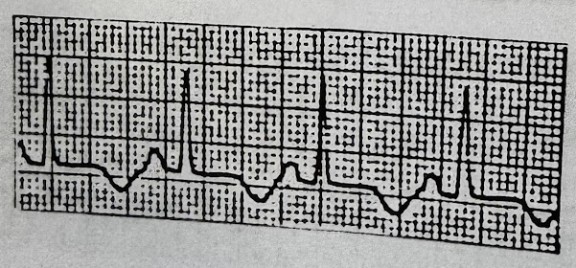
* **Causes:**
* Chronic renal failure
* Acute pancreatitis
* Hypoparathyroidism
* Medications (e.g. Cimetidine, Calcium channel blocker overdose, etc)
* Vitamin D deficiency (e.g. malnutrition, malabsorption, etc)
* Magnesium deficiency
* Toxic shock syndrome, sepsis, burns
* Tumour lysis syndrome
* **Investigations:**
* Ionized calcium and corrected calcium
* Magnesium, PO4, U&E, albumin, alkaline phosphatase, PTH
* NB – corrected calcium = measured serum calcium + 0.02 x (40 – serum albumin)
* **Therapy:** Corrected calcium of < 2.1 mmol/l is an emergency if patient symptomatic or ECG changes: (a) Replace calcium using either Calcium Chloride or Calcium Gluconate as follows:
* Calcium Chloride – Administer 10ml of a 10% solution over 10 minutes, then 35ml (diluted in 1 litre 5% D/W) over the next 6–12 hours. Monitor response. Calcium chloride must be administered via central vein access.
* Calcium Gluconate – Administer 10ml of a 10% solution over 10 minutes; then 70ml (diluted in 1 litre 5% D/W) over 12 hours. Monitor response.
* Be aware Calcium chloride 10% solution has 27mg/ml of elemental calcium whereas a 10% calcium gluconate solution has 9mg/ml (i.e. 3 times more potent). (b) Check K⁺ and Mg levels and supplement as necessary:
* If serum Mg is < 0.5 mmol/l, infuse Mg sulphate 2g in 100ml normal saline over 1 hour. (c) Recheck Ca, K⁺, Mg and pH levels every 4-6 hours. (d) Investigate and treat the cause. (e) Particularly if hypophosphataemia is present, consider Vit D Deficiency and supplement with starting dose of 0.5 µg Alfacalcidol per day, or Calciferol 50 000 IU po once or twice a week. (f) Consider oral calcium replacement.

# 1. Neurology

## Upper Motor Neuron PathwayLateral Corticospinal Tract DiagramTracts

**Corticospinal Tract**

**Definition**:  
The corticospinal tract is a descending motor pathway that originates in the cerebral cortex and is **responsible for voluntary motor control**, **primarily for fine motor movements of the limbs and trunk**.

**Neuronal Course**:

* **First-order neurons** (Upper Motor Neurons - UMNs):
  + The corticospinal tract originates in the **primary motor cortex** (precentral gyrus, Brodmann area 4).
  + Axons descend to form part of the **internal capsule**.
  + fibers pass through the **crus cerebri** in the **midbrain** and descend into the **pons**.
  + In the **medulla**, they form the **medullary pyramids**, where approximately 85-90% of the fibers decussate contralaterally.
    - These crossed fibers form the **lateral corticospinal tract**.
    - The remaining uncrossed fibers descend as the **anterior corticospinal tract** (which decussates at the level of the spinal cord).
  + The UMNs synapse with **lower motor neurons** (LMNs) in the **anterior horn** of the spinal cord.
* **Second-order neurons** (Lower Motor Neurons - LMNs):
  + LMNs are located in the **anterior horn** of the spinal cord.
  + Their axons exit the spinal cord via the **ventral root**, joining the spinal nerves, and innervate skeletal muscles for voluntary movement.

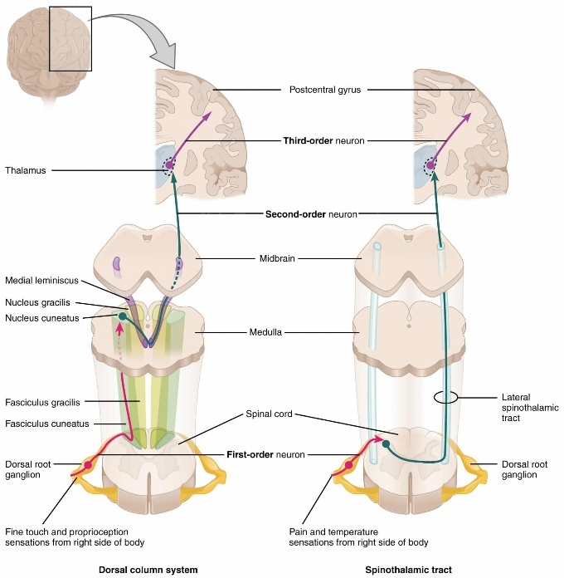**Spinothalamic Tract**

**Definition**:  
The spinothalamic tract is an ascending sensory pathway responsible for **transmitting pain, temperature, and crude touch** sensations from the body to the brain.

**Neuronal Course**:

* **First-order neurons**:
  + Sensory receptors (nociceptors, thermoreceptors, mechanoreceptors) in the skin detect stimuli and send signals through **afferent fibers**.
  + These fibers enter the spinal cord via the **dorsal root ganglia** and synapse with second-order neurons in the **dorsal horn** of the spinal cord.
* **Second-order neurons**:
  + Located in the **dorsal horn** of the spinal cord, second-order neurons receive input from the first-order neurons.
  + These neurons immediately **decussate** (cross) to the opposite side of the spinal cord via the **anterior white commissure**.
  + After decussating, the fibers ascend in the **anterolateral system** (ALS) as the **spinothalamic tract**.
  + The tract ascends through the **spinal cord**, **medulla**, **pons**, and **midbrain**, ultimately synapsing in the **ventral posterolateral nucleus** (VPL) of the **thalamus**.
* **Third-order neurons**:
  + From the VPL of the thalamus, third-order neurons project through the **internal capsule** to the **primary somatosensory cortex** (postcentral gyrus, Brodmann areas 3, 1, 2) where conscious perception of pain, temperature, and crude touch occurs.

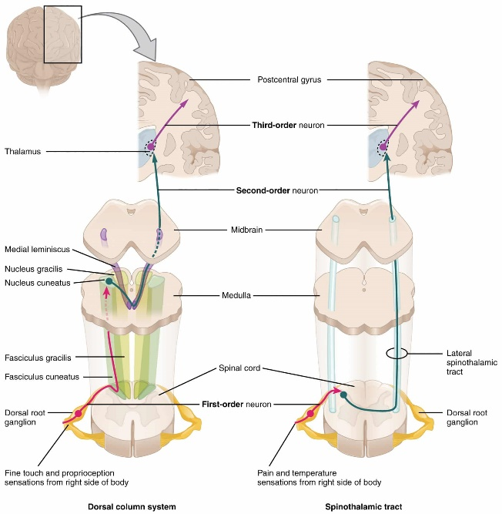**Dorsal Columns (Dorsal Column-Medial Lemniscus Pathway)**

**Definition**:  
The dorsal columns are ascending sensory pathways responsible for **transmitting fine touch, vibration, and proprioception** (sense of body position) from the body to the brain.

**Neuronal Course**:

* **First-order neurons**:
  + Sensory receptors (mechanoreceptors and proprioceptors) in the skin, muscles, and joints detect stimuli and send signals via **afferent fibers**.
  + These fibers enter the spinal cord through the **dorsal root ganglia** and ascend ipsilaterally in the **dorsal columns** of the spinal cord:
    - **Fasciculus gracilis**: carries sensory information from the lower body (below T6).
    - **Fasciculus cuneatus**: carries sensory information from the upper body (above T6).
  + The fibers ascend without decussating and terminate in the **nucleus gracilis** and **nucleus cuneatus** in the **medulla**.
* **Second-order neurons**:
  + Neurons in the **nucleus gracilis** and **nucleus cuneatus** of the medulla receive input from the first-order neurons.
  + The second-order neurons decussate (cross to the opposite side) in the medulla as **internal arcuate fibers**.
  + After decussation, these fibers ascend through the **medial lemniscus** pathway to the **ventral posterolateral nucleus** (VPL) of the **thalamus**.
* **Third-order neurons**:
  + From the VPL of the thalamus, third-order neurons project to the **primary somatosensory cortex** (postcentral gyrus, Brodmann areas 3, 1, 2), where conscious perception of fine touch, vibration, and proprioception occurs.

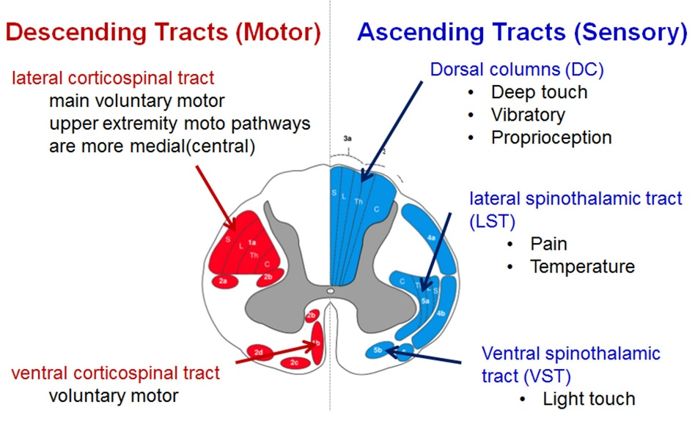

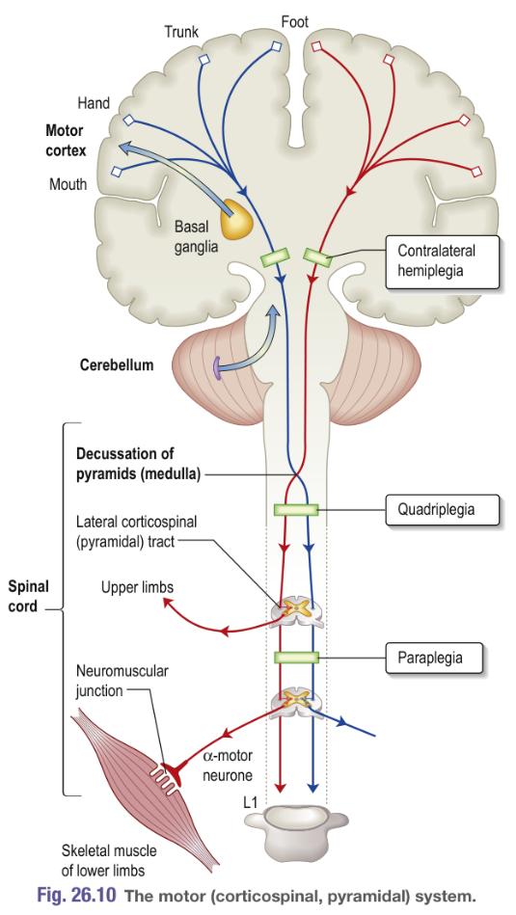**Peripheral Nervous System**

* CNS is confined to brain and spinal cord
* PNS includes (in anatomical order):
  + **Anterior horn cell** (located within spinal cord)
  + Spinal nerve roots (radicles)
  + Plexi (brachial and lumbosacral)
  + Named peripheral nerves (e.g. median, peroneal)
  + Tiny nerve endings (sensory fibers and tiny branches of lower motor axons at the neuromuscular junction)
  + Neuromuscular junction and muscle

**MOTOR CONTROL SYSTEMS**

There are three systems, each of which interacts by feedback loops with the other two, with sensory input from the reticular formation:

* **The corticospinal (or pyramidal) system** enables purposive, skilled, intricate, strong and organized movements. Defective function is recognized by a distinct pattern of signs – loss of skilled voluntary movement, spasticity and reflex change – seen, for example, in a hemiparesis, hemiplegia, or paraparesis.

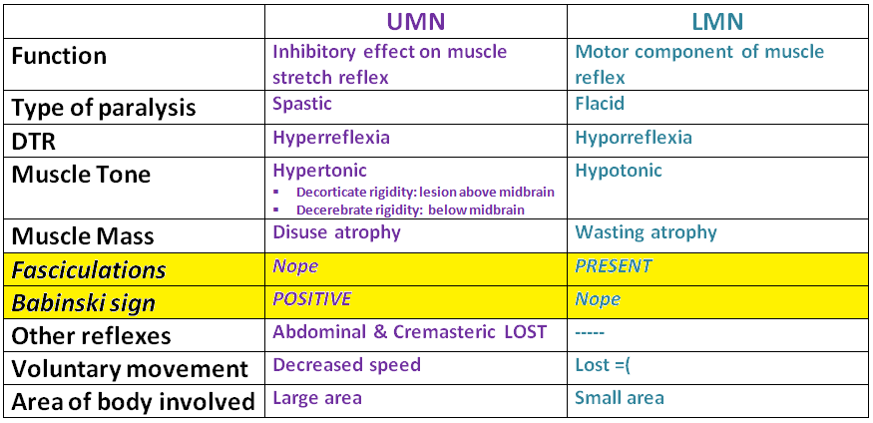

* **The extrapyramidal system** facilitates fast, fluid movements that the corticospinal system has generated. Defective function produces slowness (bradykinesia), stiffness (rigidity), and/or disorders of movement (rest tremor, chorea, and other dyskinesias). One feature (e.g., stiffness, tremor, or chorea) will often predominate.
* **The cerebellum** and its connections have a role coordinating smooth and learned movement, initiated by the pyramidal system, and in posture and balance control. Cerebellar disease leads to unsteady and jerky movements (ataxia), with characteristic limb signs of past-pointing, action tremor, and incoordination, gait ataxia, and/or truncal ataxia.

**Pyramidal tracts (UMN neurons)**

Tracts responsible for conscious, voluntary control of body and face muscles. They are divided into two tracts

* Corticospinal tract: neurons of motor cortex 🡪 through internal capsule 🡪 cross in medulla (decussation of pyramids)🡪 pass to contralateral cord as lateral corticospinal tracts 🡪 terminates spinal cord anterior horn cells. A proportion of corticospinal outflow is uncrossed (anterior corticospinal tracts).
* Corticobulbar tract: cortex 🡪 motor nuclei of cranial nerves

Disease of the pyramidal system causes UMN lesion.

|  |  |  |  |  |  |  |  |  |  |  |  |  |  |
| --- | --- | --- | --- | --- | --- | --- | --- | --- | --- | --- | --- | --- | --- |
| |  |  | | --- | --- | | **Spastic Paraparesis** | Bilateral damage to corticospinal pathways🡪weakness/spasticity. Cord compression or cord disease. Mid-cerebral lesions. | | |  |  | | --- | --- | | **Hemiparesis** | **Lesion** | | Motor Cortex | Monoparesis: isolated motor cortex lesion e.g. infarct, 2ry neoplasm | | Internal Capsule | Large deficit: Middle cerebral artery branch infarct. | | Pons | Pontine lesion 🡪adjacent structures (CN 6,7 nuclei)= lateral gaze palsy/diplopia/facial weakness | | Spinal Cord | Isolated lesion of 1 lateral corticospinal tract (cervical cord injury)🡪ipsilateral UMN lesion Level informed by changes in reflexes, mm. wasting at level of lesion | |

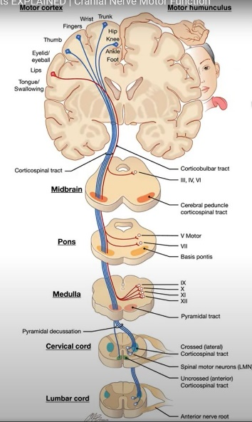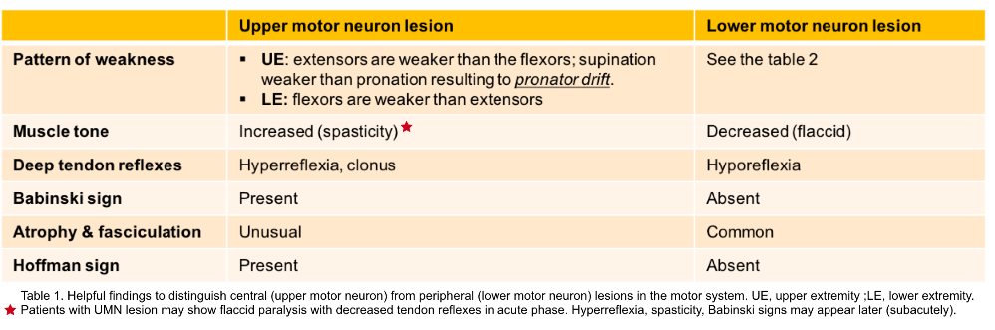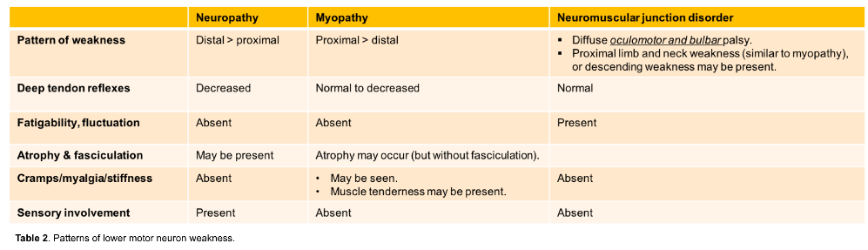

**Characteristics of pyramidal lesions**

* Tone changes: flaccid🡪spastic
* ++tendon reflexes
* Drift of upper limb
* Weakness & loss of skilled movement

**Patterns of UMN disorders**

* There are three main patterns:
* **Hemiparesis** means weakness of the limbs on one side; it is usually caused by a lesion in the brain and occasionally in the cord.
* **Paraparesis** means weakness of both lower limbs and is usually diagnostic of a cord lesion; bilateral medial brain lesions (e.g. parasagittal meningioma) occasionally cause paraparesis.
* **Tetraparesis** (also called **quadriparesis**) means weakness of four limbs.  
  Hemiplegia, paraplegia and tetraplegia (strictly) indicate total paralysis but are often used to describe severe weakness.

**LOWER MOTOR NEURONE LESIONS**

The lower motor neurone (LMN) is the pathway from the

* anterior horn cell or the
* cranial nerve nucleus

via a peripheral nerve 🡪 to muscle motor end-plates. Anterior horn cell **activity is modulated by** impulses from:

* 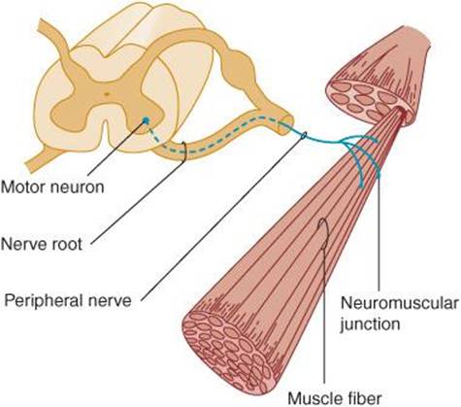corticospinal tracts
* the extrapyramidal system
* the cerebellum
* afferents via posterior roots.

**Clinical features of lower motor neurone lesions**

These are **seen in voluntary muscles** that depend on an intact nerve supply for both contraction and metabolic integrity. Signs follow rapidly if the LMN is interrupted.

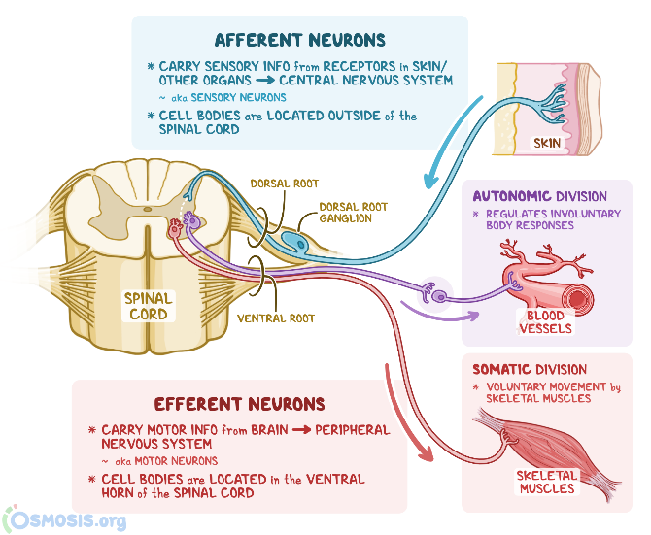

**Aetiology**

* Examples of LMN lesions at various levels include:
* **cranial nerve nuclei (Bell’s palsy**) and **anterior horn cell (motor neurone disease)**
* **spinal root** – **radiculopathy**, e.g. **cervical and lumbar disc protrusion**
* **peripheral (or cranial) nerve** – **trauma, entrapment, and polyneuropathy**

**SENSORY PATHWAYS AND PAIN**

**Lesions of the sensory pathways**

* Altered sensation, tingling (paraesthesia), clumsiness, numbness, and pain are the principal symptoms of sensory lesions.

|  |  |  |
| --- | --- | --- |
| **Peripheral nerves & spinal roots**  Peripheral nerves carry all modalities of sensation. Sensory distribution of spinal roots = dermatomes  **Peripheral nerve lesions**   * Symptoms are felt within the distribution of a peripheral nerve. * Section of a sensory nerve is followed by complete sensory loss. * Nerve entrapment causes numbness, pain, and tingling. * Tapping the site of compression sometimes causes a sharp, electric shock-like pain in the distribution of the nerve, known as Tinel’s sign, such as in carpal tunnel syndrome.   **Spinal root lesions**   * **Root pain**: Pain of root compression is felt in the myotome supplied by the root, and there is also a tingling discomfort in the dermatome. * The pain is worsened by manoeuvres that either stretch the root or increase pressure in the spinal subarachnoid space. * Cervical and lumbar disc protrusions are common causes of root lesions. * **Dorsal spinal root lesions**: Section of a dorsal root causes loss of all modalities of sensation within a dermatome. * However, overlap between adjacent dermatomes makes it difficult to detect anaesthesia when a single root is destroyed. | **Spinal cord**  **Posterior columns**: Axons in the posterior columns whose cell bodies are in the ipsilateral gracile and cuneate nuclei in the medulla carry sensory modalities of **vibration, joint position (proprioception), light touch, and two-point discrimination**. Axons from second-order neurones then **cross in the brainstem** to form the medial lemniscus, **passing to the thalamus**.  **Posterior column lesions**: These cause:   * + tingling   + electric shock-like sensations   + clumsiness   + numbness   + tight band-like sensations   **Spinothalamic tracts**: Axons carrying **pain and temperature** sensation synapse **in the dorsal horn of the cord, cross within the cord**, **and pass in the spinothalamic tracts to the thalamus** and reticular formation.  **Spinothalamic tract lesions**   * contralateral loss of pain and temperature sensation with a clear level below the lesion. * light touch remains preserved. Seen in syringommeyelia (cavity)   **Spinal cord compression**   * Cord compression causes progressive spastic paraparesis (tetraparesis/quadriparesis) with sensory loss below the level of compression. * **Sphincter disturbance is common**. * **Brown-Sequard** = damage to one spinoth. Tract (contralateral loss of pain/temp+ipsil. Corticospinal tract (originally termed cord hemisection)- complains of numbness one side and weakness the other. P.865 | **Sensory cortex**  Fibres from the thalamus **pass to the parietal region sensory cortex**. **Connections exist between the thalamus, sensory cortex, and motor cortex**.  **Pontine lesions**   * Since lesions (e.g. an MS plaque) lie above the decussation of the posterior columns, there is loss of all forms of sensation on the side opposite the lesion. * CN3,4,5,6,7 may indicate level   **Thalamic lesions**   * Thalamic pain (also called **central post-stroke pain** or **thalamic syndrome**) follows a small thalamic infarct. The patient has a stroke (hemiparesis and sensory loss).   **Parietal cortex lesions**   * Sensory loss, neglect of one side, apraxia, and subtle disorders of sensation occur. Pain is not a feature of destructive cortical lesions. |

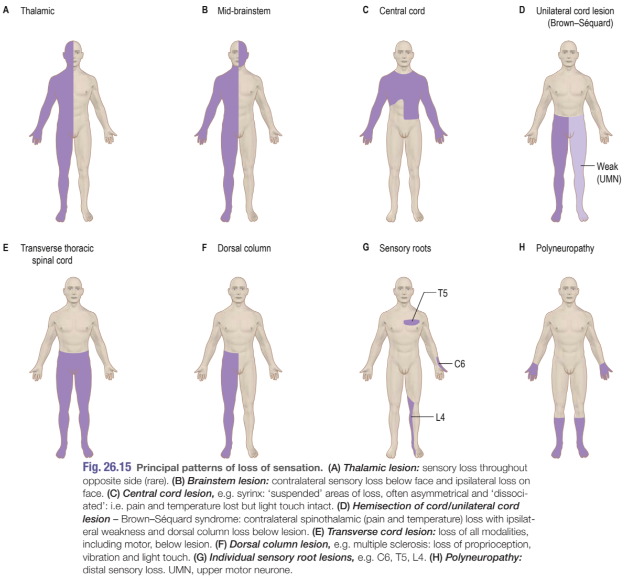

**Peripheral Nerve Disease**

* **Neuropathy** = pathology affecting a peripheral nerve (mononeuropathy = 1 nerve)
* **Polyneuropathy** (**peripheral neuropathy**) describes diffuse, symmetrical disease, usually commencing peripherally. The course may be acute, chronic, static, progressive, relapsing or towards recovery. Poly neuropathies are motor, sensory, sensorimotor and autonomic. They are classified broadly into demyelinating and axonal types- often impossible to differentiate. Many systemic diseases cause neuropathies. Widespread loss o tendon reflexes is typical, with distal weakness and distal sensory loss.
* **Radiculopathy** means disease affecting nerve roots and
* 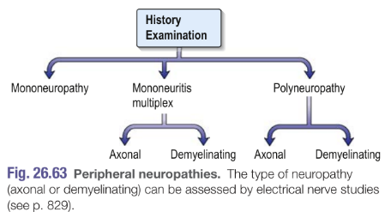**plexopathy**, the brachial or lumbosacral plexus.

**Polyneuropathies**:

* **Immune mediated**: **Guillain–Barré syndrome (Acute inflammatory demyelinating polyradiculoneuropathy**), Chronic inflammatory demyelinating polyradiculoneuropathy
* Idiopathic sensorimotor neuropathy
* Metabolic, toxic and vitamin deficiency neuropathies (see Box 26.70)

## Spinal Cord Lesions

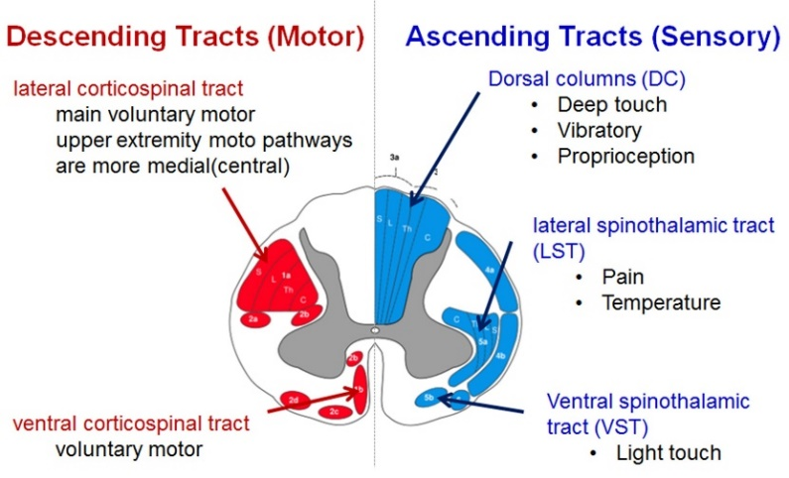

**General approach to Spinal Cord Lesions**

Need to localize anatomically (1 and 2 below), then determine etiology (3):

|  |  |  |
| --- | --- | --- |
| **1. At which (vertical) level of the SC is the lesion localized?**   * ***NB principle in SC lesions****: LMN level signs at the level of the lesion, UMN signs below level of the lesion* * If an UMN lesion but no signs of hypertonia, hyperreflexia, and clonus – think spinal shock. * **Bladder & bowel involvement?**   + **Both🡪 spinal problem**.   + **If one or the other, it may be a local problem**.     - LMN lesion: flaccid bladder = urine retention (because detrusor cannot contract); will eventually result in overflow incontinence if the bladder is not catheterized; ++ large volumes of urine.     - UMN lesion will cause a spastic bladder = urgency, frequency, and passing of small amounts of urine; ‘irritable bladder’ + stool constipation. * **Determine a sensory level** = decreased sensation below the level and normal sensation above it.   A diagram of the human body  Description automatically generated | **Upper cervical (C1-C4)**   * UMN signs in the upper and lower limbs   **C5**   * LMN weakness and wasting of deltoids, biceps, and brachioradialis   **C8**   * LMN weakness and wasting of intrinsic muscles of the hand   **Midthoracic (c. T2-T8)**   * Intercostal paralysis * UMN signs in lower limbs * Loss of upper abdominal reflexes at T7 and T8 * If unable to sit up, lesion is above T6   **T10-T11**   * Loss of lower abdominal reflexes * Upward displacement of the umbilicus when the patient attempts to lift their head (Beevor sign) – suggests weakness of the rectus abdominis muscle (T10-T12 LMN lesion)   **L1**   * Normal abdominal reflexes but loss of cremasteric reflex * UMN signs in lower limbs   **L4**   * LMN weakness and wasting of the quadriceps * Loss of knee jerk reflex * Ankle jerks may be hyperreflexic with extensor plantar response (upgoing toes), but more often the whole conus is involved, causing a LMN effect.   **L5-S1**   * LMN weakness of knee flexion and hip extension (S1) and hip abduction (L5), plus calf and foot muscles * Knee jerks present * No ankle jerks or plantar responses * Anal reflex present   **S3-S4**   * No anal reflex * Saddle sensory loss * Normal lower limbs | **2. Which part/s of the SC (i.e. in cross-section) are involved?**   * Spinal cord lesions can be intramedullary, extramedullary (intradural) or extramedullary (extradural) * Important questions to answer to help determine where the problem is, include:   + **Is there pain?** (Intramedullary – pain is rare vs extramedullary – radicular or bone pain is common)   + **Are the symptoms symmetrical?** (Intramedullary lesion = symmetrical symptoms vs extramedullary = asymmetrical)   + **Is incontinence early or late?** (Intramedullary lesion = early vs extramedullary = late incontinence)   **3. Then determine the most likely aetiology.**   * See diagram from Dr Zamparini below with an approach to causes for each (intra/extramedullary). |

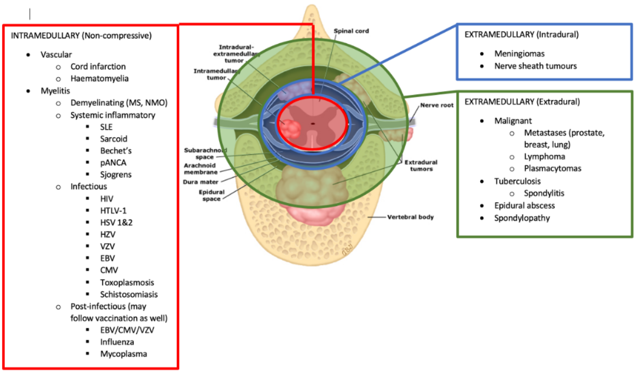 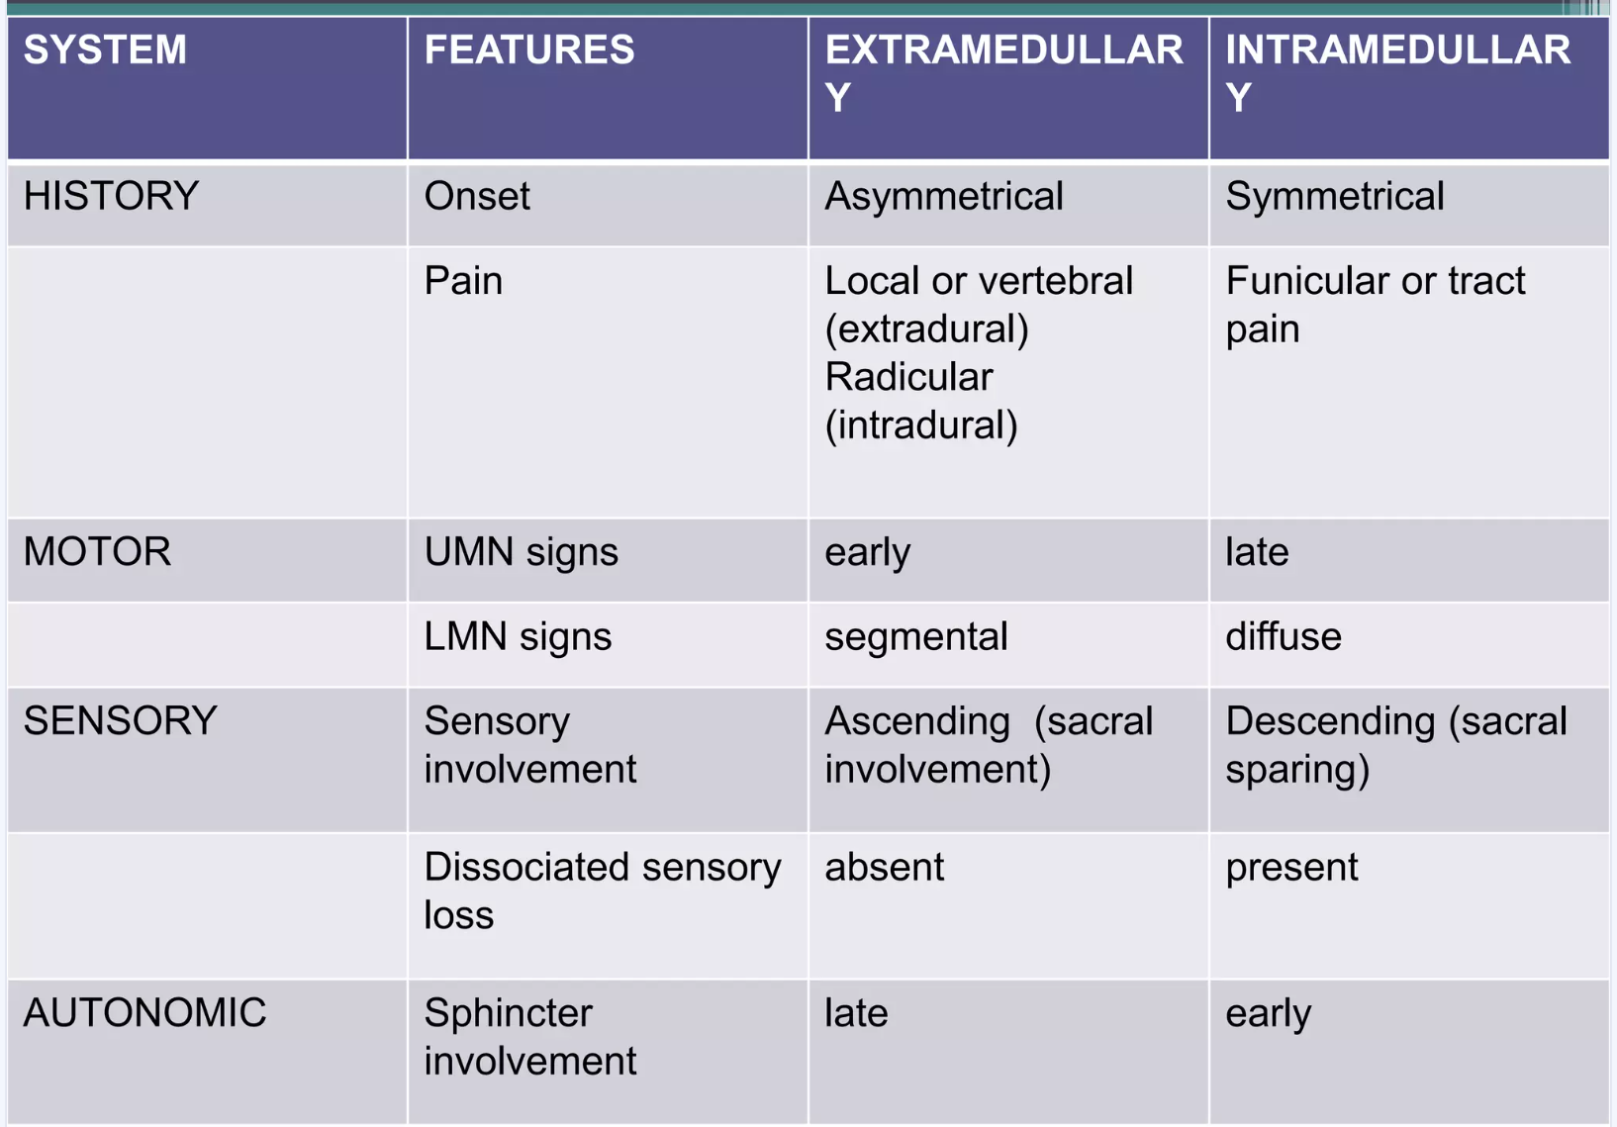 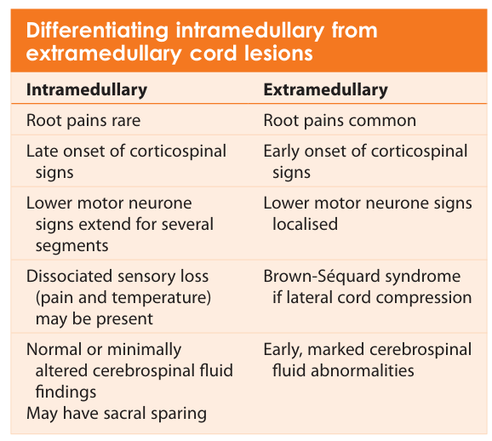

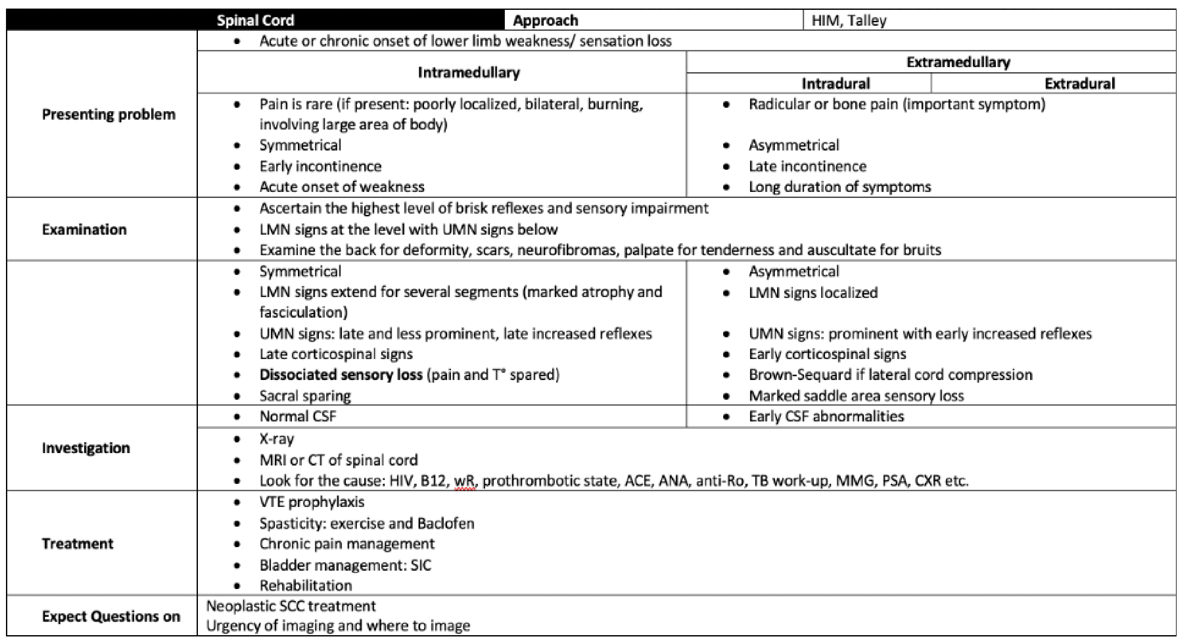

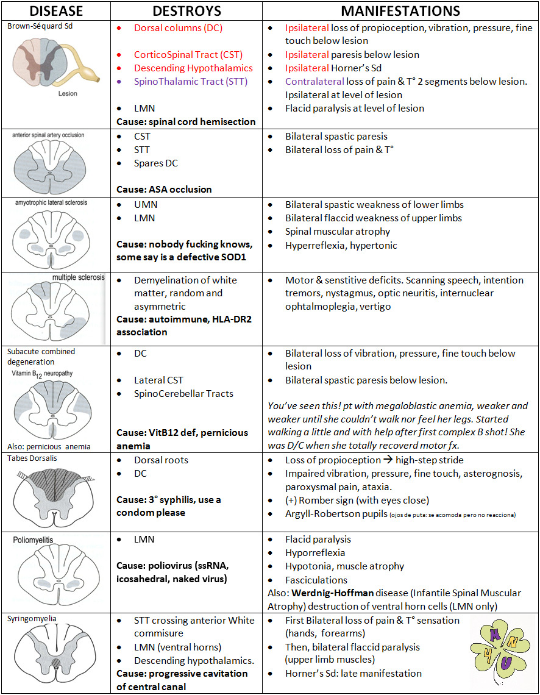

|  |
| --- |
| Cauda equina syndrome   * Compression and disrupted function of the cauda equina (i.e. nerve roots arising from L1-L5 supplying **motor + sensory** innervation to the legs, bladder, anus, and perineum). * Unlike a lesion higher up which produces UMN signs at levels below, **cauda equina syndrome produces LMN features**:   + Bilateral flaccid lower limb weakness   + Sacral numbness (‘saddle anaesthesia’)   + Retention of urine (i.e. flaccid bladder)   + Erectile dysfunction   + Areflexia   + Usually with back pain radiating to the legs   + +- intermittent claudication (if chronic onset) * Onset is either acute (an acute flaccid paraparesis) or chronic. * Onset of bladder, bowel, and erectile dysfunctions are usually late. * Most **commonly caused by a herniated disc**. Other causes include: stenosis of the spinal canal, spinal tumor, infection, inflammation, hemorrhage, or fracture; complication of spinal trauma; arteriovenous malformation. * **Neuro emergency** – urgent imaging and surgical decompression is indicated. |
| The Brown Sequad Syndrome Is Shown In This Diagram And Shows How ItBrown-Sequard syndrome   * Hemisection of the spinal cord. * Causes: multiple sclerosis, angioma, trauma, myelitis, and postradiation myelopathy. * **Motor changes**:   + UMN signs below the hemisection on the same side as the lesion.   + LMN signs at the level of the hemisection on the same side. * **Sensory changes**:   + Pain and temperature loss on the opposite side to the lesion.   + Vibration and proprioception loss on the same side of the lesion.   + Light touch detection usually normal.   A close-up of a white background  Description automatically generated |
| Subacute combined degeneration of the cord (SACD)   * Aka ‘posterolateral column syndrome’. * Caused by vitamin B12 deficiency. * Posterior column loss symmetrically (vibration and proprioception) causing ataxic gait. * UMN signs in the lower limbs symmetrically with absent ankle reflexes; knee reflexes are absent or, more often, exaggerated. * Peripheral sensory neuropathy (mild). * Optic atrophy. * Dementia.   A close-up of a white background  Description automatically generated |
| Syringomyelia   * Central lesion of the spinal cord. * **Clinical triad**:   + Loss of pain and temperature over the neck, shoulders, and arms (‘cape’ distribution).   + Amyotrophy (atrophy and areflexia) of the arms.   + UMN signs in the lower limbs.   + +- Thoracic scoliosis due to asymmetrical weakness of the paravertebral muscles.   A close up of a sign  Description automatically generated |

## Weakness

**Overview** [**Weakness - WikiMSK**](https://wikimsk.org/wiki/Weakness)

When evaluating weakness, the following distinction is made:

1. **Pyramidal/Upper motor neuron lesions** (lesion in cerebral cortex, brainstem, or descending motor pathway of the spinal cord). Also called pyramidal tract disease, long tract signs, or central weakness. Causes increased tone, increased reflexes, pyramidal pattern of weakness (weak extensors in the arm, weak flexors in the leg).
2. **Lower motor neuron lesions** (lesion in peripheral nerve and anterior horn cells of the spinal cord). Also called denervation disease or peripheral weakness. Causes wasting, fasciculation, decreased tone, and absent reflexes.
3. **Muscle disease (Myopathy):** Causes wasting, decreased tone, impaired or absent reflexes.
4. **Neuromuscular junction disorders:** Causes fatigable weakness, normal or decreased tone, normal reflexes.
5. **Functional weakness:** Causes normal tone, normal reflexes without wasting with erratic power.

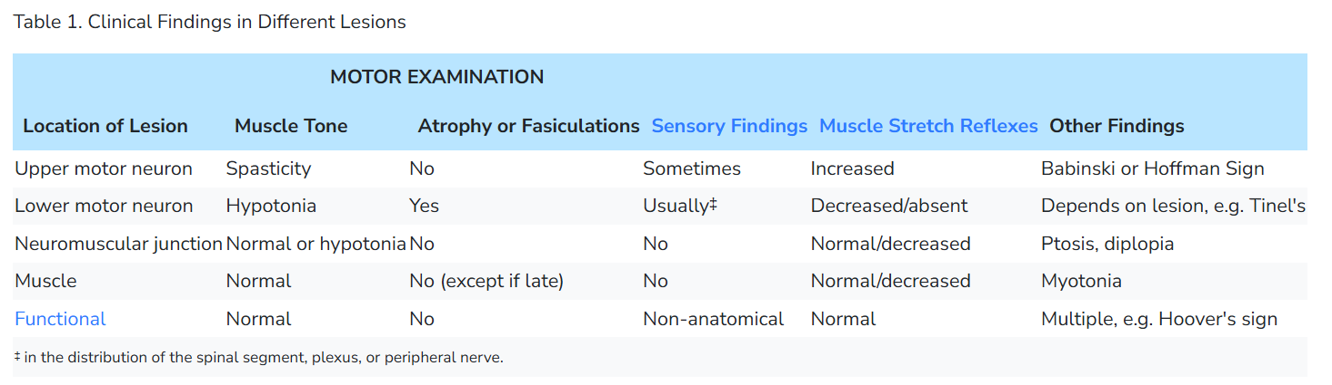

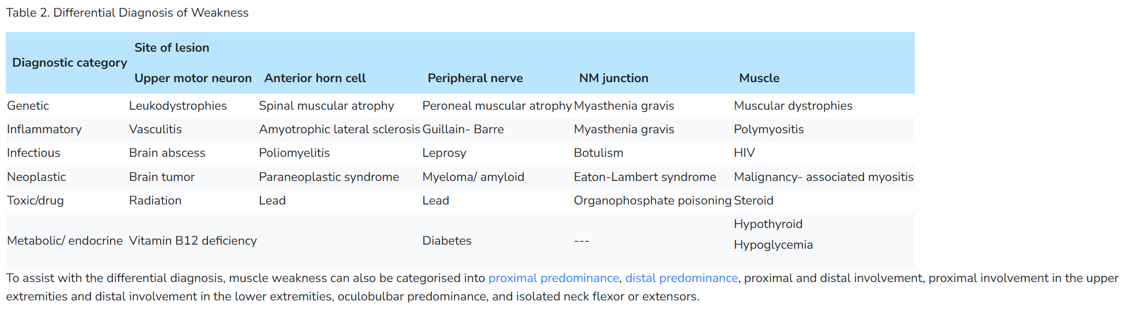

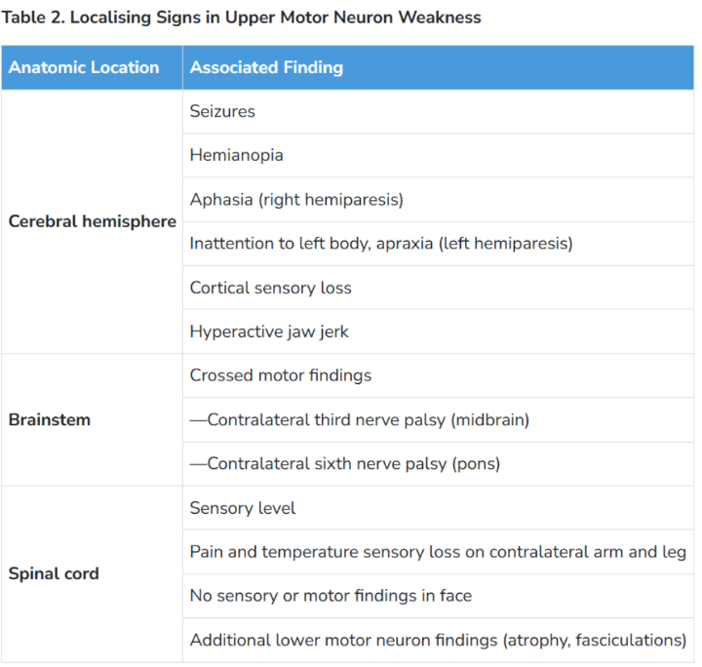**Upper Motor Neuron Weakness**

**Upper motor neuron lesion:** Weak and flaccid (generally distal) muscles that eventually become spastic, hypertonic, and hyperreflexive. There is an association with pathologic reflexes (such as Babinski's and Hoffmann) and induced clonus of the ankle or wrist. Spasticity is prominent in the antigravity muscles (flexors of the upper extremities and extensors of the lower extremities). Spasticity is associated with clasp-knife finding due to a variable degree of resistance to passive motion.

Upper motor neurons cross over to the contralateral side at the **decussation of the pyramids (between the brainstem and spinal cord**). Therefore upper motor neuron type weakness can result from:

* Ipsilateral spinal cord lesion: In spinal cord lesions there may be both upper and lower motor neuron type weakness. Lower motor neuron type weakness occurs at the level of the lesion, and upper motor neuron type weakness occurs below the level of the lesion.
* Contralateral brainstem lesion
* Contralateral cerebral hemisphere lesion

**Common aetiologies are cerebrovascular disease, multiple sclerosis, and brain tumors**.

The **upper motor neuron pathway extends from the cerebral cortex down** through the spinal cord. It travels in tight quarters with central neurons that innervate other structures. Therefore, there are localizing lesions in this pathway to pinpoint its location:

**Lower Motor Neuron Weakness**

**Lower motor neuron lesion:** Weakness and paralysis of (generally distal) affected muscles. Flaccidity, hypotonia, diminished or absent stretch reflexes, and eventually atrophy. Fasciculations occur which are visible twitches of small groups of muscle fibers. There are no pathologic reflexes.

**Common aetiologies are polyneuropathy (diabetes, alcohol use disorder), disc herniation, mononeuropathies, and trauma.**

In non-paraparesis of lower motor neuron type, first determine if the affected muscles are supplied by a single spinal segment (radiculopathy), peripheral nerve (peripheral neuropathy), or a combination (plexopathy). The lesion is always ipsilateral to the side of the weakness. Some discussion on how differentiation can be done is provided in the pages on cervical radicular pain and lumbar radicular pain. The myotomal pattern of innervation is different from the dermatomal pattern of innervation. By referencing the complete myotomes chart, one can differentiate between a proximal lesion (spinal nerve or root) versus a lesion in a peripheral nerve (radial, ulnar, median, peroneal nerve, etc.). For example, patients with C6 radiculopathy may have scapular winging in addition to distal weakness. A peripheral nerve lesion is not going to cause proximal motor weakness.

Try and determine the distribution of weakness. Generalized weakness can occur in myasthenia gravis, long-standing periodic paralysis, prolonged bed rest-induced disuse atrophy, muscle wasting from malignancy, and longstanding motor neuron disease.

If weakness is not generalized, it can be classified as symmetric or asymmetric. Asymmetric weakness is likely to indicate central or peripheral nervous system disease. Moreover, lesions of the motor cortex, spinal cord, spinal nerve root, and peripheral nerve have distinct distribution patterns. Symmetric patterns of weakness can be further classified as distal, proximal, or specific distributions.

Distal weakness is characterized by decreased grip strength, weakness of wrist flexion or extension, decreased plantar flexion strength, and foot drop. Patients with distal symmetric weakness face difficulty walking on their heels or toes. Distal symmetric weakness is typical of early motor neuron disease or peripheral neuropathy.

Proximal weakness involves the axial muscle groups, deltoids, and hip flexors. Patients with proximal weakness may face difficulty flexing or extending the neck against resistance and rising from a seated position. Proximal muscle weakness is commonly seen in various myopathies, certain muscular dystrophies, and myasthenia gravis. Specific distributions of weakness are characteristic of certain neuropathies or muscular dystrophies. Examples of localized disorders include facioscapulohumeral dystrophy, scapuloperoneal dystrophy, and scapulohumeral dystrophy.

**Combined Upper and Lower Motor Neuron Weakness**

Seen in myelopathy and amyotrophic lateral sclerosis.

**Differentiating Upper from Lower Motor Neuron Weakness**

Both cause a weakness that is typically confined to the distal muscles and can be either symmetric or asymmetric.

Hemiparesis is a feature of upper motor neuron disease. Other than hemiparesis, the location of weakness doesn't distinguish upper from lower motor neuron disease.

What does distinguish them is associated findings, especially muscle tone, reflexes, fasciculations, and atrophy. Lower motor neuron disease weakens or paralyzes muscles, while upper motor neuron disease impairs their movements (see Table 1).

The "upper motor neuron" pattern of weakness of weaker extensors than flexors in the upper limb and vice versa in the lower limb may be an illusion. In normal individuals, this is the case. More diagnostic weight should be put on other signs of an UMN lesion than the pattern of weakness.

**Neuromuscular Disease**

**Neuromuscular disease:** **Consider in patients where the weakness varies during the day, or in those with diplopia or ptosis**. **Neuromuscular disease can be excluded if there are abnormalities of sensation, tone, or reflexes**. Fatiguability is a unique hallmark. Resting improves strength. Neuromuscular disease symptoms are also typically very proximal; hence they affect the facial muscles with ptosis, diplopia, difficulty chewing and swallowing, slurred speech, and facial weakness. There is no sensory loss.

**Autoimmune Myasthenia Gravis is the cardinal clinical disease here**. The test is AChR antibodies, but some patients have rare antibodies like anti-MuSK, and some can be antibody negative.

There are also over 30 Congenital Myasthenic Syndromes (CMS) with different clinical manifestations, some of which can cause predominant limb-girdle weakness along with other features. The initial test is neurophysiology—specifically, repetitive nerve stimulation and single fiber EMG. The second test is genetic testing. However, in New Zealand, genetic testing may be significantly faster and more accessible than neurophysiology. See the algorithm here. Differentiation between different forms is critical because of different treatment strategies.

**Muscle Disease**

**Muscle disease:** Consider if a patient has **symmetrical weakness of the proximal muscles of the arms and legs**. This can be associated with muscle pain, dysphagia, and weakness of the neck muscles.

**Weakness Syndromes**

|  |  |
| --- | --- |
| **Unilateral**   * **Unilateral weakness, ipsilateral face**   + Lesion: Contralateral cortex, internal capsule   + Causes: Stroke (sudden onset), demyelination/mass (gradual onset)   + Symptoms: Neglect, visual field cut, aphasia   + Findings: UMN signs   + Key features: Association with headache suggests haemorrhage or mass * **Unilateral weakness, contralateral face**   + Lesion: Brainstem   + Causes: Vertebrobasilar insufficiency, demyelination   + Symptoms: Dysphagia, dysarthria, diplopia, vertigo, nausea/vomiting   + Findings: CN involvement, cerebellar abnormalities * **Unilateral weakness, no facial involvement**   + Lesion: Contralateral medial cerebral cortex, discrete internal capsule   + Causes: Stroke   + Rare causes: Brown-Sequard if contralateral hemibody pain and temperature sensory disturbance * **Unilateral weakness single limb (monoparesis/plegia)**   + Lesion: Spinal cord, peripheral nerve, NMJ   + UMN signs: Brown-Sequard if contralateral pain and temperature sensory disturbance   + LMN signs: Radiculopathy if associated sensory disturbance   + Normal reflexes, normal sensation: Consider NMJ disorder | **Bilateral**   * **Bilateral weakness of lower extremities (paraparesis/plegia)**   + **Lesion**: Spinal cord, peripheral nerve, bilateral medial brain lesion (parasagittal meningioma)   + **UMN signs**: Anterior cord syndrome (compression, ischemia, demyelination) if contralateral pain and temperature sensory disturbance   + **Cauda equina**: Loss of perianal sensation, loss of rectal tone, or urinary retention i.e no saddle anaesthesia, dec. rectal tone   + **GBS**: If no signs of cauda equina and sensory disturbances, paralyzing ascending weakness (with hyporeflexia) i.e. lower extrem., * **Bilateral weakness of upper extremities**   + **Lesion**: Central cord syndrome   + **Causes**: Syringomyelia, hyperextension injury   + **Findings**: Pain and temperature sensory disturbances in the upper extremities (intact proprioception) * **Bilateral weakness of all four extremities (quadriparesis/plegia)**   + **Lesion**: Cervical spinal cord   + **Findings**: UMN signs below the level of injury, strength/sensory testing identifies level * **Bilateral weakness, proximal groups**   + **Lesion**: Muscle   + **Causes**: Rhabdomyolysis, polymyositis, dermatomyositis, myopathies   + **Findings**: No UMN signs or sensory disturbances * **Bilateral weakness, distal groups**   + **Lesion**: Muscle or Nerve   + **Causes**: Early motor neuron disease, peripheral neuropathy, myotonic dystrophy type 1   + **Findings**: No UMN signs or sensory disturbances * **Facial weakness, upper and lower face**   + **Lesion**: CNVII   + **Causes**: Bell's palsy, mastoiditis, parotitis   + Other CN involvement suggests brainstem lesion, multiple cranial neuropathies, or NMJ |

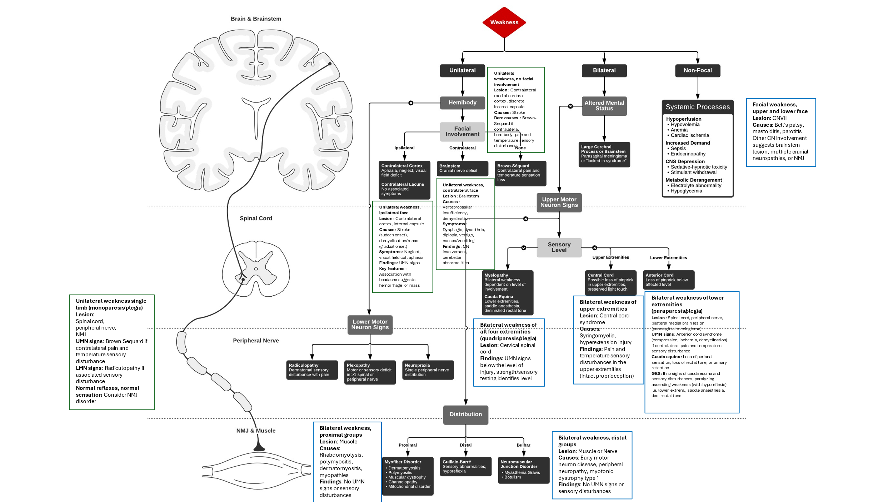

## Speech & Higher Centres****

**Dysphasia**

|  |  |
| --- | --- |
| **Wernicke’s**: Receptive dysphasia = sensory dysphasia = typically fluent   * Patient can’t understand spoken word (auditory dysphasia) or written word (alexia). Speech fluent but disorganized. * **Lesion** (infarction, haemorrhage or space-occupying tumor) in dominant hemisphere in Wernicke’s area (temporal lobe) * **Ask:** Name objects, repetition “six cats, fix mats”, reading, writing. | **Broca’s**: Expressive dysphasia = sensory dysphasia = typically fluent   * Patient understands but cannot answer appropriately. Speech non-fluent. * **Lesion**: front lobe of dominant hemisphere (Broca’s area) * **Ask**: Name object, repetition, reading writing, look for hemiparesis (arm>leg) |

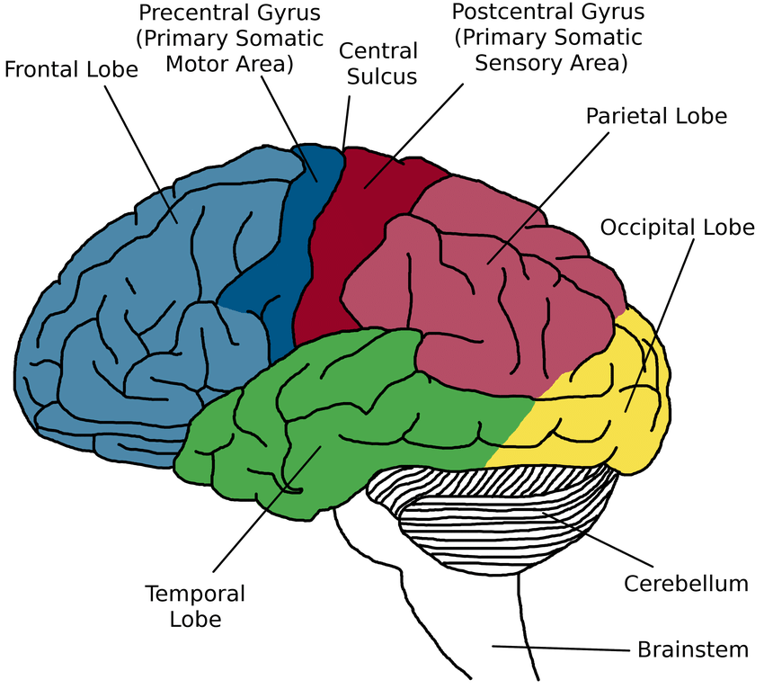

**Cerebral Hemispheres**

* Parietal, temporal and frontal lobe functions are tested if patient is disoriented or has dysphasia or if cognitive decline (dementia) is suspected. If receptive aphasia🡪 tests can’t be performed.
* Used in Bramford Classification of stroke

**Parietal Lobe**

**Def**: concerned with reception & analysis of sensory information.

|  |  |
| --- | --- |
| **Dominant lobe sign (AALF)** | **Non-dominant, non-localising Parietal lobe signs (cortical sensation)** |
| Lesion here causes: Gerstmann’s syndrom   * **Acalculia**: 7s from 100 * **Agraphia**: ask patient to write * **Left-right disorientation**: touch L- ear w/ R-hand * **Finger agnosia**: name his fingers | * **Graphesthesia**: recognize numbers drawn on skin * **Spatial neglect**: draw clock face (pt with right parietal lesion may fill in numbers on left side) * **Constructional apraxia**: copy object drawn |

**Temporal lobe function**

**Def**: concerned with short term and long term memory

* **Short term**: Three objects (name, address, elephant), repeat 🡪 repeat again in 5 minutes
* **Long-Term**: Year he was born

**Frontal lobe function  
Defn**: concerned with emotion, memory, judgement, disinhibition.

**Test**: Multiple primitive reflexs are usually associated here.

* **Grasp reflex**: run fingers across the palm of hand
* **Palmomental reflex**: stroke thenar 🡪 ipsilateral contraction of mentalis mm.
* **Pout & snout reflexes**: stroking over upper lip induces pouting of lips

## Stroke*

|  |  |
| --- | --- |
| **Ischemic** (85-90%)- **Less acutely ill** | **Hemorrhagic** (ICH or SAH) (5-10%)- **Acutely ill** |
| **Cause**: artherosclerosis/arterial ds   * **Thrombotic** – typically ‘wake up stroke’ or more progressive 3-6 hours during daytime. * **Embolic** – usually during the day; sudden, may cause collapse but no loss of consciousness; **+/- associated with Valsalva maneuvers.** | **Cause:** HTN or vascular causes (AV malformations, aneurysms, cavernomas). Other causes include coagulopathies, anticoagulant use, and thrombolysis.   * HTN sites of bleeding: basal ganglia (thalamus, caudate, putamen), cerebellum, and pons. |

**Bamford/Oxford Classification System for Strokes**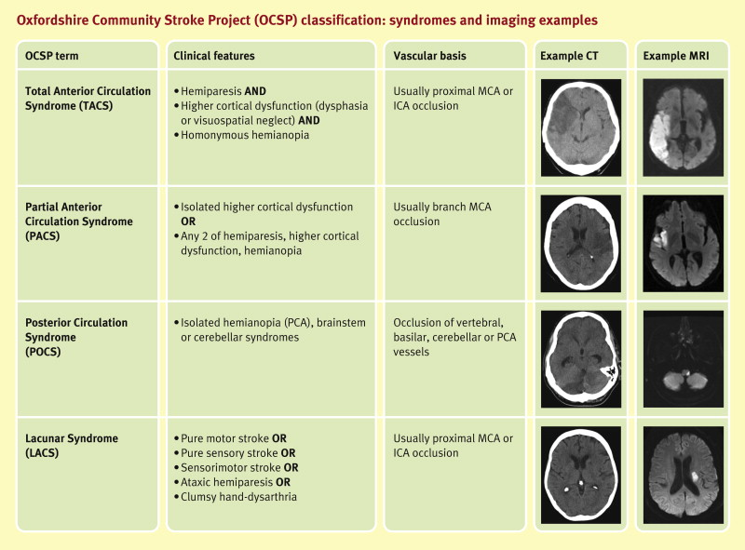

|  |  |  |  |
| --- | --- | --- | --- |
| **Total Anterior Circulation Syndrome (TACS)** | **Partial Anterior Circulation Syndrome (PACS)** | **Lacunar Syndrome (LACS)** | **Posterior Circulation Syndrome (POCS)** |
| Large cortical stroke in MCA/ACA areas. Usually proximal MCA or ICA occlusion. | Cortical stroke in MCA/ACA areas. Usually branch MCA occlusion. | Subcortical stroke d/t small vessel ds. No evidence of higher cortical dysfn. Usually, proximal MCA or ICA occlusion. |  |
| All **three** of the following:   * Hemiparesis * Homonymous hemianopia * Higher cortical dysfunction (dysphasia, visuospatial neglect) | **Two** of the following:   * Hemiparesis * Homonymous hemianopia * Higher cortical dysfunction (dysphasia, visuospatial neglect) | **One** of the following:   * Pure sensory stroke * Pure motor stroke * Sensorimotor stroke * Ataxic hemiparesis | **One** of the following:   * CN palsy & contralateral motor/sensory deficit * Bilateral motor/sensory deficit * Conjugate eye movement disorder (e.g. gaze palsy) * Cerebellar dysfunction (e.g. ataxia, nystagmus, vertigo) * Isolated homonymous hemianopia or cortical blindness |

**Questions on History**

* **Presenting complaint**:
  + **Motor/Sensory**: Weakness and/or numbness (loss of sensation) – which part/s of the body?
  + **Cranial Nerves**: Loss of/change in speech? disturbance of vision? Difficulty swallowing?
  + How quickly did it start? How long ago?
  + Has it worsened/improved/gone away?
  + Any associated features? (e.g. severe headache, meningism – more likely to be haemorrhagic)
    - Strokes tend to have a more sudden onset and stay the same or get better
    - space-occupying lesions are insidious/progressive 🡪 tend to involve pressure symptoms e.g. nausea, vomiting, headaches
* **Past Medical History** of any strokes? What was the treatment/outcome? Or any similar, milder events recently (possibly a preceding TIA)?
* **Family History** of strokes or cardiovascular disease?
* **Medication history** – anticoagulants, aspirin, warfarin, etc.; OCP use (young stroke).
* **Ask about risk factors**:
  + Age, obesity, inactivity, hypertension, diabetes, smoking, alcohol, hyperlipidaemia, arrhythmias (e.g. AF), ischemic heart disease (e.g. MI), valvular disease, endocarditis, hypercoagulable states, sleep apnea, cocaine use.

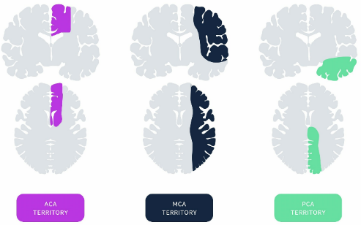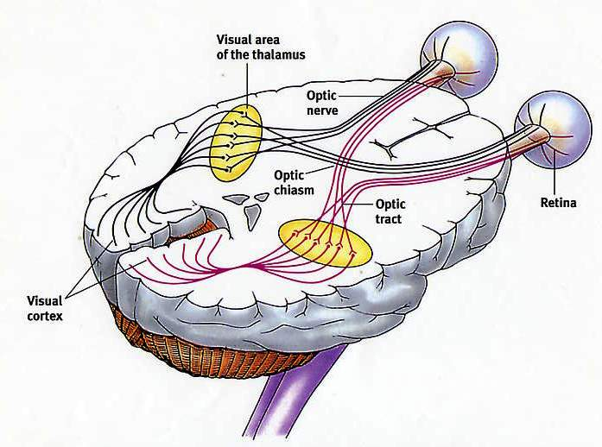

**Differential diagnosis for a stroke**

* Space-occupying lesion (e.g. tumor)
* Infections (e.g. meningitis)
* Migraine
* Metabolic disturbances
* Seizures

**Examination Findings**

* **CVS exam**:
  + Full exam to identify any cardiac defects that might precipitate a stroke (especially in young patients) e.g. cardiomyopathy, valvular disease.
  + **NB**: Remember to check all pulses and listen for carotid artery bruits.
* **Neuro exam**:
  + Do **neuro exam** (higher functions, cranial nerves, motor, sensory) **and CVS exam** if stroke is suspected.
  + Localization of the stroke and the territory involved **using cortical homunculus**

|  |  |  |
| --- | --- | --- |
| **ACA (Anterior Cerebral Artery)** | * Contralateral weakness of **leg >** face (lower half)/arm * Contralateral sensory loss of **leg >** face (lower half)/arm * Frontal lobe deficits e.g. apathy, apraxia, confusion |  |
| **Internal capsule lesion**  *(supplied by lenticulo-striate branch of MCA)* | * Contralateral motor (**face=arms=legs**) * Contralateral sensory loss (**face=arms=legs**) * Contralateral homonymous hemianopia * Aphasia (if dominant Internal Capsule) | The Basal Ganglia - Direct - Indirect - Nuclei- TeachMeAnatomy |
| **MCA (Middle Cerebral Artery) - (more common)**  MCA affects arms>legs according to homunculus (ACA supplies “legs”) | * Contralateral weakness of **face (lower half) and arm >** leg * Contralateral sensory loss of **face (lower half) and arm >** leg * +/- Contralateral homonymous hemianopia * Aphasia (if dominant/left hemisphere affected) * Contralateral hemineglect (if non-dominant/right hemisphere parietal lobe affected) * Eye deviation to the side of the lesion |
| **PCA (Posterior Cerebral Artery)** | * Homonymous hemianopia (unilateral lesions) or cortical blindness/‘Anton’s syndrome’ from bilateral lesions * **Midbrain**: CN III & IV palsy + hemiparesis * **Thalamic**: sensory loss, amnesia, confusion, reduced LOC * **Bilateral**: cortical blindness, prosopagnosia, hemiballismus |  |
| **Carotid artery dissection** | * Neck/face pain * Ipsilateral Horner’s syndrome from compression of sympathetic plexus around carotid artery * Lower cranial nerves (X and XII) clinically involved |  |

**Stroke Assessment**

1. History
2. Risk Factors
3. Differentials
4. Examination🡪 Weakness, sensory loss, aphasia, CN etc
5. Localize arteries🡪
6. Bramford classify
7. Investigations
8. Acute Management
9. Chronic Management

**Approach to Acute Management**

|  |  |
| --- | --- |
| **Acute Management** |  |
| * **Stabilize patient** | * Protect the airway to avoid hypoxia/aspiration * Give O₂ by mask * NPO until swallowing is assessed |
| * **Thrombolysis** if <4.5h & ischaemic stroke & no C/I.   + Reduce BP < 185/110 then   + IV tPA (Alteplase): 0.9 mg/kg up to maximum 90 mg     - First 10% as a bolus     - Rest as an infusion over an hour | * <4.5h send Emergency non-contrast CT🡪 exclude haemorrhagic stroke. * >4.5h then CT within 24h.   **Thrombolysis C/I**:   * Bleeding diathesis w/ PLT <100 or INR >1.7 or therapeutic (not prophylactic) Rx with Clexane or LMWH * Previous intracranial haemorrhage * Known structural lesions w/ risk of bleeding e.g. neoplasm, recent stroke, head trauma, surgery * A GIT or genitourinary bleed in the last 21 days * Massive/major infarct on CT * AVM or aneurysm (relative CI) * Severe liver disease, varices, or Portal HPT * Serum glucose <3 or >22 * Rapidly improving symptoms |
| * **Mechanical thrombectomy indications**: | * Large artery occlusion in proximal anterior circulation * Needs an urgent CT Brain and CT Angio * Done in the first 6-24 hours |
| * **Maintain homeostasis**:   + **Maintain Blood glucose** 4-10 mmol/l. Avoid dextrose (may precipitate cerebral oedema).   + **Monitor BP** and treat only if hypertensive emergency (persistently >220/110) or if thrombolysis is considered (needs to be <185/110).     - **NB**: Reducing BP may impair cerebral perfusion because cerebral autoregulation is lost in an acute stroke; maintaining it helps perfuse the ischemic penumbra.   + **Prevent hyperthermia** (increases infarct size). If pyrexial, use paracetamol or cooling blankets. |  |
| * **Anti-platelet therapy**   + **Aspirin:** Dose: 325 mg daily until discharge, then 75-150 mg prophylaxis daily for the rest of life.   + **OR** Clopidogrel monotherapy (long-term alternative to aspirin) | * If thrombolysed: Initiate 24 hours after thrombolysis. * If not thrombolysed: Initiate as soon as haemorrhage is excluded. |
| **For a haemorrhagic stroke**   * No tPA. * Treat in Neuro ICU or stroke unit. * Reverse any existing anticoagulation (e.g., IV vitamin K and clotting factor concentrates for patients on warfarin). * **NB** to control SBP >180 w/ IV meds (can reduce it quickly). * Reduce ICP if needed (mechanical ventilation +- mannitol). * +- Urgent neurosurgical evacuation of hematoma or AVM correction. * +- Placement of external ventricular drain if obstructive hydrocephalus |  |
| **Further Management** |  |
| * Ideally, admit the patient to a stroke unit for further Rx. * Monitor fluid, electrolyte, and infection status – these patients are at high risk of dehydration and infection (e.g., orthostatic pneumonia). * **NB**: Speech therapy to do a swallow assessment. * **Prophylaxis**:   + Statin: initiate prophylactically once oral meds are tolerated.   + DVT prophylaxis: Clexane 40 units SC. * Investigate for cause and risk factors and treat appropriately. * Initiate early allied discipline input, i.e., physiotherapy, speech and language therapy, OT. * Lifestyle modification advice, e.g., smoking cessation, weight loss. * Medical Mx of comorbidities, e.g., DM, HPT, etc. * Facilitate transition to rehabilitation (specialized unit or community). |  |

## Approach to a 'Young Stroke'

**Causes** of strokes in patients < 45 years:

* **Cardiac defects**:
  + Congenital e.g., patent foramen ovale
  + Acquired e.g., arrhythmias, myocarditis, endocarditis, cardiomyopathy, valvular disease, prosthetic valves, myocardial ischemia
* **Vasculitides**:
  + **Primary Vasculitides**:
    - Takayasu arteritis
    - Giant cell arteritis
    - Polyarteritis nodosa
    - Carotid dissection
  + **Secondary Vasculitides**:
    - SLE
    - HIV vasculopathy
    - Syphilitic arteritis
* **Haematologic causes**:
  + Sickle cell disease
  + Prothrombotic coagulopathies e.g., Factor V Leyden, Antiphospholipid syndrome, Protein C/S deficiency, Antithrombin deficiency
* **Hypertension** (usually secondary, not essential HPT)
* **Substance use** – cocaine and methamphetamine (sympathomimetics causing HPT, vasospasm, or vasculitis)
* **Recent pregnancy** and other hypercoagulable states
* **Metabolic disorders** – very rare, small vessel disease:
  + Fabry disease (X-linked lysosomal storage disorder d/t deficiency in alpha-galactosidase A)
  + Homocystinuria
  + Menke’s disease (impaired copper transport and cerebral vessel tortuosity)
  + Mitochondrial disorders

**Additional investigations in young stroke patients**:

* ECG + Echocardiography for cardiac defects
  + If negative, do a 24-hour Holter ECG
* CT Angiography of neck and head (from aortic arch to brain) to identify vessel defects.
* Carotid Doppler if atherosclerosis of carotids is suspected.
* **Additional bloods**:
  + HbA1c
  + Lipogram
  + Cardiac enzymes, troponin if myocardial ischemia is suspected
  + Inflammatory markers – CRP, ESR, ANA
  + Vasculitis screen
  + Antiphospholipid antibodies (anticardiolipin, lupus anticoagulant, beta-2-glycoprotein I antibodies) – especially large vessel strokes.
  + Thrombophilia screen (Prot C/S, antithrombin, Factor V Leyden).
  + Drugs of abuse screen e.g., for cocaine (hemorrhagic stroke).
  + Alpha-galactosidase for Fabry’s disease (very rare X-linked metabolic disorder).

## Chronic Venous Sinus Thrombosis

**What is it?**

* **Cerebral vein and dural sinus thrombosis** (CVT) is a less common type of stroke, mainly affecting younger patients.
* Thrombosis in cerebral veins or dural sinuses obstructs blood drainage from brain tissue, leading to cerebral parenchymal lesions (stroke) and dysfunction.
* It increases venous and capillary pressure, causing disruption of the blood-brain barrier.

**History Features**

* **Risk factors and associated conditions:**
  + Prothrombotic conditions (genetic/acquired)
  + Obesity
  + Oral contraceptives
  + Pregnancy and puerperium
  + Malignancy
  + Infection
  + Head injury
* **Symptoms:**
  + Headache (with/without vomiting, papilloedema, visual issues)
  + Focal deficits (monoparesis, hemiparesis, aphasia)
  + Seizures
  + Encephalopathy (altered mental state, stupor, coma)

**Exam Findings**

* Findings are consistent with stroke, based on history and clinical features.

**Investigations**

* **Imaging:**
  + Urgent brain MRI + MR venography, or CT brain + CT venography.
* **Laboratory:**
  + FBC + differential (to check for infection/inflammation with WCC)
  + U&E (baseline)
  + PT and aPPT (for hypercoagulable state)
  + D-Dimers (increased in CVT)
  + Lumbar puncture (to exclude meningitis)
  + Coagulation screen (if concerned about thrombophilic state)
    - Includes tests for antithrombin, protein C/S, factor V Leiden, APLS screen, homocysteine

**Differential Diagnosis**

* Bacterial/viral meningitis or meningoencephalitis
* Intracerebral hemorrhage
* Subarachnoid hemorrhage
* Ischemic stroke

**Management**

* **Initial anticoagulation:** Subcutaneous LMWH or IV heparin (if no contraindications)
* **Seizure management:** Seizure prophylaxis (e.g., valproate, levetiracetam)
* **Antibiotic therapy:** If infection is present
* **Long-term anticoagulation:** Warfarin or DOAC
* **Treat underlying cause:** APLS (antiphospholipid syndrome) or other conditions

## Guillain-Barre Syndrome****

**GUILLAIN-BARRÉ SYNDROME** (Acute inflammatory poly-radiculo-neuropathy)

**What is it?** An immune-based disease that may present 7-10 days after an infective illness (viral or bacterial), commonly *Campylobacter jejuni* gastroenteritis, resulting in ascending flaccid paralysis.

**Guillain–Barré syndrome (GBS)** = acute inflammatory demyelinating polyradiculoneuropathy (AIDP) affecting the **peripheral nervous system (peripheral nerves).** Quick onset, symmetrical ascending weakness. May affect sensory nerves causing a sensory neuropathy. B cells create antibodies against pathogen that match proteins on nerve cells- may target proteins of myelin sheath (of motor nerve) or on nerve axon itself.

GBS is the most common acute polyneuropathy (3/100000 per year); it is usually demyelinating or occasionally axonal, and **has an immune-mediated, often post-infectious, basis**. GBS is monophasic – it does not recur.

* **Paralysis follows 1–3 weeks after an infection (*Campylobacter jejuni* and CMV) recognized causes of severe GBS.** **Infecting organisms induce antibody responses against peripheral nerves**.
* Clinical course: symptoms start 4 weeks🡪 2-4weeks symptoms peak🡪 months/years recovery period
* Diagnosis: clinically

**History Features**

* History of preceding infection: present over +/-1 week later and progresses over days to 6 weeks
  + Gastroenteritis (most common)- campylobacter jejuni
  + Influenza A and B
  + CMV, EBV
  + HIV
  + Covid-19
  + Zika virus
* Symmetrical weakness in lower limbs progressing to involve the upper limbs
* **Back pain (radiculitis - nerve root pain)**
* Loss of sensation
* Paraesthesia in hands and feet
* Urinary retention
* Symptoms usually progress over 2 weeks

**Exam Findings**

1. **Autonomic:**
   * BP dysregulation
   * Arrhythmia (including bradycardia)
   * **+/- bladder dysfunction - urinary retention (“LMN sign”)** if at the appropriate level.
2. **Cranial nerves:**
   * **Facial nerve palsies occur in some patients**
   * Oropharyngeal weakness
   * Oculomotor weakness/ophthalmoplegia (less common)
3. **Motor:**
   * Unable to walk
   * **Reduced power bilaterally** (lower limbs +/- upper limbs)
   * **Reduced tone bilaterally = flaccid**
   * **Reduced/absent deep tendon reflexes bilaterally**
4. **Sensation:**
   * Reduced/absent sensation (neuropathic pain) - often patchy on testing
   * Glove & stocking paraesthesia’s
   * Loss of proprioception and vibration

**Investigations**

* **Bedside:**
  + ECG - if suspect an arrhythmia
* **Lab:**
  + FBC + diff - to check for infection
  + U&E - check baseline electrolytes or if any abnormalities present
  + CRP/ESR - to check and monitor infection
  + Comprehensive metabolic profile
    - Serum glucose
    - HbA1c
  + **Lumbar puncture**:
    - Expect CSF to have **high protein** and **normal WCC** (albuminocytologic) & normal glucose
* **Imaging:**
  + MRI of brain and spine with contrast
    - MRI of brain and cervical spine in patients with bulbar weakness and/or quadriparesis
    - MRI of brain and thoracic & lumbar spine in patients with lower extremity weakness to evaluate for transverse myelitis or another cause of myelopathy
  + Ultrasound - may have enlarged cervical nerve roots
* **Electrodiagnostic studies:**
  + Nerve conduction studies (NCS) and electromyography (EMG) - to support diagnosis of GBS and provide prognostic information about the nature and severity of nerve dysfunction

**Differential Diagnosis**

* Chronic inflammatory demyelinating polyneuropathy (CIDP)
  + Onset over months includes sensory loss and remitting/relapsing couse
* Other polyneuropathies:
  + Thiamine Deficiency
  + Toxic neuropathies
  + Tick paralysis
  + HIV
* Spinal cord disorders
* Neuromuscular junction disorders - myasthenia gravis, botulism
* Muscle disorders - dermatomyositis

**Management**

* Stabilise the patient
* Monitor for any deterioration - HR, RR, BP, saturation, FVC
* **Supportive care:**
  + ~~Hypotensive: IV fluids, low-dose phenylephrine~~
  + ~~Severe hypertension: labetalol, nicardipine~~
  + ~~Life-threatening arrhythmias: atropine~~
  + Respiratory failure: intubation & ventilation🡪 admission to ICU
* **DVT prophylaxis:** clexane 5mg SC
* **VTE prophylaxis:** pulmonary embolism leading cause of death.
* **Analgesia:**
  + Neuropathic pain: carbamazepine
  + Opioids and NSAIDs
* **Immunotherapy:**
  + IV Immunoglobulin (IVIG)
  + Plasma exchange (PLEX)- remove antibodies
  + Physical therapy

## 

## Myasthenia Gravis

|  |  |  |
| --- | --- | --- |
| **What is it?** An autoimmune disease of the neuromuscular junction with circulating antibodies against acetylcholine receptors. It is characterized by skeletal muscle weakness that fluctuates over the course of the day (**muscle power decreases with use**) and there is little wasting and no sensory change.  **History Features**  Specific muscle weakness - mainly ocular and bulbar muscles (oropharyngeal and facial muscles)   * **Ocular symptoms:**   + Ptosis (start unilateral and become bilateral)   + Diplopia   + Drooping eyelids * **Oropharyngeal symptoms:**   + Dysarthria - speech becoming unintelligible during prolonged speaking   + Dysphagia   + Fatigable chewing * **Facial symptoms:**   + Appear expressionless - lost their smile   + Myasthenic sneer = attempt to smile and mid-lip rises but outer corners of mouth don't move * Proximal limb weakness * Episodic symptoms initially with asymptomatic intervals lasting hours to weeks * Over time, symptoms worsen and are more persistent * **Other rare presentations:**   + Distal limb predominating weakness   + Isolated neck weakness   + Isolated respiratory muscle weakness | **Exam Findings**   * **Eyes:**   + Ptosis - present continually or develop within 60 seconds of sustained upward gaze     - Check by holding up opposite eyelid with examiner's finger (curtain sign)     - May improve with testing after the application of an ice pack on the closed lid   + Diplopia - disappears when patient closes or occludes one eye     - Horizontal or vertical     - Test extraocular movements (draw 'H') * **Tone:**   + Truncal hypotonia * **Power:**   + Hold arms in shoulder abduction - repeatedly press down until they weaken (**power will decrease with repeated muscle contraction**) * **Sternum:**   + Inspect for thymectomy scar over sternum (treatment for generalized myasthenia)   **Investigations**   * **Lab:**   + FBC - routine   + U&E - routine   + Autoantibodies:     - Against acetylcholine receptor (AChR)     - Against muscle receptor-associated proteins:       * Muscle-specific tyrosine kinase (MuSK)       * Low-density lipoprotein receptor-related protein 4 (LRP4)     - If symptomatic with no autoantibodies = seronegative | * **Electrodiagnostic testing:** for seronegative patients   + Evidence of impaired signal transmission at the neuromuscular junction   + Nerve conduction testing with repetitive nerve stimulation   + Electromyography - evaluates the electrical activity of muscle both at rest and with voluntary muscle contraction   **Management**   * Symptomatic treatment:   + Acetylcholinesterase inhibitors - pyridostigmine * **Chronic immunotherapies:**   + Glucocorticoids   + NSAIDs * **Rapid but short-acting immunomodulating treatments:**   + Therapeutic plasma exchange   + IV immunoglobulin (IVIG) * **Surgical:**   + Thymectomy |

## 

## Transverse Myelitis****

|  |  |  |
| --- | --- | --- |
| **Definition**   * Acute inflammatory disorder affecting the cord with swelling and loss of function. Typically one or two segments are affected- a cross section. Clinically a myelopathy evolves over days🡪 partial/full recovery over weeks/months.   **Aetiology**  **Infectious**   * HIV * HTLV-1 * Herpes viruses - HSV 1 and 2, EBV, CMV, VZV, HHV6, HHV7, and HHV8 * Toxoplasmosis * Syphilis * Schistosomiasis * Post infectious (following vaccination) - EBV, CMV, and VZV   **Non-infectious**   * Demyelinating conditions:   + Multiple sclerosis   + Neuromyelitis optica     - Patchy involvement and progressive * **Autoimmune:**   + SLE   + Vasculitis   + Sarcoid   + Behçets   + Sjögrens * Cord infarction * Vitamin B12 deficiency | **History**   * Rapid onset * Leg +/- arm weakness (symmetrical) * Paraesthesia * Bladder and bowel incontinence (early)- UMN sign * Sexual dysfunction   **Exam Findings**   * **Motor: (UMN/LMN manifestations)**   + Power - decreased bilaterally (usually in lower limbs)   + Tone - hypertonic below the lesion and hypotonic at the level of the lesion   + Reflexes - brisk reflexes bilaterally   + Positive Babinski bilaterally   + Truncal hypotonia if the lesion is in the T spine * **Sensory:**   + Reduced sensation below the level of the lesion   + Decreased proprioception * **Autonomic nervous system:**   + Bladder and bowel incontinence if UMN pathology (spastic bladder) - may be the first sign   + UMN signs below level of lesion | **Differential Diagnosis**   * **Extramedullary intradural**   + Meningioma   + Nerve sheath tumour * **Extradural**   + Neoplasm:     - Mets from breast, prostate, lung, and kidney     - Lymphoma     - Plasmacytoma   + TB   + Epidural abscess   + Spondylopathy     - Radicular/bone pain, asymmetrical, late incontinence, long duration of symptoms   **Investigations**   * URGENT MRI of the spine * **Bedside:**   + May not be necessary if the patient is stable * **Labs:**   + FBC - raised WCC   + U&E - check renal function   + CRP - inflammation   + Blood cultures and TB bactec   + GXP * **LP:**   + Cytology, MCS, and GXP   **Management**   * **Steroids** to reduce the inflammation   + IV dexamethasone or IV methylprednisolone   + Radiation oncology to further reduce the swelling     - Don’t need a diagnosis     - Treat underlying cause |

## 

## Muscle Weakness Localization

Muscle weakness can be due to

* Myopathy (primary disease of muscle)- no sensory loss
* Individual peripheral nerve lesions, - no sensory loss
  + mononeuritis multiplex,
* peripheral neuropathy or (Guillain-Barre has sensory loss)- never a spastic bladder but rather a urinary retention (= bladder dysfunction)
* spinal cord disease/myelopathy (urinary incontinence below level of lesions- spastic bladder?)

Each of these has a characteristic pattern. **Primary disease of muscle (myopathy) causes weakness without sensory loss**. The motor weakness is similar to that of the lower motor neurone type. There are two major patterns: proximal myopathy and distal myopathy.

Distinguishing aetiology of paraparesis

* **Talley: Upper motor neuron signs occur when the lesion is in the brain or spinal cord above the level of the lower motor neuron. Spasticity occurs because of destruction of the corticoreticulospinal tract, resulting in stretch reflex hyperactivity.**
* Note Guillain-Barre syndrome paraparesis differentiation from spinal cord/mid-sagittal lesion. Guillain- Barre exhibits reduced tone, power depending on the affected nerves, but it doesn’t exhibit UMN signs below that level because the cord is not affected. Look for UMN signs when distinguishing between the two.
* Transverse myelitis 🡪 paraparesis
* Cauda Equina Syndrome = bilateral paraparesis with urinary retention (all LMN signs L1-L5)
* No sensory loss for myopathies; skin receptors 🡪 1st order neuron (sensory)🡪 dorsal root ganglion🡪 2nd order neuron 🡪 cross🡪 ST tract. Muscle not involved

|  |  |  |  |  |  |  |
| --- | --- | --- | --- | --- | --- | --- |
|  | **Proximal Myopathy** | **Distal Myopathy** | Motor Neurone Disease | NM Junction (Myasthenia Gravis) | **Peripheral Neuropathy:** | **Peripheral Neuropathy: Motor predominant** |
| **Sensory loss** | None | None | None | None | Distal loss first (glove stocking) |  |
| **Motor weakness** | LMN type, proximal commonest | Yes | Yes | Proximal predominantly | Distal loss first |  |
| **Wasting** | Yes | Yes |  | Minimal |  |  |
| **Reflexes** | Reduced | Reduced |  |  |  |  |
| **Tone** | Flaccid | Flaccid |  | Truncal hypotonia | Flaccid, ascending |  |
| **Fasicul.** |  |  |  |  |  |  |
| **Bladder /bowel** | +/- Retention | +/- Retention |  | +/- Retention | +/- Retention |  |
| **Notes** | Genetic (muscular dystrophy)  Or acquired | Always genetic |  | Antibodies on Ach Receptors | Guillain-Barre: Antibodies against motor nerve axons or myelin |  |
| **Causes** | **Causes of myopathy**   * Hereditary muscular dystrophy (see List 35.9) * Congenital myopathies (rare)   **Acquired myopathy (mnemonic, PACE, PODS):**   * **P**olymyositis or dermatomyositis (see Fig. 35.11) * **A**lcohol, AIDS (HIV infection) * **C**arcinoma * **E**ndocrine (e.g. hyperthyroidism, hypothyroidism, Cushing’s syndrome, acromegaly, hypopituitarism) * **P**eriodic paralysis (hyperkalaemic, hypokalaemic or normokalaemic) * **O**steomalacia * **D**rugs (e.g. statins, chloroquine, steroids) * **S**arcoidosis   **Note**: Causes of proximal myopathy with a peripheral neuropathy include:   * Paraneoplastic syndrome * Alcohol * Hypothyroidism * Connective tissue diseases. | |  |  | **Causes (differential diagnosis) of peripheral neuropathy**   * Drugs (e.g. isoniazid, vincristine, phenytoin, nitrofurantoin, cisplatinum, heavy metals, amiodarone) * Alcohol abuse (with or without vitamin B₁ deficiency) * Metabolic (e.g. diabetes mellitus, chronic kidney disease) * Guillain–Barré syndrome * Malignancy (e.g. carcinoma of the lung [paraneoplastic neuropathy], leukaemia, lymphoma) or chemotherapy (e.g. vincristine, cisplatin, paclitaxel, etoposide) * Vitamin deficiency (e.g. B₁₂) or excess (e.g. B₆) * Connective tissue disease or vasculitis (e.g. PAN, SLE) * Hereditary (e.g. hereditary motor and sensory neuropathy) * Other (e.g. amyloidosis, HIV infection) * Idiopathic | **Causes of a predominant motor neuropathy**   * Guillain–Barré syndrome, chronic inflammatory polyradiculoneuropathy * Hereditary motor and sensory neuropathy * Diabetes mellitus * Other (e.g. acute intermittent porphyria, lead poisoning, diphtheria, multifocal motor neuropathy with conduction block)   **Causes of a painful peripheral neuropathy**   * Diabetes mellitus * Alcohol * Vitamin B₁ or B₁₂ deficiency * Carcinoma * Porphyria * Arsenic or thallium poisoning |
|  |  |  |  |  |  |  |
|  |  |  |  |  |  |  |
|  |  |  |  |  |  |  |
|  |  |  |  |  |  |  |
|  |  |  |  |  |  |  |

# 2. Cardiology

## 2.0 Heart Failure

|  |  |  |  |
| --- | --- | --- | --- |
| **Pathology** | **Symptoms** | **Signs** | **Investigations** |
| **LHF Symptoms > Sx** | * PND, Orthopoea, Dyspnoea * Fatigue, Poor Exercise Tolerance * Wheeze [cardiac asthma] * Pulmonary oedema: * Nocturnal Cough [pink frothy sputum) * Wheeze * Clammy peripher. | * Pulmonary oedema: * Bibasal inspiratory crackles * ± Pleural effusion * Wheezing * S3/S4 left gallp * Displaced/Myopathic apex beat * ++Cap Refill Time * Weak, thready pulse * +- MR murmur * Pulsus alternans – beat to beat variability of pulse strength   A x-ray of a chest  Description automatically generated | **CXR**   * ↑CTR> 50% * Pulmonary oedema * Upper lobe diversion=cephalization of vessels * Batwing shadowing * Kerley B lines/ septal lines (interlobular oedema) * Peri-bronchial cuffing * Pleural effusion: blunted costophrenic angles, meniscus sx * Air bronchograms= alveolar oedema, pneumonia, haemorrhage) |
| **RHF Sx > Symptoms** | * RUQ pain | * +↑JVP, + hepatojugular reflux * PHTN: Palpable P2, P-heave * Tender, pulsatile hepatomegaly, splenomegaly * Peripheral Oedema: pedal, sacral, Ascites * S3 right * +- TR |  |

**Note**:

* **S3 = volume overload** (e.g. CHF, MR/TR, DCM, HOHF). Results from large amounts of blood filling higher compliant left ventricle.
* **Cor pulmonale** = Right Heart Failure d/t pulmonary cause (hypertension) (commonly COPD)

|  |  |  |
| --- | --- | --- |
| **Type of Therapy** | **Purpose of Treatment** | **Treatment** |
| **Guideline Directed Medical Therapy (↓ Ventricular Dysfunction)** | - ↓ SNS Activity - ↓ RAAS Activity - Alternatives to ACE-I / ARBs in AA - Alternative to Beta Blocker if NSR (normal sinus rhythm) | - Beta Blockers - SGLT2-I - ACE-I or ARBs or ARNi - Aldosterone Antagonists - Hydralazine + ISDN - Ivabradine |
| **↓ Venous Congestion** | - ↑ Natriuresis | - Loop Diuretics - Thiazide Diuretics |
| **Device Therapy (LVEF < 35%)** | - ↑ Ventricular Synchrony (e.g., LBBB) - ↓ Ventricular Arrhythmias (e.g., VT/VF) - Bridge to Transplant | - CRT (Cardiac resynchronization therapy) - AICD - LVAD |
| **Cardiogenic Shock** | - ↑ Systemic Perfusion - ↓ Pulmonary Edema | - Inotropes - IABP or VA-ECMO - Diuretics and BIPAP |

## 2.1 Infective Endocarditis

**Infective Endocarditis (IE)**

**Definition:** Infection of the cardiac endocardium involving the valves (MV > AV > TV > PV), resulting in vegetations made up of platelets, fibrin, inflammatory cells, and microorganisms.

**Causes:**

**Native Valve:**

* **Common:**
  + Streptococcus viridans (50-70%)
  + Staphylococcus aureus (25%)
  + Enterococci
* **Less Common:**
  + Gram-negative bacilli including HACEK organisms:
    - Haemophilus spp
    - Aggregatibacter spp
    - Cardiobacterium spp
    - Eikenella corrodens
    - Kingella spp
  + Fungi

**Prosthetic Valve:**

* **Common:**
  + Staphylococcus epidermidis
  + Staphylococcus aureus
  + Streptococci
  + Enterococci
* **Less Common:**
  + Fungi
  + Gram-negative organisms including HACEK

**IV Drug Users:**

* **Right-sided endocarditis (tricuspid valve):**
  + Staphylococcus aureus
  + Enterococcus faecalis
  + Pseudomonas aeruginosa

**Culture-Negative Endocarditis:** Up to 20% of patients with IE

* Brucella spp
* Coxiella burnetii
* Bartonella spp
* Chlamydia spp
* Mycoplasma spp
* Fungi

**History Features:**

* **Risk Factors:**
  + Prosthetic heart valve
  + Previous IE
  + Congenital heart disease (unrepaired or repaired within 6 months but still defective)
  + Cardiac transplant with valve disease
  + IV drug use
  + Poor dentition - dental abscess
  + Chest trauma
  + Venous catheter
  + Hemodialysis
  + Comorbidities such as DM and HIV
* **Symptoms:**
  + Fever, chills, rigors, night sweats
  + Weakness
  + Weight loss and anorexia
  + Chest pain
  + Dyspnoea
  + Signs of CHF: orthopnoea, PND, non-productive cough

**Exam Findings:**

* **General Signs:**
  + Fever
  + Weight loss
  + Pallor
* **Hands:**
  + Splinter haemorrhages
  + Clubbing (within 6 weeks of onset)
  + Osler’s nodes
  + Janeway lesions
* **Arms:**
  + Evidence of IV drug use
* **Eyes:**
  + Conjunctival pallor
  + Conjunctival haemorrhages
  + Retinal haemorrhages = Roth spots (yellow centre surrounded by red ring)
* **Heart:**
  + Acquired: MR, MS, AS, AR - clinical features and signs associated
  + Congenital: PDA, VSD, CoA
  + Prosthetic valves
* **Abdomen:**
  + Splenomegaly
  + Renal angle tenderness - glomerulonephritis
* **Peripheral Evidence of Embolisation to Limbs or CNS:**
  + Mycotic aneurysms
  + Erythematous nodules on toes, ankles, buttocks
  + Ischaemic limb or stroke (large emboli)
* **Urinalysis:**
  + Haematuria

**Differential Diagnosis:**

* Rheumatic fever

**Investigations:**

* **Bedside:**
  + Urine dipstick - look for proteinuria, haematuria, red cell casts
  + Urine MC&S - if findings on dipstick
  + ECG - any changes suggesting the cause (e.g., prolonged PR interval for perivalvular abscess)
* **Lab:**
  + FBC + diff - check Hb for anaemia, look at WCC for infection
  + U&E - check for any electrolyte abnormalities
  + CRP - indication for infection/response to treatment
  + RF
* **Imaging:**
  + CXR - increased CTR if presenting in failure
  + Echo - presence of vegetations on affected valve, abscesses, regurgitation, perforation

**Complications:**

* Aneurysms
* Valve incompetence
* CCF
* Embolisation of vegetations leading to multi-organ infection & sepsis
* Loosening of sutures leading to periprosthetic leaks & ring abscesses
* Rupture of ring abscess - fistula formation into surrounding tissue, intracardiac shunting

**Management:**

* **Stable Patient:**
  + Wait for culture results before initiating treatment unless septic
* **Empiric Antibiotic Therapy if Unstable:**
  + Administer only after blood culture
  + 1st line for native valve: vancomycin + gentamicin or ceftriaxone
  + 1st line for prosthetic valve: vancomycin + gentamicin + rifampicin
* **Targeted Antibiotic Therapy:**
  + Adjust based on valve, organism, and susceptibilities for 4-6 weeks
* **Post-Treatment Prophylaxis:**
  + For high-risk individuals (prosthetic valve, previous IE, congenital heart disease, cardiac transplant)
  + Prior to dental procedures, invasive procedures of the respiratory tract, or procedures on infected skin or musculoskeletal tissue - give amoxicillin
* **Surgery:**
  + Indicated in cases of refractory CHF, growing lesions despite treatment, fungal lesions, mycotic aneurysms, abscess formation, vegetations on the right side > 2 cm, vegetations on the left side > 1 cm, S. aureus, multiple systemic embolic episodes, CVS complications, relapse despite 6-8 weeks of antibiotic therapy, prosthetic valve rupture
  + Valve replacement - mechanical, tissue, or bioprosthetic

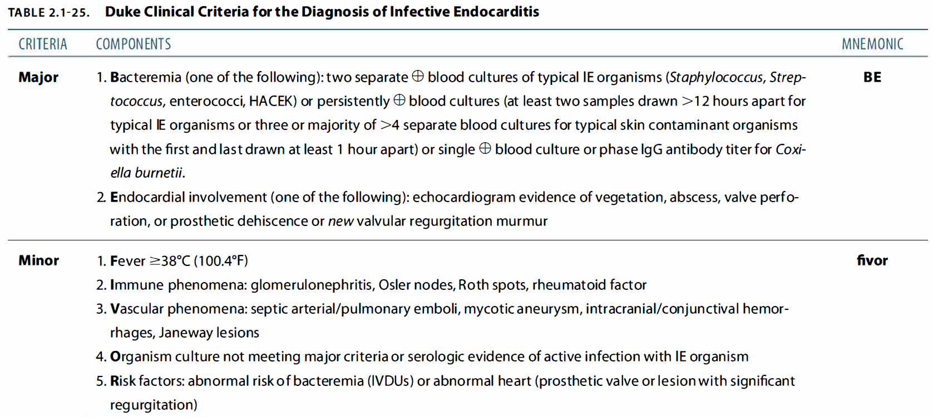

|  |  |  |
| --- | --- | --- |
| **Infective Endocarditis (IE)**  **Defn:** Infection of the cardiac endocardium involving valves MV > AV > TV > PV, 🡪 vegetations = platelets, fibrin, inflammatory cells & m-organisms.  **Causes**  **Native Valve**   * **Common:**   + Streptococcus viridans (50-70%)   + Staphylococcus aureus (25%)   + Enterococci (UTI, cystitis, pyelonephritis) * **Less Common:**   + Gram-negative bacilli: HACEK, Coxiella   + Fungi: esp. candida   **Prosthetic Valve**   * **Common:**   + Staphylococcus epidermidis (skin)   + Staphylococcus aureus (skin)   + Streptococci   + Enterococci (UTI, pyelonephritis, cystitis) * **Less Common:**   + Fungi   + Gram-negative organisms including HACEK   **IV Drug Users**   * **Right-sided endocarditis (tricuspid valve):**   + Staphylococcus aureus   + Enterococcus faecalis   + Pseudomonas aeruginosa   **Culture-Negative Endocarditis:** Up to 20% of patients with IE   * Brucella, Coxiella burnetti, Bartonella * Chlamydia spp * Mycoplasma spp * Fungi | **History Features**   * **Risk Factors:**   + Prosthetic heart valve   + Previous IE   + Congenital heart disease (unrepaired or repaired within 6m but still defective)   + IV drug use   + Venous catheter   + Comorbidities: DM, HIV   + Poor dentition - dental abscess   + Chest trauma   + Haemodialysis   + Card. transplant w/ valv. ds * **Symptoms:**   + Fever, chills, rigors, night sweats   + Chest pain (pleuritic)   + Dyspnoea   + CHF sx: orthopnoea, PND, non-productive cough (MR/AR 🡪 pulmon. oedema)   + Weakness, Weight loss and anorexia   **Exam Findings: FROM JANE C:** Fever, Roth, Osler, Murmur, Janeway, ACD, Nails, Emboli, **Clubbing**   * **General Signs:**   + Fever, Weight loss   + Pallor (microcytic ACD d/t ++IL6🡪 ++hepcidin🡪 dec. s-iron, ++ferritin) * **Hands:**   + Splinter haemorrhages   + Clubbing (within 6 weeks of onset)   + Osler’s nodes   + Janeway lesions * **Arms:** IV drug use * **Eyes:**   + Conjunctival pallor (anaemia)   + Roth spots = Retinal haemorrhages   + Conjunctival haemorrhages * **Heart:**   + Acquired: MR, MS, AS, AR - clinical features and signs associated | * + Congenital: PDA, VSD, CoA   + Prosthetic valves * **Abdomen:**   + Splenomegaly: immune response, septic emboli🡪 hyperplasia   + Renal tenderness: glomerulonephritis, renal infarcts/abscess * **Peripheral Evidence of Embolization to Limbs or CNS:**   + Mycotic aneurysms   + Erythematous nodules: toes, ankles, buttocks   + Ischaemic limb or stroke (large emboli)   **Differential Diagnosis**   * Rheumatic fever   **Investigations**   * **Bedside:**   + Urine dipstick: proteinuria, haematuria   + Urine MC&S (strep Enterococci🡪UTI/cystitis/pyelonephritis), RBC casts, RBC dysmorphic)   + HGT: DM🡪 Candidal susceptible   + ECG - any changes suggesting the cause (e.g., prolonged PR interval for perivalvular abscess: BBB, AV block), * **Lab:**   + FBC+diff: Hb anaemia (microcytic hypochromic, ACD), ++WCC   + ALP, GGT: Enterococcus 🡪 biliary tree   + U&E – electrolytes, renal function (glomerulonephritis)   + CRP, ESR – Acute phase reactants   + RF- if sterile IE * **Imaging:**   + CXR:     - ++CTR if presenting in failure     - septic pulmonary emboli, abscesses   + Echo: vegetations, perivalvular abscesses, regurgitation, perforation   + U/S: septic emboli/Immune response🡪 splenomegaly   + MRI: brain, spine (abscess, septic arthritis)   **Complications**   * Aneurysms, Valve incompetence, CCF * Vegetations embolise 🡪 multi-organ infection & sepsis * Loosening of sutures🡪periprosthetic leaks & ring abscesses * Ring abscess rupture- fistula formation into surrounding tissue, intracardiac shunting |

|  |  |  |  |  |  |  |  |  |  |  |  |  |  |  |  |  |  |  |  |  |  |  |  |  |  |  |  |  |  |  |  |  |  |  |  |  |  |  |  |  |  |  |  |  |  |  |  |  |  |  |  |  |  |  |  |  |  |  |  |  |  |  |  |  |  |  |  |  |  |  |  |  |  |  |  |  |  |  |  |  |  |  |  |  |  |  |  |  |  |  |  |  |
| --- | --- | --- | --- | --- | --- | --- | --- | --- | --- | --- | --- | --- | --- | --- | --- | --- | --- | --- | --- | --- | --- | --- | --- | --- | --- | --- | --- | --- | --- | --- | --- | --- | --- | --- | --- | --- | --- | --- | --- | --- | --- | --- | --- | --- | --- | --- | --- | --- | --- | --- | --- | --- | --- | --- | --- | --- | --- | --- | --- | --- | --- | --- | --- | --- | --- | --- | --- | --- | --- | --- | --- | --- | --- | --- | --- | --- | --- | --- | --- | --- | --- | --- | --- | --- | --- | --- | --- | --- | --- | --- | --- | --- |
| **Management**   * **Stable Patient:**   + If septic 🡪 Initiate, otherwise wait * **Empiric Antibiotic Therapy if Unstable:**   + Administer only after blood culture   + **1st line native valve**: vancomycin + gentamicin or ceftriaxone   + **1st line prosthetic valve**: vancomycin + gentamicin + rifampicin * **Targeted Antibiotic Therapy:**   + Adjust: 4-6 weeks * **Post-Treatment Prophylaxis: Amoxicillin**   + **IV/IM**: Ampicillin   + **For high-risk individuals** (prosthetic valve, previous IE, congenital heart disease, cardiac transplant)   + **Prior to procedures**: dental, invasive procedures of the respiratory tract, or procedures on infected skin or musculoskeletal tissue – * **Surgery: Indications**   + Emergency surgery     - Refractory pulmonary oedema     - Refractory cardiogenic shock     - Fistula formation   + Urgent surgery     - Persistent heart failure     - Locally uncontrolled infx       * Abscess, enlarging vegetations     - Persistent fever & +blood cultures > 1w     - Large vegetations   + Elective surgery     - No signs of heart failure     - Fungal / multi-resistant organism   Surgery: Valve replacement - mechanical, tissue, or bioprosthetic | |  |  | | --- | --- | | **Empiric Treatment for Endocarditis** | | | **Native Valve** | - Ampicillin + flucloxacillin (2g 4hrly) | |  | - Gentamicin (80mg 12-hourly) | | **IV Drug User** | - Vancomycin (1g 12-hourly) | |  | - Gentamicin (80–120mg 8-hourly) | | **Prosthetic V.** | - Vancomycin (1g 12-hourly) | |  | - Gentamicin (80–120mg 8-hourly) | |  | - Rifampicin | | **Definitive Treatment for Endocarditis** | | | **Strep viridans & Enterococci (4-6w)** | - Benzylpenicillin (1.2g 4-hourly) | |  | - Gentamicin (80mg 12-hourly) | | **Staph (4-6w)** | **Methicillin Sensitive** | |  | - Flucloxacillin (2g 4-hourly) | |  | - Gentamicin (80–120mg 8-hourly) | |  | - Rifampicin | |  | **Methicillin Resistant** | |  | - Vancomycin (1g 12-hourly) | |  | - Gentamicin (80–120mg 8-hourly) | |  | - Rifampicin | | **HACEK (4-6w)** | - Ceftriaxone | | **Coxiella B.** | - Usually requires surgery | |  | - Doxycycline + second agent (co-trimoxazole, rifampicin, or quinolone) | | **Diagnosis**   |  |  | | --- | --- | | **Modified Duke's** | 2 major, 1 major + 3 minor, 5 minor | |  |  | | **Major Criteria** | | | 1. Positive blood culture | Typical microorganism: 2 separate cultures, at least 12 hours apart | | - Strep viridans, Staph Aureas | | - Strep bovis | | - HACEK | | - Enterococci | | Typical microorganism in all of 3 of ≥4 cultures with first and last taken at least an hour apart | | Single positive blood culture for Coxiella burnetii | | Phase I IgG ab titre to Coxiella burnetii > 1:800 | | 2. Endocardial involvement on echo | Vegetation (oscillating intracardiac mass) | | Abscess | | New valve regurgitation | | New partial dehiscence of prosthetic valve | | **Minor Criteria** | | | 1. Predisposition | Predisposing heart conditions | | ·       Valvular disease | | ·       Prosthetic valve | | ·       Congenital heart abnormality | | ·       Previous endocarditis | | ·       Hypertrophic cardiomyopathy | | IV drug use | | 2. Fever | ≥ 38°C | | 3. Vascular phenomena (I-JACS) | Intracranial Haemorrhage | | Janeway Lesions | | Arterial Emboli (PAD) | | Conjunctival Haemorrages | | Septic pulmonary infarcts | | 4. Immunological phenomena (ROGR) | Roth’s spots | | Osler’s nodes | | Glomerulonephritis | | Rheumatoid factor | | 5. Microbiological evidence | Atypical organisms | | Typical organism but not meeting major criterion | |

## 2.2 Rheumatic Heart Disease

* **Common in**: Developing countries.
* **Peak incidence**: 5 - 15 years.
* **Cause**: Streptococcus pyogenes → causes pharyngitis and, if untreated → rheumatic fever.
* **Pathophysiology**:
  + Antibody to the carbohydrate cell wall of Strep cross-reacts with the valves (antigenic mimicry) → permanent damage to heart valves.
  + Initial damage leads to progressive fibrosis.
  + **Valve Involvement**: Mitral valve > Aortic valve > Tricuspid > Pulmonary.
* **Mitral Stenosis (MS)**: More common in females.
* **Aortic Regurgitation (AR)**: More common in males.

**Diagnosis:** Jones Criteria

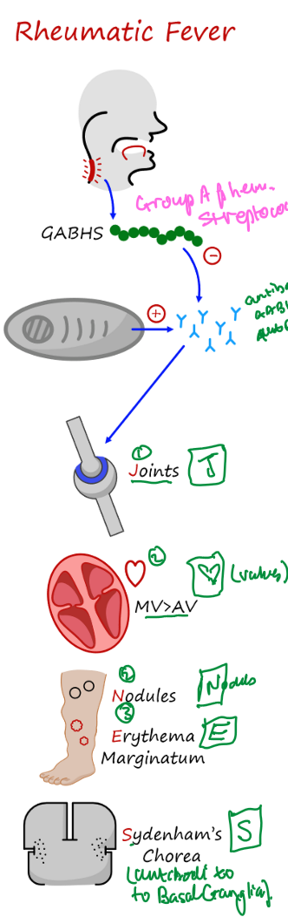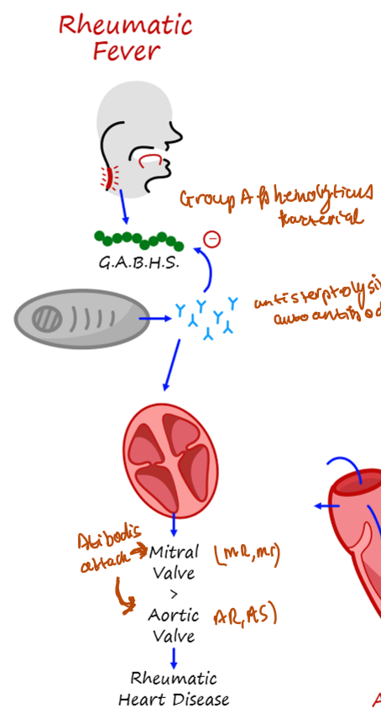

**Investigations**

* **Bedside**:
  + **ECG**:
    - 1st degree heart block – prolonged PR.
    - Pericarditis – ST elevation with PR depression and reversed in AVR.
    - T wave inversion.
    - Decreased QRS voltages.
* **Labs**:
  + FBC – leukocytosis.
  + U&E.
  + CRP – infection.
  + Blood culture – if febrile.
  + Throat swab – MCS.
  + Antistreptolysin O antibodies – rising titers or levels > 200 in adults.
  + Anti-DNase B titers.
* **Radiology**:
  + **CXR**: Cardiomegaly, pulmonary congestion.
  + **Echo**:
    - Look for carditis.
    - Valve dysfunction.

**Management**

* **Bed rest**:
  + Decrease joint pain and cardiac workload.
  + Continue for 2 weeks after CRP has normalized.
* **Antibiotics**:
  + Benzylpenicillin 0.6 - 1.2g IV stat, then Penicillin V 250 - 500 mg 4 times daily for 10 days.
  + If allergic to penicillin, use erythromycin or azithromycin for 10 days.
* **Analgesia**:
  + Aspirin 100 mg/kg/day PO for 2 days, then 70 mg/kg/day for 6 weeks.
    - Toxicity: Causes tinnitus, hyperventilation, metabolic acidosis.
    - Risk of Reye syndrome in children.
  + If moderate to severe carditis (cardiomegaly, CCF, or 3rd-degree heart block), add prednisone.
* **If heart failure present**: Add diuretic and ACE inhibitor.
* **Valve disease**: Surgery may be needed.
* **Immobilize** joints if severe arthritis.
* **Haloperidol/diazepam**: For chorea.
* **Secondary prophylaxis**:
  + Pen V 250 mg PO BD OR sulfadiazine 1g daily OR erythromycin 250 mg daily.
    - If carditis and valve disease – continue until 40 years.
    - If carditis only – continue for 10 years.
    - If no carditis – continue for 5 years or until 21 years old.

**Differential Diagnosis**

|  |  |  |
| --- | --- | --- |
| **Polyarthritis and Fever** | **Carditis** | **Chorea** |
| - Septic arthritis (including disseminated gonococcal infection) | - Innocent murmur | - Systemic lupus erythematosus |
| - Connective tissue and other autoimmune diseases | - Mitral valve prolapse | - Drug intoxication |
| - Viral arthropathy | - Congenital heart disease | - Wilson's disease |
| - Reactive arthropathy | - Infective endocarditis | - Tic disorder |
| - Lyme disease | - Hypertrophic cardiomyopathy | - Choreoathetoid cerebral palsy |
| - Sickle cell anemia | - Myocarditis: viral or idiopathic | - Encephalitis |
| - Infective endocarditis | - Pericarditis: viral or idiopathic | - Familial chorea (including Huntington's) |
| - Leukemia or lymphoma |  | - Intracranial tumor |
| - Gout and pseudogout |  | - Lyme disease |
|  |  | - Hormonal causes |



**Prognosis**

* **60%** with carditis develop chronic rheumatic heart disease.
* **Acute attack** lasts 3 months.
* **Recurrent episodes**: Triggers include strep infections, pregnancy, OCP.
* **Progression**: Regurgitant valve lesions develop first, followed by stenotic lesions years later.

## 2.3 Dilated Cardiomyopathy

* **Definition**:
  + Unexplained dilation + impaired systolic function of one or both ventricles.
  + – contractility, --EF<40%
* **Aetiology**:
  + **Commonest**: Idiopathic & familial (most common causes),
  + Ischaemia, Hypertension
  + Postpartum
  + Infection: Myocarditis, Coxsackie B, HIV, Chaga’s ds
  + Alcohol
  + Beri-Beri
  + Drugs: doxorubicin, AZT (zidovudine), Cocaine, Clozapine, Chloroquine
  + Endocrinopathies: thyroid dysfn, acromegaly, phaeochromocytoma
  + Familial
* **Signs and Symptoms**:
  + Fatigue
  + Right ventricular failure: Ascites, JVD, pitting, oedema
  + Emboli
  + A-fib
  + VTac
* **Signs**:
  + Tachycardia
  + Hypotension
  + RH signs:
    - Pedal edema, Raised JVP, Hepatomegaly, Ascites
    - Jaundice
  + LH signs:
    - Apex: Displaced, diffuse, hyperdynamic
    - S3, , PND, orthopnoea, Dyspnea
    - Pulmonary edema: Bibasal inspire. Crackles, wheeze, Pleural effusion
    - MR, TR
* **Investigations**:
  + **Bedside**:
    - ECG:
      * Variable ST-T wave abnormalities
      * R wave progression
      * Conduction deficit (BBB)
      * Arrhythmia - AF, VT
  + **Bloods**:
    - FBC: Hb, Wcc
    - U&E: Kidney fn (cause of ascites, CT contrast), electrolyte imbalance
    - HCO3-:
    - BNP: rule out CHF
    - CK and troponin
    - LFT: ++AST, ++ALT
    - TFT: endocrinopathy (hyper/hypo thyroid)
  + **Radiology**:
    - CXR - cardiomegaly, CHF sx, pleural effusion
    - Echo – Diagnostic: chamber enlargement, hypokinesis, --LVEF, MR, TR, mural thrombi
    - Coronary angiography - select patients (exclude IHD)
  + **Biopsy**: Endomyocardial - not routine, rule out treatable cause
* **Management**:
  + Treat underlying disease (e.g. alcohol use, endocrine disorders)
  + Supportive - bed rest
  + Treat CHF:
    - Diuretics
    - Beta-blockers
    - ACE inhibitors
  + Anticoagulation with warfarin:
    - Atrial fibrillation, history of VTED
  + Treat arrhythmias
  + Vaccinate against flu and pneumococcus
  + **Invasive/surgical**:
    - Biventricular pacemaker
    - ICD if LVEF < 30%
    - LVAD
    - Transplant
* **Prognosis**:
  + Dependent on etiology
  + Better with reversible conditions
  + Worst with infiltrative diseases
  + Death due to CHF or ventricular arrhythmias
  + Systemic emboli are a significant cause of mortality
  + 20% mortality in the first year, 10% thereafter
* **Differential Diagnosis**:
  + Acute coronary syndrome
  + Hypertrophic cardiomyopathy (HCMO)
  + Restrictive cardiomyopathy
  + Myocarditis
  + Pericarditis

|  |  |  |
| --- | --- | --- |
| **Dilated Cardiomyopathy**   * **Definition**:   + Eccentric dilation + impaired systolic function of one or both ventricles.   + –contractility, --EF<40%   + Biventricular Failure * **Aetiology**:   + **Commonest**: **Idiopathic,** **familial**   + ~~Hypertension~~, Ischaemia, Postpartum   + **A**lcohol   + **B**eri-Beri (thiamine def.)   + **D**rugs: doxorubicin, AZT (zidovudine), Cocaine, Clozapine, Chloroquine   + **E**ndocrinopathies: thyroid dysfn, acromegaly, phaeochromocytoma   + **F**amilial   + **H**aemochromatosis   + **I**nfection: Myocarditis, Coxsackie B, HIV, Chaga’s ds * **Signs and Symptoms**:   + Fatigue, recent URI (cocksackie B🡪 myocarditis🡪 DCM)   + Emboli * **Signs**:   + Tachycardia   + Hypotension   + A-Fib, Vtac   + RH signs:     - Pitting oedema, JVD, Hepatomegaly, Ascites     - Jaundice   + LH signs:     - Apex: Displaced, diffuse, hyperdynamic     - S3, PND, orthopnoea, Dyspnea     - Pulmonary oedema: Bibasal inspir. crackles, wheeze, Pleural effusion     - MR, TR | * **Investigations**:   + **Bedside**:     - Vitals: HTN     - ECG:       * Variable ST-T wave abnormalities       * R wave progressions       * Conduction deficit (BBB)       * Arrhythmia - AF, VT   + **Bloods**:     - FBC:       * Hb (macrocytic Anaemia- alcohol)       * WCC (Chaga’s + infections)       * iron (haemochromatosis)     - U&E: Kidney fn (cause of ascites, CT contrast), electrolyte imbalance     - HCO3-:     - BNP (released by myocytes on stretch)     - CK & troponin (MI)     - LFT: ++AST, ++ALT (alcoholic AST>2ALT)     - TFT: endocrinopathy (hyper/hypo thyroid)   + **Imaging**:     - CXR - cardiomegaly, CHF sx, pleural effusion     - Echo – Diagnostic: chamber enlargement, hypokinesis, --LVEF, MR, TR, mural thrombi     - Coronary angiography - select patients (exclude IHD)   + **Biopsy**: Endomyocardial - not routine, rule out treatable cause * **Differential Diagnosis**:   + Acute coronary syndrome   + Hypertrophic cardiomyopathy (HCM)   + Restrictive cardiomyopathy   + Myocarditis   + Pericarditis | * **~~Management~~**~~:~~   + ~~Treat underlying disease (e.g. alcohol use, endocrine disorders)~~   + ~~Supportive - bed rest~~   + ~~Treat CHF:~~     - ~~Diuretics~~     - ~~Beta-blockers~~     - ~~ACE inhibitors~~   + ~~Anticoagulation with warfarin:~~     - ~~Atrial fibrillation, history of VTED~~   + ~~Treat arrhythmias~~   + ~~Vaccinate against flu and pneumococcus~~   + **~~Invasive/surgical~~**~~:~~     - ~~Biventricular pacemaker~~     - ~~ICD if LVEF < 30%~~     - ~~LVAD~~     - ~~Transplant~~ * **~~Prognosis~~**~~:~~   + ~~Dependent on etiology~~   + ~~Better with reversible conditions~~   + ~~Worst with infiltrative diseases~~   + ~~Death due to CHF or ventricular arrhythmias~~   + ~~Systemic emboli are a significant cause of mortality~~   + ~~20% mortality in the first year, 10% thereafter~~ |

## 2.4 Valvulopathies****

|  |  |  |  |
| --- | --- | --- | --- |
| **MITRAL STENOSIS**  **History**   * Dyspnea on exertion * Orthopnea * PND * Fatigue * Palpitations * Oedema of legs and abdomen   **Exam**   * Malar flush with cyanosis of the lips (mitral facies) * A Fib * Low volume pulse * Raised JVP - no A wave * Parasternal heave - LA enlargement * Palpable thrill - if severe * Diastolic murmur - best heard with the bell in the lateral decubitus position * Tapping, no displaced apex * Loud S1 * Loud P2 and palpable P2 - if pulmonary HT present   **Investigations**   * **Bed side:**   + ECG:     - Left atrial enlargement in V1-P mitrale     - RVH     - Right axis deviation     - A fib * **Lab:**   + FBC - check to see if anaemia   + U&E - renal function   + INR - check to see if correct level is achieved   + Medication levels such as digoxin * **Radiology:**   + CXR:     - Left atrial enlargement - double shadow in right cardiac silhouette     - Pulm oedema     - Mitral valve calcification   + Echo:     - Confirm the stenosis   + Cardiac catheterization:     - Indications - previous valvotomy, signs of other valve disease, angina, pulmonary HT, calcified mitral valve   **Management**   * If A fib is present - rate control * Anticoagulant with warfarin * Diuretics to decrease the preload * Surgery - if medical therapy fails   + Balloon valvuloplasty - pliable, non calcified valve   + Open mitral valvotomy - if mild calcification and leaflet/chordal thickening   + Valve replacement | **MITRAL REGURGITATION**  **Definition**   * Backflow through the mitral valve during systole   **Causes**   * Functional - annular dilation d/t LV dilation * CRHD * IE * Mitral valve prolapse * Rupturing of Chordae tendineae * Papillary muscle dysfunction * CT d/o e.g. Marfan’s or Ehlers-Danlos   **History**   * Dyspnoea * Fatigue * Palpitations * Signs of infection if d/t IE   **On Exam (severity signs in red)**   * **General exam**   + Tachypnoea   + Normal pulse - A. Fib is commonly associated with MR though   + **Small volume pulse** * **Palpation**   + Inferolaterally displaced hyperdynamic apex (volume loaded)   + May palpate a pansystolic thrill * **Auscultation**   + Pansystolic murmur heard at apex and radiates to:     - Axilla if ant. leaflet is regurgitant     - Parasternal if post. leaflet is regurgitant   + Soft S1     - IF S1 IS LOUD it is either 1) ruptured cord, 2) Ass. MS or 3) Mitral prolapse d/t mixed mitral disease   + **S3**   **Investigations**   * ECG - LVH and P-mitrale and may show AF if present * CXR - cardiomegaly d/t big LA and LV + pulmonary oedema * Echo - diagnostic and required to assess severity by measuring EF * Laboratory tests can help to ID the cause e.g:   + Blood MC+S (and echo) - IE   **Management**   * If there is AF then control the rate w/ cardioversion * **Medical**   + Diuretics improve symptoms * **Surgical** - aim to replace the valve before LV function gets too bad   + Can assess fitness for surgery by doing a modified stress test   + Valve types:     - Mechanical - last longer but needs warfarin thus need constant INR monitoring (NEVER GIVE DOACs)     - Bioprosthetic - lasts only +/-10y and only needs anticoagulation in the first 3 months | **AORTIC STENOSIS**  1) **Definition**   * Aortic stenosis is the narrowing of the aortic valves and thus there is decreased blood flow to the rest of the body requiring the heart to increase its SV to maintain a normal CO.   2) **Differential Causes of an AS**   * Senile calcifications (most common) * Rheumatic heart disease * Congenital eg. bicuspid valve   3) **On History**   * Angina/Chest pain * **Exertional dyspnoea** * Palpitations * Syncope * Fatigue * PND * Orthopnoea   4) **On Exam** (*severity signs in red*)   * **General exam**   + **Slow rising pulse** (parvus et tardus - delayed carotid upstroke)   + Narrow pulse pressure   + **Absent pulses** * **Palpation**   + Heaving non-displaced apex (pressure loaded - has to pump harder to get blood through stenotic valve)   + **Aortic thrill** * **Auscultation**   + Ejection systolic murmur which radiates to clavicle and carotid arteries (but may be heard everywhere and even extend to the apex)   + Loudest on expiration + sitting upright   + **Splitting S2 as A2 becomes more delayed and eventually isn’t heard**   5) **Investigations**   * ECG - LVH w/ P-mitrale * CXR - LVH w/ calcified aortic valve * Echo - diagnostic - want to establish the pressure gradient on either side of the valve   6) **Management**   * Echos every 6-12mths for monitoring * **Medical**   + Don’t give diuretics and vasodilators - don’t decrease SV * **Surgical**   + Valve replacement (bioprosthetic or mechanical) or for older patients may need doing a TAVI (transcatheter aortic valve implantation). | **AORTIC REGURGITATION**  1) **Definition**   * Aortic regurgitation is when the aortic valves don’t close properly and results in retrograde blood flow back into the LV.   2) **Causes**   * **Acute**   + IE   + Ascending aortic dissection   + Trauma * **Chronic**   + Congenital   + CT disorders: Marfan’s Syndrome or Ehlers-Danlos   + Rheumatic Fever   + Syphilitic Aortitis   + Takayasu’s Arteritis   + Rheum - SLE, RA and Ankylosing spondylitis   3) **On History**   * *Symptoms on history depend on the severity of the regurg and stage of the heart failure* * Exertional SoB * Orthopnoea and PND * Fatigue * Palpitations * Comorbid conditions: Marfan’s or Ankylosing spondylitis or Arthropathies * Rheumatic fever as a child? * Been diagnosed with IE before - may have been told to have antibiotics before dental procedures   4) **On Exam** (*severity signs in red*)   * **General exam**   + **Water-hammer pulse** (shows a widened pulse pressure)   + On BP the Systolic - Diastolic BP is >60 to show a widened pulse pressure * **Inspection**   + **Corrigan’s sign** - prominent carotid pulsations   + **Quincke’s sign** - pulsations in nails when a light shone from underneath   + **De Musset’s sign** - head bobbing w/ every heartbeat   + **Mueller’s sign** - bouncing uvula   + **Sherman’s sign** - easily palpable dorsalis pedis pulse IN PATIENTS >75y/o * **Palpation**   + **LVH**: eccentrically displaced (volume loaded apex) - inferolaterally * **Auscultation**   + **Soft A2** (second part of S2)   + Diastolic decrescendo by the aortic valve - *may be long*   + **Austin-flint murmur** - this is a pre-systolic murmur at the apex and is heard from the regurgitant jet from the Aorta causing a relative stenosis of the mitral valve as it is filling the LV   + **S3**   + **Duroziez’s sign**: compress femoral a w/ your finger - above your finger you will hear the diastolic sound and below your finger you should hear pistol shot sounds (*Traube’s sign*)   + **Liver pulsation**   5) **Investigations**   * ECG - LVH * CXR - cardiomegaly, dilated asc aorta + pulmonary oedema * Echo - diagnostic and required to assess severity by measuring EF * Laboratory tests can help to ID the cause eg:   + Blood MC+S (and echo) - IE   + TPHA (blood antibodies) - syphilis   + ANA/RF/Anti-CCP - rheum causes   + MRA - Takayasu’s arteritis   6) **Management**   * Echos every 6-12mths for monitoring * **Medical**   + ACE-i: to decrease the systolic hypertension * **Surgical** - aim to replace the valve before LV function gets too bad   + Severe AR w/ enlarging ascending aorta   + Deteriorating LV function   + IE refractive to antibiotic management   + Predictors of poor post-op response: EF<50% and NYHA III or IV or CCF for >12mths   + Valve types:     - Mechanical - last longer but needs warfarin thus need constant INR monitoring (NEVER GIVE DOACs)     - Bioprosthetic - lasts only +/-10y and only needs anticoagulation in the first 3 months |

## 2.5 Afib, A-Flutter Emergency Management

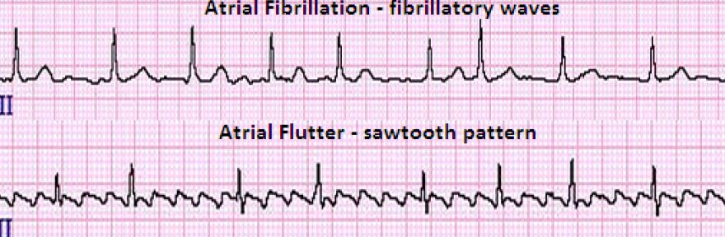

1. Look for a precipitating factor:
   * CAD, hypoxia, anaemia, HPT, CCF, PE, thyrotoxicosis, electrolyte abnormalities (low K or Mg), or drug-induced causes (e.g., digoxin, alcohol, or stimulants).
2. **Consult a cardiologist/senior**.
3. **If arrhythmia causes hypotension (hpt) or decompensated CCF**:
   * Cardioversion: with IV bolus dose of LMWH (60 U/kg) right before and
   * anticoagulation for 4 weeks after
4. **3x cardioversion and still unsuccessful**:
   * Administer amiodarone (300 mg over 10-20 minutes) 🡪 repeat cardioversion.
   * Follow up with an amiodarone infusion (900 mg over 24 hours).
5. **If the patient is stable and the arrhythmia is acute (<48 hours)**:
   * Restore sinus rhythm.
6. **If the patient is stable and the arrhythmia is chronic (>48 hours)**:
   * Aim to control the ventricular rate.

## 2.6 Heart Failure

**Types & Causes**

**Systolic Heart Failure**

* **Characteristics**: Ventricles unable to contract normally, Reduced Ejection Fraction (EF) < 40%
* **Causes**:
  + IHD (MI)
  + Myocarditis
  + DCM
  + Advanced valvular ds
  + Advanced HTN

**Diastolic Heart Failure**

* **Characteristics**: Ventricles unable to relax and fill normally, EF > 50%
* **Causes**:
  + HOCM, RCM
  + HTN, Valv. Ds (AS)
  + Constrictive pericarditis
  + Tamponade

Obesity **Precipitants of Acute Heart Failure**

* **Infection** (e.g., UTI, pneumonia, myocarditis)
* **High output states** (e.g., thyrotoxicosis, anemia, sepsis, pregnancy)
* **Arrhythmias** (e.g., d/t AFib, heart block, faulty pacemaker)
* **Valvular heart disease** (e.g., endocarditis, dysfunction of mechanical valve)
* **Lung pathology** (e.g., COPD exacerbation)
* **Hypertension** (uncontrolled/under-medicated/non-adherence)
* **Deteriorating LV function** (e.g., anti-remodelling therapy non-adherence/under-dosing)
* **Pulmonary Embolism**

**History**

**Left Heart Failure**

* Dyspnoea
* Orthopnoea
* Paroxysmal nocturnal dyspnoea (PND)
* Palpitations
* Fatigue/reduced exercise intolerance
* Pre-syncope
* Syncope
* Cough +- frothy pink sputum
* Wheeze
* Nocturia
* Weight loss

**Right Heart Failure**

* Body swelling (feet, legs, abdomen, breasts)
* +- facial engorgement/epistaxis
* RUQ pain
* Early satiety
* Nausea & Vomiting
* Fatigue/reduced effort intolerance

**Examination Findings**

**Left Heart Failure**

* Bibasal pulmonary crackles (pulmonary oedema)
* S3 gallop
* Displaced apex beat
* Myopathic apex beat
* Clammy peripheries
* Increased Capillary Refill Time
* Weak, thready pulse
* +- Mitral Regurgitation murmur
* Pulsus alternans – beat to beat variability of pulse strength

**Right Heart Failure**

* Pedal oedema
* Raised JVP +- positive hepatojugular reflex
* Ascites
* Hepatomegaly – tender, pulsatile
* Palpable P2
* Parasternal heave
* S3 gallop (right-sided)
* +- Tricuspid regurgitation
* Low volume pulse

**Management**

***LMNOP:****Loop diuretics, Modify medications, Nitrates, Oxygen, Position (sit upright)*

**Stabilize**

* Airway/breathing/circulation; place on O2 if low SATS on room air
* Use non-invasive positive pressure ventilation (NIV) in severe pulmonary oedema

**Reduce Preload (fluid overload symptoms**)

* **Diuretic** e.g., **IV Furosemide** – bolus of 40-80 mg IV QID
* **Nitrate** e.g., **nitro-glycerine 10-20 ug/min🡪 200mcg/min**
  + in MI or severe fluid overload
  + Vasodilator + improve coronary perfusion
  + **Or isosorbide dinitrate 1mg/hr 🡪 10mg/hr**
* Place on sodium +- fluid restriction
* Monitor input/output and aim for > 0.5kg per day weight loss

**Reduce Afterload**

* **ACE-inhibitor** e.g., **Enalapril 5mg PO daily**
* **or ARB** (**valsartan/losartan 160bid/150bid**)

**Inotropic Support (in Afib or shocked/hypotensive HF)**

* **Dobutamine**: ++contractility
* **Digoxin** **in AF** with rapid ventricular response and sufficient SBP
* **Urgent reperfusion:** if hypotensive heart failure is caused by ACS

**Longer-term Cardiac Remodelling Therapy**

* **ACE-inhibitor** e.g., **Enalapril** **5mg PO daily**
* **Beta blocker** e.g., **Carvedilol 25mg bid**
  + (if LVEF < 35%)
  + if no pulmonary oedema
* **MRA** e.g., **Spironolactone 50mg** **o.d**.

**Address/ Treat Underlying Cause**

* Valvular disease, medication adherence, untreated hypertension, MI

**Stepwise Reduction of BP**

1. HCTZ (Ridaq) 12.5mg (increase to 25 mg before step 2)
2. Add ACE-i (Caucasian) or CCB (Black). Optimize doses before step 3.
3. Add what wasn’t used in step 2. Maximize dose before step 4.
4. Add beta blocker.
5. Patient-specific (e.g., alpha blocker in BPH) / specialist support.

**Hypertensive Emergency**

* Clear indications for IV BP lowering therapy (Labetalol or Nitrosine):
  1. Acute pulmonary oedema
  2. Hypertensive encephalopathy
  3. Aortic dissection
  4. Pregnant patient with eclampsia
  5. Acute Myocardial Infarct

|  |  |  |  |  |  |  |  |  |
| --- | --- | --- | --- | --- | --- | --- | --- | --- |
| **Heart Failure**   |  |  | | --- | --- | | **Systolic Heart Failure**  Volume overload  Dec. contractility  Associated S3   * **Characteristics**: Ventricles unable to contract normally   + HFrEF (< 40%)   + Dec. contractility * **Causes**:   + IHD (MI)   + Myocarditis   + DCM   + Advanced valvular ds   + Advanced HTN | **Diastolic Heart Failure**  Incr. Afterload  Ventricular non-compliance  Associated S4   * **Characteristics**: Ventricles unable to relax & fill normally   + HFpEF (> 50%)   + Non-compliance * **Causes**:   + HOCM, RCM   + HTN, Valv. Ds (AS)   + Constrictive pericarditis   + Tamponade   + Obesity |   **Precipitants of Acute Heart Failure**   * **Infection** (e.g., UTI, pneumonia, myocarditis) * **High output states** (e.g., thyrotoxicosis, anaemia, sepsis, pregnancy) * **Arrhythmias** (e.g., d/t AFib, heart block, faulty pacemaker) * **Valvular heart disease** (e.g., endocarditis, dysfunction of mechanical valve) * **Lung pathology** (e.g., COPD exacerbation) * **Hypertension** (uncontrolled/under-medicated/non-adherence) * **Deteriorating LV function** (e.g., anti-remodelling therapy non-adherence/under-dosing) * **Pulmonary Embolism** | **History**   |  |  | | --- | --- | | **Left Heart Failure**   * Dyspnoea * Orthopnoea, PND * Palpitations * Fatigue, --exercise intolerance * Syncope * Cough +- frothy pink sputum * Wheeze * Nocturia * Weight loss | **Right Heart Failure**   * Body swelling (feet, legs, abdomen, breasts) * +- facial engorgement/epistaxis * RUQ pain (tender hepatosplenomegaly) * Early satiety * Nausea & Vomiting * Fatigue/reduced effort intolerance |   **Examination Findings**   |  |  | | --- | --- | | **Left Heart Failure**   * pulmonary oedema: Bi-basal crackles, wheezing etc * S3/S4 left gallop * Displaced Apex beat   + Volume loaded   + ++preload * Myopathic apex beat * Clammy peripheries * ++ Cap Refill Time * Weak, thready pulse * +- MR murmur * Pulsus alternans – beat to beat variability of pulse strength | **Right Heart Failure**   * Pedal oedema * Raised JVP +- hepatojugular reflex * Ascites * Hepatomegaly – **tender**, **pulsatile** * Palpable P2 * Parasternal heave * S3 gallop (right sided) * +- TR * Low volume pulse |   S4 assoc. ventricular noncompliance (e.g. HTN H Ds, AS, HCM, RCM) | **Investigations**  **Bedside**   * **ECG** – MI, arrhythmia, heart block, pulmonary embolus * **Urine dipstick** – proteinuria (kidney-related cause of oedema) * **ABG**:type1/2 resp. failure (in pre-existing lung disease)   **Imaging**   * **CXR** – LHF signs; pulmonary venous congestion, alveolar oedema, ‘Kerley B’ lines, cardiomegaly, upper lobe diversion, pleural effusion   + lung pathology (e.g., pneumonia, COPD) * **Echo** – valvular function, ejection fraction, cardiomyopathy   **Bloods**   * Troponins – MI * proBNP – heart failure ‘rule out’ * FBC, CRP, PCT – infection, anemia * U&E * LFTs (transaminitis in the 1000s indicates heart failure/ DILI or hepatitis) * Thyroid function * D-dimer if PE suspected * INR (warfarin Rx range: 2.5-3.5) if mechanical valve replacement |

|  |  |  |  |  |  |  |  |  |  |  |  |  |  |  |  |  |  |  |  |  |  |  |  |  |  |  |  |  |  |  |  |  |  |  |  |  |  |  |  |  |  |  |  |  |  |  |  |  |  |  |  |
| --- | --- | --- | --- | --- | --- | --- | --- | --- | --- | --- | --- | --- | --- | --- | --- | --- | --- | --- | --- | --- | --- | --- | --- | --- | --- | --- | --- | --- | --- | --- | --- | --- | --- | --- | --- | --- | --- | --- | --- | --- | --- | --- | --- | --- | --- | --- | --- | --- | --- | --- | --- |
| **Management**   |  |  | | --- | --- | | ***Aim****: stabilize, ++CO by optimizing preload & contractility whilst --afterload* | | | **Stabilize**   * ABC; place on **O2** if low SATS on room air🡪 SpO2 94-98% (88-92% if COPD). ~ 15L/min w/ reservoir mask * Use NIVPPV in severe pulmonary oedema | | | **Medical Management (IMMEDIATE) LMNO2PP** | | | **Reduce Preload (overload sx**) | **Reduce Afterload** | | * **Loop Diuretic** e.g., **IV Furosemide** – **bolus of 20-40 mg IV QID** * **Nitrate** e.g., **nitro-glycerine 10-20 ug/min🡪 200ug/min**   + **in MI or severe fluid** **overload**/severe hypertension   + ***C/I****:* SBP<90mmHg, AS   + Vasodilator + improve coronary perfusion   + **Or isosorbide-dinitrate** 1mg/hr 🡪 10mg/hr * **Position:** Sit upright * **Place** on sodium +- fluid restriction * **Monitor** input/output and aim for > 0.5kg per day weight loss | * **ACE-inhibitor** e.g., **Enalapril** 5mg PO daily * **or ARB** (**valsartan/losartan** 160bid/150bid) * *Hydralazine=arteriodilator (-- afterload),* | | **If Hypertensive**: Reduce BP with labetalol + oral anti-hypertensives | | | **Inotropic Support (in Afib or shocked/hypotensive HF)** | | | * **Dobutamine** 10ug/kg/min: ++contractility in severe hypotension (or dec. urine output) * **Digoxin** **in AF** uncontrolled tachy despite BB and sufficient SBP * **Urgent reperfusion:** if hypotensive HF is caused by ACS | | | **Longer-term Cardiac Remodelling (for LVEF <40%)** | | | * **ACE-inhibitor** e.g., **Enalapril** 5mg PO daily * **Beta blocker** e.g., **Carvedilol** 3.125mg PO daily   + (if LVEF < 35%) – systolic dysfunction   + If pulmonary oedema controlled * **AA=MRA** e.g., **Spironolactone** 50mg o.d.(aldost. Antagonist) * **SGLT2-I** * **Address/ Treat Underlying Cause** * Valvular disease, medication adherence, untreated HTN, MI | | | **Differential Diagnoses**  AHF may mimic other conditions:   |  |  | | --- | --- | | Condition | Description | | Asthma + COPD | Respiratory symptoms or pulmonary oedema d/t left-sided heart failure. | | ARDS | Difficult to diff. from pulm. oedema d/t ARDS in non-cardiac causes. | | Non-cardiogenic pulm. oedema | E.g. sepsis, major trauma, inhalation injury. | | Exacerbations of COPD | May cause dyspnoea similar to AHF. | | Pulmonary embolism (PE) | Can present with sudden onset dyspnoea. | | Pneumonia | Infectious cause of breathlessness. | | Pneumothorax | Sudden chest pain and shortness of breath due to lung collapse. |   **Complications**   |  |  | | --- | --- | | Complication | Description | | Arrhythmias | Atrial fibrillation, ventricular tachycardia, or ventricular fibrillation may occur. | | Thromboembolic events | Risk of DVT, PE, or stroke. | | Renal failure | Acute kidney injury secondary to poor perfusion. | | Resp. failure | Can be acute or chronic. | | Cardiogenic shock | Heart’s inability to meet the body’s needs. | | Sudden cardiac death | Increased risk in patients with significant left ventricular dysfunction. | |

### 2.6.1 CHATGPT Heart Failure (GeekyMedic)

**Introduction**

Acute heart failure (AHF) refers to the rapid onset or worsening of the signs and symptoms of heart failure.

* **Life-threatening condition**: The heart does not pump enough blood to meet the body’s needs.
* **Presentation**: AHF can occur in patients without known cardiac disease, as a complication of chronic heart failure (CHF), or as decompensation of CHF.
* **Clinical manifestations**: Includes acute pulmonary oedema (APO) or cardiogenic shock.
* **Management goal**: Rapid identification of the aetiology of AHF and early initiation of therapy.

**Aetiology**

**Pathophysiology**

AHF results from an imbalance between the heart’s pumping capacity and the body’s demands. The following table summarizes the mechanisms:

|  |  |
| --- | --- |
| **Mechanism** | **Description** |
| **Congestion** | Increased hydrostatic capillary pressure due to backlog of blood in the left atrium and pulmonary veins (e.g., decreased pumping capacity). |
| **Volume overload** | Hypervolemia, an increase in circulating blood volume (e.g., due to kidney failure or increased sodium intake). |
| **Increased peripheral resistance** | Increased afterload (e.g., in patients with hypertension, aortic stenosis, or severe coarctation of the aorta). |

**ESC Classification of AHF**

The European Society of Cardiology (ESC) classifies AHF based on hemodynamic profiles:

|  |  |
| --- | --- |
| **Type** | **Description** |
| **AHF + congestion at rest** | Signs of congestion in the lungs due to higher hydrostatic pressure. |
| **AHF + low perfusion at rest** | Signs of hypoperfusion, leading to lower oxygen supply to vital organs. |
| **AHF + congestion and low perfusion at rest** | Combination of the above two types. |
| **AHF without congestion or low perfusion at rest** | No significant hemodynamic disorder. |

**Causes**

|  |  |
| --- | --- |
| **New Onset AHF**   * Acute myocardial infarction * Hypertensive emergencies (e.g., AHF secondary to hypertensive crisis) * Arrhythmias * Acute valvular disease (e.g., infective endocarditis) * Acute myocarditis * Acute mechanical complications of AMI (e.g., ruptured chordae tendineae | **Acute Decompensation of CHF**   * Infection * Pulmonary embolism * Renal failure (e.g., nephrotic syndrome, hepatic cirrhosis) * Iatrogenic causes (e.g., inappropriate fluid therapy or pharmacotherapy) * Excessive salt or fluid intake * Non-adherence to therapy * Severe anaemia * Acute coronary syndrome * Surgery * Antiarrhythmic, calcium-channel blockers, or β-blocker therapy |

#### Clinical Features

##### History

Common symptoms of AHF:

|  |  |
| --- | --- |
| **Symptom** | **Description** |
| **Dyspnoea** | Shortness of breath. |
| **Fatigue** | Generalized tiredness. |
| **Exercise intolerance** | Difficulty performing physical activities. |
| **Orthopnoea** | Shortness of breath when lying flat. |
| **Paroxysmal nocturnal dyspnoea** | Sudden breathlessness at night. |
| **Pink frothy sputum** | Associated with acute pulmonary oedema. |
| **Abdominal pain, nausea, vomiting** | May indicate right-sided AHF or severe decompensated biventricular AHF. |
| **Palpitations** | Sensation of rapid or irregular heartbeat. |
| **Mental confusion** | Altered mental status due to poor perfusion. |
| **Decreased urine output** | Sign of poor kidney perfusion. |

##### Clinical Examination

Signs of AHF can include congestion, respiratory embarrassment, and poor perfusion.

|  |  |
| --- | --- |
| **Signs of Pulmonary Congestion** | **Signs of Poor Perfusion** |
| Fine crackles or crepitations | Cold, clammy peripheries |
| Paradoxical respiratory effort | Decreased capillary refill time |
| Pink frothy sputum (APO) | Hypotension (late sign of cardiogenic shock) |
| Tachycardia |  |
| Tachypnoea |  |
| Central cyanosis |  |
| Pulsus alternans |  |

#### Differential Diagnoses

AHF may mimic other conditions:

|  |  |
| --- | --- |
| **Condition** | **Description** |
| **Asthma + COPD** | Respiratory symptoms or pulmonary oedema d/t left-sided heart failure. |
| **ARDS** | Difficult to diff. from pulm. oedema d/t ARDS in non-cardiac causes. |
| **Non-cardiogenic pulmonary oedema** | E.g., sepsis, major trauma, or inhalation injury. |
| **Exacerbations of COPD** | May cause dyspnoea similar to AHF. |
| **Pulmonary embolism (PE)** | Can present with sudden onset dyspnoea. |
| **Pneumonia** | Infectious cause of breathlessness. |
| **Pneumothorax** | Sudden chest pain and shortness of breath due to lung collapse. |

#### Investigations

##### Bedside Investigations

* Routine observations: Pulse, blood pressure, etc.
* ECG: Assess heart rhythm and ischemic changes.
* Echocardiogram: Evaluate heart function and structure.

##### Laboratory Investigations

|  |  |
| --- | --- |
| **Test** | **Purpose** |
| **Full blood count (FBC)** | Check for anaemia or sepsis. |
| **Urea and electrolytes** | Assess renal function (e.g., elevated creatinine or potassium). |
| **Cardiac enzymes** | Assess myocardial infarction (e.g., troponins or BNP). |
| **Thyroid function tests** | Hypothyroidism or hyperthyroidism as causes of heart failure. |
| **Liver function tests (LFTs)** | Assess liver function. |

##### Imaging

* **Chest X-ray**: Signs of AHF such as pulmonary oedema or cardiomegaly.
* **Other Imaging Modalities**: Echocardiography or CT scan as needed.

##### Chest X-ray Findings in AHF:

|  |  |
| --- | --- |
| **Finding** | **Description** |
| Alveolar or interstitial oedema | Cloudy or 'ground glass' appearance in lung fields. |
| Enlarged heart shadow | Cardiomegaly indicating heart enlargement. |
| Pleural effusion | Fluid accumulation in the pleural space. |
| Kerley B lines | Linear markings indicating interstitial oedema. |
| Prominent upper lobe vessels | Redistribution of blood flow to upper lobes (cephalization). |

#### Management

**Investigate Underlying Causes**

Identify conditions with an acute potentially reversible cause:

* Acute coronary syndrome (ACS)
* Hypertensive emergencies
* Tachyarrhythmias and bradyarrhythmias
* Infection
* Pulmonary embolism
* Renal failure
* Decompensated heart failure

##### Medical Management

|  |  |
| --- | --- |
| **Treatment** | **Details** |
| **Oxygen** | Maintain oxygen saturation between 94%-98%. In hypercapnic respiratory failure, aim for 88%-92%. |
| **Diuretics** | Patients with chronic kidney disease may need higher doses of diuretics. Monitor fluid balance, renal function, and electrolytes. |
| **Nitrates** | Administer IV or sublingual nitrates in cases of increased preload. Be cautious in patients with low blood pressure. |
| **Non-invasive ventilation (NIV)** | Useful in acute pulmonary oedema when oxygen therapy fails. Options: CPAP or BiPAP. |
| **Cardiogenic shock** | Inotropes (e.g., dopamine, dobutamine) may be required. Avoid inotropes in hypovolemic patients; consider fluid resuscitation with caution. |

##### Long-term Management

**Pharmacological Interventions**:

|  |  |
| --- | --- |
| **Drug Class** | **Indication** |
| **Diuretics** | Loop diuretics for symptom management. Adjust dose to avoid dehydration. |
| **Beta-blockers** | Gradual titration in patients with LVEF < 40% to avoid sudden decompensation. |
| **ACE inhibitors or ARBs** | Indicated in all patients with LVEF < 40% for mortality reduction. |
| **Aldosterone antagonists** | Spironolactone in symptomatic patients with LVEF < 40% despite ACE inhibitors or ARBs. |

##### Additional Interventions:

|  |  |
| --- | --- |
| **Intervention** | **Details** |
| **Statins** | Consider in heart failure of ischemic aetiology. |
| **Antiplatelet agents** | Aspirin or clopidogrel in patients with coronary artery disease or ischemic stroke. |
| **Other pharmacological interventions** | Ivabradine, digoxin, or hydralazine plus nitrates for specific indications. |

##### Devices:

* **ICDs or CRT**: Consider in patients with heart failure meeting specific criteria. Comprehensive assessment required before device implantation.

#### Complications

|  |  |
| --- | --- |
| **Complication** | **Description** |
| **Arrhythmias** | Atrial fibrillation, ventricular tachycardia, or ventricular fibrillation may occur. |
| **Thromboembolic events** | Risk of DVT, PE, or stroke. |
| **Renal failure** | Acute kidney injury secondary to poor perfusion. |
| **Respiratory failure** | Can be acute or chronic. |
| **Cardiogenic shock** | Heart’s inability to meet the body’s needs. |
| **Sudden cardiac death** | Increased risk in patients with significant left ventricular dysfunction. |

## 2.7 Cor Pulmonale

|  |  |  |
| --- | --- | --- |
| **Definition:** Right heart failure caused by chronic pulmonary arterial hypertension.  **An approach to causes of cor pulmonale**  **Lung disease**   * COPD * Bronchiectasis * Interstitial lung disease * Cystic Fibrosis * Severe chronic asthma * Autoimmune lung disease e.g., scleroderma * Lung resection   **Pulmonary vascular disease**   * Pulmonary Embolism * Pulmonary vasculitis * Primary pulmonary hypertension * ARDS * Sickle cell disease   **Thoracic cage abnormality**   * Kyphosis * Scoliosis   **Hypoventilation**   * Sleep apnoea (or enlarged adenoids in children)   **Signs and symptoms**  *(those of right heart failure – see section on Heart Failure - together with the aetiological pathology e.g., COPD, bronchiectasis etc.)*   * Symptoms of: dyspnoea, fatigue, syncope, swelling of legs and abdomen * Signs of: cyanosis, tachycardia, raised JVP, RVH, palpable P2, loud P2, pansystolic (TR) murmur, hepatomegaly, oedema. | **Investigations**  *(see Heart Failure section)*  Note: CXR of a patient with pulmonary artery hypertension may show enlarged pulmonary arteries.  **Management**   * Treat the underlying cause e.g., COPD, PE * Treat the acute respiratory failure   + If PaO2 is reduced, give oxygen     - In COPD patients, long term oxygen therapy increases survival thus assess patient with chronic hypoxia once stable for long term oxygen therapy. * Treat cardiac failure *(see Heart Failure section)*   + Lasix 40-160mg/ PO orally * Monitor U&E and supplement potassium +- amiloride if needed. Alternatively, use spironolactone |  |

## 2.8 Venous Thromboembolic Disease (DVT & PE)

|  |  |  |
| --- | --- | --- |
| **Definition**   * **DVT**: A thrombosis originating in the deep veins of the leg.   + If confined to the calf veins = calf/distal DVT.   + If it extends and reaches the popliteal vein or above = proximal DVT. * **PE**: Clots that embolize, typically from a DVT, pass through the right side of the heart and lodge in the pulmonary circulation. Rare causes may include:   + Post-MI right ventricular thrombus.   + Septic emboli from right-sided endocarditis.   + Fat, air, or amniotic fluid embolism.   + Neoplastic cells.   + Parasites.   **Risk Factors on History**   * Recent surgery, especially abdominal, pelvic, hip, or knee replacement. * Prolonged bed rest/reduced mobility. * Thrombophilia (e.g., antiphospholipid syndrome). * Leg fracture (fat embolism). * Malignancy. * Pregnancy/postpartum period. * OCP use. * Previous pulmonary embolism.   **Symptoms on History**   * Acute shortness of breath. * Pleuritic chest pain (versus radiating to arm/shoulder/jaw in PE leading to MI). * Hemoptysis. * Dizziness. * Syncope. * Leg pain, swelling, and redness (DVT).   **Signs on Examination**  **DVT:**   * Unilateral leg pain & swelling. * Leg may be erythematous and warm to the touch. * Tenderness along the course of deep veins + dilation of superficial veins. | **PE:**   * Pyrexia. * Cyanosis. * Tachypnea. * Tachycardia. * Hypotension. * Pleural rub + crackles over the localized area of pulmonary infarction. * Pleural effusion (stony dullness to percussion, reduced vocal fremitus, absent breath sounds, bronchial breathing above effusion). * Severe PE may present with MI ischemia and associated central chest pain. * Raised JVP, parasternal heave, gallop rhythm if right-sided heart failure is induced by the PE.   **Differential Diagnosis**  **DVT:**   * Cellulitis. * Ruptured Baker’s cyst. * MSK: trauma, hematoma, myositis, tendonitis. * Osteoarthritis, osteomyelitis, synovitis, fracture, bone tumor. * Lymphedema.   **PE:**   * Chest infection (e.g., pneumonia, TB). * COPD exacerbation. * Acute coronary syndrome (e.g., MI or unstable angina). * Asthma. * Pneumothorax. * MSK: trauma or costochondritis or rib fracture, muscle sprain. * Aortic dissection. * Lung cancer. * Anxiety/hyperventilation | **Investigations**   * **Bedside ABG**: May show reduced PaO2 and reduced PCO2 * **ECG**:   + Sinus tachycardia.   + Right ventricular strain pattern: T-wave inversion of inferior (II, III, aVF) and right precordial (V1-V4) leads.   + S1Q3T3 pattern: prominent S-wave in lead I, prominent Q-wave and inverted T-wave in lead III.   + Right bundle branch block.   + Arrhythmia (e.g., AFib) in massive PE. * **CXR**:   + Oligemia of affected segment.   + +/- Atelectasis.   + +/- Small pleural effusion.   + Rarely, wedge-shaped opacities or cavitation. * **Bloods**:   + FBC, U&E.   + Coagulation studies (INR/PTT).   + D-dimers.   + Cardiac markers (troponin, pro-BNP). * **Cardiac Markers**:   + In patients with 'unprovoked PE' (no risk factors), do additional investigations for underlying malignancy. * **Definitive Imaging for DVT**: Doppler ultrasound of the deep venous system. * **Definitive Imaging for PE**: Computed Tomographic Pulmonary Angiography (CTPA).   + If CTPA unavailable in very severe acute presentation, bedside transthoracic echo may be diagnostic (showing acute pulmonary hypertension and right ventricular dysfunction).   + If CTPA unavailable in less critical situations, a VQ (ventilation perfusion) scan may aid diagnosis, but results may be equivocal, requiring CTPA anyway. |

|  |  |  |  |  |  |  |  |  |  |  |  |  |  |  |  |  |  |
| --- | --- | --- | --- | --- | --- | --- | --- | --- | --- | --- | --- | --- | --- | --- | --- | --- | --- |
| **Modified Wells Criteria:** to assess the clinical probability of a PE and direct investigations:   |  |  | | --- | --- | | **Criteria** | **Points** | | Clinical signs and symptoms of DVT | 3 | | PE is #1 diagnosis OR equally likely | 3 | | Heart rate > 100 | 1.5 | | Immobilization at least 3 days OR surgery in the previous 4 weeks | 1.5 | | Previous, objectively diagnosed PE or DVT | 1.5 | | Hemoptysis | 1 | | Malignancy with treatment within 6 months or palliative | 1 |   **Interpretation Based on Wells Score**   * **If Wells score is ≤ 4**:   + Do a D-dimer:     - If D-dimer is positive:       * Immediate CTPA OR       * Treat empirically with LMWH if delayed CTPA.     - If D-dimer is negative:       * Rule out PE and consider an alternative diagnosis. * **If Wells score is > 4**:   + Immediate CTPA for definitive diagnosis OR   + Start treating empirically with LMWH if delayed CTPA. | **Management**  **Acute:**   * Stabilize ABCs (e.g., O2 if hypoxic). * Morphine 5-10 mg IV with anti-emetic if the patient is in pain or distressed. * Immediately initiate IV LMWH or Fondaparinux. * If hypotensive, give 500 mL IV fluid bolus and consult ICU. * Hemodynamically unstable?   + Yes: Consider thrombolysis (alteplase 10 mg IV bolus then IVI 90 mg over 2 hours).   + No: Treat persistent hypotension with dobutamine or noradrenaline.   **Post-Acute Stabilization:**   * Initiate long-term anticoagulation with:   + A DOAC (e.g., Rivaroxaban, Dabigatran) or Warfarin (continue LMWH while initiating warfarin, until INR > 2 for 2 consecutive days). * Identify and address the underlying cause (e.g., thrombophilia, polycythemia, malignancy, etc.). * If an obvious remedial cause (e.g., pregnancy), continue 3 months of anticoagulation; otherwise, extend for 3-6 months+ or long term if recurrent emboli or underlying malignancy.   **Prophylaxis:**   * Heparin for immobile patients. * Stop HRT and combined OCP before surgery. |

# 

# 3. Respiratory

## 3.1 Pulmonary Hypertension****

**What is it?**  
Defined as a mean pulmonary artery pressure higher than 25 mmHg and systolic pressures of > 50 mmHg.

**Causes**

* Primary/idiopathic
* Secondary:
  + Pulmonary emboli - blood clots, tumour particles, fat globules
  + Lung disease - COPD, obstructive sleep apnoea, interstitial lung disease (ILD)
  + Connective tissue disease (with or without ILD) - scleroderma
  + Left ventricular failure resulting in back-pressure into the pulmonary circulation or mitral stenosis
  + Congenital heart disease - large left to right shunts: ASD, VSD, PDA
  + Severe kyphoscoliosis

|  |  |  |
| --- | --- | --- |
| **History Features**   * Features of LVF:   + Dyspnoea   + Non-productive cough   + Orthopnoea   + PND * Features of RVF:   + Peripheral oedema   + Ascites   + Pain RUQ   **Exam Findings**   * **General signs:** * Tachypnoea * Peripheral cyanosis and cold extremities (due to low cardiac output) * Hoarseness (very rare - due to pulmonary artery compression of the left recurrent laryngeal nerve) * **Pulse:** * Small volume (usually) - due to low cardiac output * **JVP:** * Raised - with prominent a wave due to forceful right atrial contraction * **Palpation:** * Parasternal heave * Palpable P2 * Painful hepatosplenomegaly * **Auscultation:** * Systolic ejection click - due to dilation of the pulmonary artery * Loud P2 - due to forceful valve closure because of high pulmonary pressures * S4 * Pulmonary ejection murmur - due to dilation of the pulmonary artery resulting in turbulent blood flow * Murmur of pulmonary regurgitation if there is dilation of the pulmonary artery | **Differential Diagnosis**   * Left sided heart failure * Coronary artery disease * Liver disease * Budd-Chiari Syndrome   **Investigations**   * **Bedside:**   + ABG - to check for hypoxia if presenting in distress, electrolyte abnormalities   + ECG:     - Right axis deviation     - RV hypertrophy     - P-pulmonale (increased P wave altitude in lead II) = RA enlargement * **Lab:**   + FBC - to check for anaemia   + U&E - to assess renal function   + BNP - may be raised due to RV wall stretch or LV failure   + INR - if worried about pulmonary emboli as a cause * **Imaging:**   + CXR:     - Cardiomegaly with increased cardiothoracic ratio > 50% (RA and RV enlargement)   + Echo:     - RV hypertrophy/strain     - Measure tricuspid regurgitation jet velocity | **Management**   * Depends on cause and class of pulmonary hypertension:   + Class 1 pulmonary arterial hypertension → Vasodilators/ACE-I   + Class 4 thromboembolic → Anticoagulation   + Digoxin to increase contractility   **Classification**   1. Pulmonary arterial hypertension 2. Pulmonary hypertension due to **left ventricular disease** 3. Pulmonary hypertension due to **lung disease and/or hypoxia** 4. Chronic **thromboembolic** pulmonary hypertension 5. Pulmonary hypertension with unclear and/or multifactorial mechanisms (**miscellaneous**) |

## 

## 3.2 Pneumonia ****

|  |  |  |  |  |  |  |  |  |  |  |  |  |  |  |  |  |  |  |  |  |  |  |
| --- | --- | --- | --- | --- | --- | --- | --- | --- | --- | --- | --- | --- | --- | --- | --- | --- | --- | --- | --- | --- | --- | --- |
| **Classification & Aetiology 1. Community Acquired Pneumonia**   * ***Streptococcus pneumoniae* (commonest)** * *Haemophilus influenzae* * *Moraxella catarrhalis* * Viruses * Atypical bacteria: *Mycoplasma pneumoniae*, *Chlamydia pneumoniae* * *Staphylococcus aureus* * Other: *Mycobacterium tuberculosis*   **2. Hospital-acquired Pneumonia (Symptoms start > 48 hrs after admission)**   * G- enterobacteria * *Staphylococcus aureus* * *Pseudomonas aeruginosa* * *Klebsiella pneumoniae* * *Clostridia spp.*   **3. Immunocompromised Hosts**   * As above plus *Pneumocystis jirovecii* (CD4 < 200) * Other fungi, viruses (e.g., CMV, HSV), and mycobacteria   **Risk Factors to Ask About in History**   * Age < 16 or > 65 * Comorbidities: HIV, DM, CKD, malnutrition, recent LRTI * Other respiratory conditions: CF, bronchiectasis, COPD, lung malignancy * Social factors: smoking, excess alcohol, IVDU * Iatrogenic: immunosuppressant therapy (e.g., MTX, chemotherapy, prolonged corticosteroid use)   **Symptoms**   * Cough – dry or productive of purulent sputum; may include haemoptysis * Dyspnoea * Fever * Malaise, loss of appetite * Pleuritic chest pain | **Signs on Examination**   * Pyrexia, Cyanosis * Confusion (especially in elderly) * Tachypnoea, Tachycardia,Hypotension * Signs of consolidation on lung examination:   + Reduced chest expansion over the affected area (typically unilateral)   + Dullness to percussion   + Increased vocal fremitus (if severe; whispering pectoriloquy)   + Bronchial breathing   + Coarse crackles   + Possible pleural rub (early in disease) * If parapneumonic effusion present: stony dull, reduced air entry   **Investigations**   * **Bedside**   + Oxygen saturation   + ABG (if oxygen saturation < 94%)   + ECG (if severe chest pain, rule out MI) * **Lab tests**   + FBC + CRP   + U&E (Urea for CURB-65 score)   + HIV test if status is unknown   + Blood cultures + TB Bactec   + PCR for *Pneumocystis jirovecii* (if suspected)   + Sputum – MC&S, TB GXP   + If TB suspected and CD4 < 100, do ULAM   + If pleural effusion present, consider thoraco-centesis for MC&S * **Imaging**   + CXR – lobar or multilobar infiltrates, cavitation, or pleural effusion   + PA & lateral CXR: confirms dx   **CRB 65 Scoring Criteria**   |  |  | | --- | --- | | Criteria | Parameter | | C | **C**onfusion | | U | **U**rea > 7 mmol/L | | R | **R**R > 30 breaths/minute | | B | **B**lood Pressure < 90/60 mmHg | | 65 | Age ≥ **65** years | | **CURB 65 score Interpretation**   |  |  | | --- | --- | | Score | Action | | CURB 0 -1 | - **Rx as outpatients** unless significant co-morbidity, poor social circumstances, no transport, etc. (**mild**) | | CURB 2 | - **Hospitalize**/admit (**moderate**) | | CURB ≥ 3 | - Consider ICU (**Severe**) |   **Note: CRB 65 (without urea)** is as valuable in community setting  **Management**   * **Stabilize the patient acutely (ABCs):**   + NPO2 if oxygen saturation < 94% (unless known COPD: maintain at 88-92%)   + IV fluids in hypotensive or volume-depleted patients * **Antibiotics:**   + Oral antibiotics if tolerable and not severe pneumonia; for severe (CURB-65 >2) give IV   + **Mild to moderate** CAP: Amoxicillin/Co-amoxiclav or Cefuroxime for 5 days   + **Severe**: IV Co-amoxiclav or Cephalosporin + Clarithromycin for 7-10 days   + MSSA: Flucloxacillin / MRSA: Vancomycin   + Legionella: Fluoroquinolone + Clarithromycin   + PCP: High-dose Co-trimoxazole   + **TB: RHZE x2m then RH x4m** * **Thromboprophylaxis**   + If admitted for >12h, consider SC LMWH + compression stockings * **Anti-pyretic/Analgesia** if pleuritic chest pain   + Paracetamol or NSAIDs * Dietitian, physiotherapy   **Prevention**   * Annual Influenza A, B vaccine for at risk (e.g. >65, immunocompromised) * Pneumococcal polysaccharide vaccine (PPV) * Smoking cessation (reduces risk of CAP)   **Complications**   * Local empyema (pus in pleural space), lung abscess, * ARDS: pulmonary oedema & severe lung inflammation * Pleural effusion * Post-infective bronchiectasis (permanent dilation & thickening of airways) * Systemic sepsis, pneumococcal meningitis, post infectious glomerulonephritis |

**Ambulatory Care** (CURB ≤1, no comorbidities)

|  |  |
| --- | --- |
| Medication | Dosage |
| Amoxicillin (agent of choice) | **2g bd PO 5/7** |
| Or Amoxicillin/clavulanate | 2g bd PO 5/7 |
| Or 2nd generation cephalosporin (Cefuroxime) | 1g 8 hourly PO **5/7** |
| Macrolide/Azalide (Clarithromycin) | **500mg PO bd 5/7** |
| New fluoroquinolone | - **Moxifloxacin**: 400mg daily |
|  | - **Levofloxacin**: 500mg bd or 750mg daily |

**Hospitalized Patients** (CURB ≥1)

|  |  |  |
| --- | --- | --- |
| CURB | Medication | Dosage |
| CURB 1 or 2,  no comorbidity | **Amoxicillin** ± Macrolide/Azalide (**Clarithromycin**) | **1g 6-hourly IV 5/7 500mg IV bd (infuse over 60min)** |
| CURB 1 or 2 w/ comorbidity | **Amoxicillin-clavulanate** **or** 2nd gen cephalosporin (**Cefuroxime**)  ± Macrolide/Azalide (**Clarithromycin**) | **1.2g 8-hourly IV 5/7** 1.5g 8-hourly IV 5/7 **500mg IV bd (infuse over 60min)** |
| CURB ≥ 3 | **Amoxicillin-clavulanate** **or** 2nd gen cephalosporin (**Cefuroxime**) **or** 3rd gen cephalosporin (**Ceftriaxone**, Cefotaxime) | **1.2g 8-hourly IV 1/52** **Cefuroxime: 1.5g 8-hourly IV 1/52** Ceftriaxone: 1g bd Cefotaxime: 2g 8-hourly IV |
|  | **PLUS,** **Gentamicin** | **5mg/kg/day** 3/7 if sputum; G- organisms |
|  | **PLUS, Macrolide** Azithromycin **Clarithromycin** Erythromycin | **Atypical cover** (**Legionella**) &  500mg dly or  **500mg IV bd (infuse over 60min**  500mg bid **if pregnant** |

**(SIMPLIFIED) Hospitalized Patients** (CURB ≥1)

|  |  |  |
| --- | --- | --- |
| CURB | Medication | Dosage |
| CURB 1 or 2,  no comorbidity | **Amoxicillin** ± Macrolide/Azalide (**Clarithromycin**) | **1g 6-hourly IV 5/7 500mg IV bd (infuse over 60min)** |
| CURB 1 or 2 w/ comorbidity | **Amoxicillin-clavulanate** ± Macrolide/Azalide (**Clarithromycin**) | **1.2g 8-hourly IV 5/7**  **500mg IV bd (infuse over 60min)** |
| CURB ≥ 3 (severe) | **Amoxicillin-clavulanate** | **1.2g 8-hourly IV 1/52** |
|  | **PLUS,** **Gentamicin** | **5mg/kg/day** 3/7 if sputum contains G- orgs. |
|  | **PLUS, Macrolide** Azithromycin **Clarithromycin** Erythromycin | **Atypical cover** (**Legionella**)  500mg dly or  **500mg IV bd (infuse over 60min**  500mg bid **if pregnant** |

## 

## 3.3 Pleural Effusion****

* Small: parapneumonic, PE. Low protein
* Large: NBL
  + Dull at apex & >50% lung involved
  + Trachea likely shift: if it doesn’t, likely have a collapse of other lung

**Signs and Symptoms:**

* Often asymptomatic
* Dyspnea
* Orthopnea
* Pleuritic chest pain
* Decreased chest expansion on the affected side
* Trachea deviates away from the side of the effusion (if large)
* Decreased vocal fremitus
* Stony dullness
* Auscultation:
  + Decreased breath sounds
  + Bronchial breathing and egophony just above the air-fluid level
  + Pleural friction rub

**Investigations:**

* **Bedside**:
  + ABG - assess level of distress
  + ECG - rule out cardiac causes and cor pulmonale
* **Laboratory**:
  + Blood: Protein, LDH, and glucose of blood
  + Pleural fluid: Protein, LDH, glucose, pH, cytology, GXO, culture, and MCS of pleural fluid
    - If very low pH (< 7.2) - empyema
    - If low glucose - likely infective cause
* **Radiology**:
  + CXR:
    - Small effusions - blunt the costophrenic angle
    - Large effusions - see if they have an air-fluid level
    - Can do a lateral decubitus to confirm the presence of fluid
  + CT:
    - Differentiate pleural from parenchymal pathology
    - Need to tap them dry if massive to allow for visualization
      * Max tap at a time is 1.5L → if more is removed, can get post-expansive edema
  + US:
    - Detect small effusions
    - Guide the thoracentesis
* **Thoracentesis**:
  + Can be diagnostic and therapeutic
  + Therapeutic - help ease the discomfort of the patient
  + Diagnostic - determine the type of effusion
* **Pleural biopsy** - if suspect mesothelioma, TB, malignancy
  + Needle biopsy - often done blindly with low pick-up rate
  + VATS - video-guided biopsy and the use of staining helps with identification of the lesion.

**Types of Effusions:**

**Determine using light’s criteria**

|  |  |  |  |
| --- | --- | --- | --- |
| Criteria | Light's Criteria | Modified Light's Criteria: Transudate | Modified Light's Criteria: Exudate |
| Protein - Pleural/Serum | >0.5 | <0.5 | >0.5 |
| LDH - Pleural/Serum | >0.6 | <0.6 | >0.6 |
| Pleural LDH | >2/3 upper limit of normal serum LDH |  | >2/3 upper limit of normal serum LDH |
|  |  | Hypoalbuminemia (cirrhosis, nephrotic syndrome)  CHF  Constrictive Pericarditis | Autoimmune ds  Esophageal rupture  Infection (parapneumonic, TB, fungal, empyema)  Malignancy  Pancreatitis  Post-CABG  PE |
| Exudate = any one criterion | Exudate = any one criterion |  | Exudate = any one criterion **Light’s for transudative but serum albumin – pleural albumin <12 g/L confirms effusion is exudative** |

|  |  |
| --- | --- |
| **Transudative effusions**:   * Alteration in Starling’s forces resulting in abnormality of production and absorption of the fluid * Typically serous/straw-colored * Usually bilateral * Causes:   + CCF   + Cirrhosis   + Hypoalbuminemia   + Hypoproteinemia   + Malnutrition   + Nephrotic syndrome   + Protein-losing enteropathy   + PE   + Peritoneal dialysis   + Hypothyroidism   + CF   + Urinothorax | **Exudative effusions**:   * Increased permeability of pleural capillaries or lymphatic dysfunction * Bloody/pus * Usually unilateral * Causes:   + Infection - parapneumonic, TB   + Malignancy - lung ca, lymphoma, breast, ovary (right-sided effusion - Meigs), kidney, mesothelioma   + Inflammation - RA, SLE, pancreatitis, PE   + Intra-abdominal - subphrenic abscess, pancreatic disease   + Intrathoracic - esophageal perforation   + Trauma - hemothorax, pneumothorax, chylothorax, iatrogenic   + Drug-induced   + Hypothyroidism |

**Management:**

* **Drainage** - if symptomatic
* **Pleurodesis**:
  + For recurrent effusions
  + Iodine solution injected → cause pleuritis and fusion of the membranes but can't have any fluid present
* **If pus** - use a chest drain
* **Treat underlying cause**
* **Purulent effusion**:
  + Augmentin IV 25mg/kg/day of amoxicillin component 8 hourly (don’t exceed 10mg/kg/day of clavulanate component for 10 days)
  + Or cefazolin IV 25mg/kg 8 hourly
* **If pathogens cultured** - treat according to sensitivity for prolonged period 21-42 days
* **Straw-colored/hemorrhagic effusion**:
  + Start Anti-TB therapy

## 3.4 Interstitial Lung Disease

Group of disorders which cause progressive scarring of lung tissue & impair lung function & gas exchange

**Pathophysiology**:

* Inflammatory &/or fibrosing process in the alveolar walls → distortion & destruction of normal alveoli & microvasculature
* Typically associated with:
  + Lung restriction (↓TLC & VC)
  + ↓ Lung compliance (↓ or normal FEV1/FVC)
  + Impaired diffusion (↓DLCO)
  + Hypoxaemia due to V/Q mismatch (usually without hypercapnia until end stage)
  + Pulmonary hypertension & cor pulmonale occur with advanced disease secondary to hypoxaemia & blood vessel destruction

**Aetiology**:

* 100 known causes
* Majority of cases, no cause can be identified

**History**

* Smoking
* Environmental exposure
  + Silica
  + Coal
  + Asbestos
* **Drugs**:
  + Chemo - bleomycin
  + Methotrexate
  + Antibiotics - nitrofurantoin
  + Amiodarone
  + Penicillamine
  + Cocaine
* **Radiation**
* **Autoimmune conditions**:
  + SLE
  + RA
  + Polymyositis
  + Sjogrens
  + Ankylosing spondylitis
  + Scleroderma
* **Vasculitis**:
  + Wegners
  + Churg-Strauss
  + Microscopic polyangiitis

**Signs and symptoms**

* Dyspnea on exertion
* Chronic non-productive cough
* Feel like they can’t take a deep breath
* Fine inspiratory crackles
* Clubbing - in pulmonary fibrosis and asbestosis
* Cyanosis
* Inspiratory ronchi
* Cor pulmonale - parasternal heave, palpable P2 and loud P2

**Investigations**:

* **ABGs**:
  + Hypoxaemia & respiratory alkalosis may be present with progression of disease
* **Bloods**:
  + FBC and Diff
  + ANA - autoimmune condition
  + RF - RA
  + ACE - sarcoid
  + ESR/CRP
  + ANCA - vasculitis
* **CXR/high resolution CT**:
  + Usually ↓ lung volumes
  + Reticular, nodular, reticulonodular pattern (nodular < 3mm)
  + Hilar/mediastinal adenopathy (bilateral especially in sarcoidosis)
  + Honeycombing (pathognomonic for UIP)
* **PFTs**:
  + Restrictive pattern: ↓ lung volumes & compliance
  + Normal or ↑ FEV1/FVC (> 70-80%)
  + DLCO ↓ due to V/Q mismatch (less surface area for gas exchange & PVD) & diffusion impairment
* **Other**:
  + Bronchoscopy, bronchoalveolar lavage, lung biopsy
  + RF (RA), anti-CCP, connective tissue disease (CTD), screen
  + Serum-precipitating antibodies to inhaled organic antigens (hypersensitivity pneumonitis)
  + C-ANCA (GPA), anti-GBM (Goodpasture’s)
  + Histology - biopsy if sarcoid is suspected

**Management**

* Depends on the type of ILD
* Steroids are usually given in order to slow the progression
* Avoidance of the trigger
* Supportive - O2, pulmonary HT, CCF
* Lung transplant if very severe
* If it’s IPF - anti-fibrosing agents can be given

## 3.5 Suppurative Lung Disease

**Bronchiectasis**

* Irreversible dilatation of airways
* Due to inflammatory destruction of airway walls resulting from persistently impaired mucous clearance & infected mucous
* Usually affects medium-sized airways
* Most common sputum pathogens in non-cystic fibrosis patients:
  + TB (globally the leading cause)
  + H. Influenzae
  + P. Aeruginosa
  + M. Catarrhalis
* P. Aeruginosa - seen in px with underlying lung disease (CF, bronchiectasis) or with urinary/venous catheter (like foreign objects)

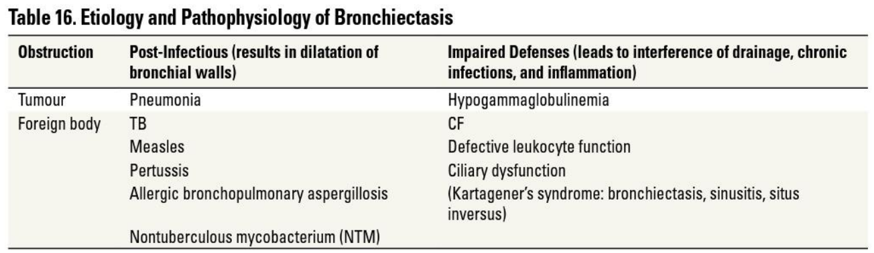

**Sign & Symptoms**:

* Chronic cough
* Copious, foul-smelling, purulent sputum (10-20% have dry cough)
* Dyspnoea
* Fatigue
* Chronic rhinosinusitis
* Hemoptysis (usually streaking, but can be massive)
* Recurrent pneumonia
* Local coarse crackles (inspiratory & expiratory)
* Rhonchi
* Wheezes
* Clubbing
* *May be difficult to differentiate from chronic bronchitis*
* **NB**: On history, ask about previous lung infections, particularly previous TB

**Exam findings**

* **Inspection** - scars from surgery, decreased chest expansion
* **Palpation** - P2, Parasternal heave (if pulmonary HT present)
* **Percussion** - dull; severe cavitary changes may produce hyperresonance
* **Auscultation** - crackles, wheeze

**Investigations**:

* **Bedside**:
  + ECG - rule out cor pulmonale
  + ABG - if patient is in distress
  + Pulse oximetry - assess level of distress
  + +- Sputum - TB GXP if active TB is suspected
* **Bloods**:
  + FBC
  + U and E
  + CRP
  + LFT
  + Sputum culture (routine and AFB)
  + Immunoglobulin panel (serum Ig levels)
  + Sweat chloride if CF suspected (upper zone predominant)
* **PFTS** - often show obstructive pattern but can be normal
* **CXR**:
  + Non-specific: ↑ markings, linear atelectasis, loss of volume in affected areas
  + Specific: Tram-tracking of airways (parallel narrow lines radiating from hilum), cystic spaces, honeycomb-like structures
  + **High resolution thoracic CT** (diagnostic, gold standard):
    - Signet ring: dilated bronchi with thickened walls where diameter bronchus >1.5x diameter of accompanying artery
    - Tram track
* **+** Nasal nitric oxide test if Primary Ciliary Dyskinesia is suspected (very low in PCD)
* **Bronchoscopy**:
  + Locate site of haemoptysis, exclude obstruction, sample for culture

**Treatment**:

* **Vaccination**: influenza & pneumococcal
* **Chest physiotherapy**, breathing exercises, physical exercise
* **Antibiotics** (oral, IV, inhaled)
  + **Empiric tx** - stable with mild bronchiectasis:
    - Amoxicillin 500mg 8 hourly for 14 days
    - Doxycycline 100mg twice daily for 14 days
    - May need prolonged therapy in some cases up to 3 weeks
    - Further antibiotic therapy based on MC&S results
* **Mucolytics**: hypertonic saline
* **Inhaled corticosteroids**: ↓ inflammation, may ↑ risk of exacerbations
* **Oral corticosteroids** for acute, major exacerbations
* **Pulmonary resection**: in selected cases with focal bronchiectasis
* **Transplant**: for end-stage diffuse causes (PCD)

**Complications**

* Pneumonia
* Pleural effusion
* Pneumothorax
* Haemoptysis
* Cerebral abscess
* Amyloidosis

**Differential diagnosis**

* COPD
* Asthma
* TB
* Lung cancer
* Inhaled foreign body
* Chronic allergic bronchopulmonary aspergillosis
* Chronic obstructive lung disease

## 3.6 Empyema

* Pus in pleural space or an effusion with organisms seen on gram stain or culture
  + Pleural fluid grossly purulent
* +ve culture not required for Dx

**Aetiology:**

* Contiguous spread from lung infection (most commonly anaerobes) or infection through chest wall (trauma, surgery)

**Signs & symptoms:**

* Fever
* Pleuritic chest pain
* Clubbing
* Mediastinal shift to opposite side
* Inspection - chest wall asymmetry, affected side is higher, redness
* Palpation - warmth and tenderness, increased fremitus
* Percussion - dullness
* Auscultation - decreased breath sounds, egophony, coarse crackles

**Investigations:**

* **Bedside**:
  + ABG - assess severity of distress
  + Pulse oximetry
* **Bloods**:
  + FBC
  + U and E
  + CRP
  + Blood cultures
* **Sputum cultures**
* **Radiology**:
  + CXR
  + Ultrasound - confirm presence of pus
  + CT chest - alternative to the CXR and US
    - Thickening of the pleura, pleural enhancement, split pleural sign, bubble in absence of drainage and septations
* **Thoracentesis**:
  + Send fluid for analysis and culture
  + PMNs (lymphocytes in TB) +/- visible organisms on gram stain

**Treatment**:

* **Antibiotics** - at least 4-6 weeks
* Complete pleural drainage with chest tube
* If loculated - difficult to drain → surgical drainage
  + **VATS**
    - Decreased pain, decreased blood loss, better outcome
  + **Open thoracotomy**
    - Indications - uncontrolled bleeding, damage to structure that can’t be repaired with laparoscopy, can’t tolerate one-lung ventilation, VATS failed

**Complications**

* Fibrosis
* Lung restriction
* Respiratory distress

**Differential diagnosis**

* Pneumonia
* Heart failure
* Pulmonary infarction
* Sequestration

## 3.7 Lung Abscess

* Circumscribed area of pus or necrosis in the pulmonary parenchyma
* Most arise as a complication of aspiration
* Typically polymicrobial
* Can also arise from secondary infection of pre-existing lung cavities, bronchial obstruction, septic embolisation, or direct extension from local infection such as empyema
* **Primary**:
  + Result from direct infection of the pulmonary parenchyma in otherwise healthy persons
  + Mostly result from aspiration
  + Less likely result from infection from pyogenic bacteria (S. aureus)
* **Secondary**:
  + Occur when there is a predisposing condition such as bronchial obstruction (foreign body, neoplasm), haematogenous spread (R-sided endocarditis) or immunocompromised

**Pathogenesis**:

* Aspiration → localised areas of pneumonia → necrosis → cavitation
* Embolisation (blood-borne) - haematogenous spread
* Direct extension
* Endobronchial obstruction
* Infection of lung cysts

**Aetiology**:

* **Aspiration** - polymicrobial: oral & gingival flora
  + Strep & anaerobes most common
* **Pneumonia caused by pyogenic bacteria**:
  + S. aureus
  + Klebsiella pneumoniae
  + Pseudomonas aeruginosa
  + S. pyogenes
  + H. Influenzae
  + Legionella
  + Nocardia
  + Actinomyces
* **Non-bacterial pathogens**:
  + Aspergillus spp
  + Cryptococcus spp
  + Histoplasma capsulatum
  + Mycobacterium TB
* **Opportunistic infections**:
  + P. aeruginosa in immunocompromised patients
  + Nocardia
  + Aspergillus & Cryptococcus spp

**Clinical features**:

* Non-specific & mimic pneumonia

**Signs & symptoms**:

* Fever & chills
* Clubbing
* Productive cough - putrid, sour-tasting
* Dyspnoea
* Pleuritic chest pain
* Haemoptysis
* Symptoms evolve over weeks to months
* **Systemic Symptoms**: night sweats, weight loss, anorexia, fatigue, malaise

**Exam findings**:

* **Inspection** - decreased chest expansion, decreased symmetry
* **Palpation** - increased vocal fremitus
* **Percussion** - dull
* **Auscultation** - decreased breath sounds, crackles, bronchial breathing

**Diagnosis**:

* **CXR**:
  + Fluid-filled space
  + Air-fluid interface
  + Area of consolidation, mass, nodule
  + Unilateral

**Investigations**:

* **Bedside**:
  + ECG - cor pulmonale
  + ABG
  + Pulse oximetry
* **Bloods**:
  + FBC - anaemia and neutrophilia
  + U and E
  + CRP
  + LFT
  + Blood culture
* **Sputum microscopy culture and cytology**
* **Radiology**:
  + CXR - walled cavity with air fluid level
  + Chest CT - exclude obstruction
* **Other**:
  + Echocardiography - exclude cardiac dysfunction
  + Bronchoscopy - obtain diagnostic specimen
  + Transthoracic needle aspiration or biopsy
  + Thoracentesis
  + Transtracheal aspiration

**DDx**:

* Malignancy
* Non-infectious granulomatous disease
* TB
* Chronic pulmonary aspergillosis
* Hydatid cyst
* Empyema

**Treatment**:

* **Empiric antibiotics**
  + Beta-lactam-beta-lactamase inhibitor
  + Carbapenem
  + **Allergy to penicillin**: clindamycin/moxifloxacin/metronidazole
* Adjust antibiotics once MC&S results are back
* Postural drainage & chest percussion (chest physiotherapy)
* Needle/catheter drainage
* Surgical intervention

## 3.8 COPD

**CHRONIC OBSTRUCTIVE PULMONARY DISEASE (COPD)**

1) **Definition**

* COPD is a progressive disorder characterised by airway **OBSTRUCTION** w/ **NO REVERSIBILITY**
* Includes chronic bronchitis (chronic inflammation of the airway to cause chronic sputum production - lasts for >3 months for 2+ consecutive years) and emphysema (air trapping in alveoli w/ broken down walls ie bullae)

2) History Features

* SoB which is progressively getting worse - worsening MMRC grade over time
* Cough w/ sputum production
* **+ Wheeze** (Therefore a differential is Asthma and need to check for bronchodilator reversibility)
* 35 years old
* Significant smoking history
* Minimal diurnal variation
* Closely related to pollution or smoky environment
* **NO HAEMOPTYSIS**

**Exam**

* **General Exam**
  + Plethora from polycythemia
* **Inspection**
  + **Acute Flare**: Resp distress, cyanosed and tripod position
  + Barrel-shaped chest i.e. increased AP diameter - hyperinflation sign
  + Accessory muscle usage
  + Pursed lip breathing
  + Hoover's sign
  + Tar staining of hands
  + **NO CLUBBING**
  + +/- drowsiness if there is a high level of CO2 retention
* **Palpation**
  + Decreased chest expansion - hyperinflation sign
  + Apex difficult to palpate - hyperinflation sign
  + + Tracheal tug
  + Decreased cricosternal distance (<3 of their own fingers)
* **Percussion**
  + Hyperresonant - hyperinflation sign
  + Decreased cardiac and liver dullness - hyperinflation sign
* **Auscultation**
  + Vesicular breath sounds bilaterally - in later stage may become reduced d/t reduced TLC
  + Wheeze
  + May hear early inspiratory crackles

**\*On history and Exam there may be signs of RHF if the COPD is VERY late stage**

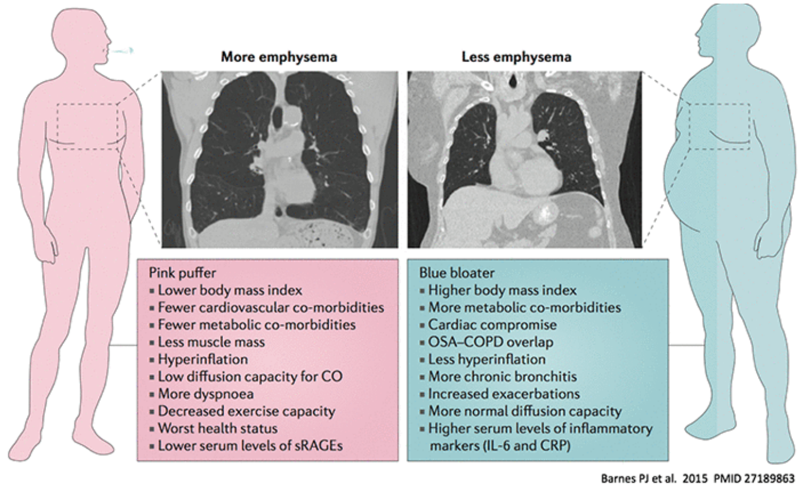

4) **Investigations**

* **Bedside**
  + CXR - hyperinflation, flat diaphragms, decreased pulmonary vascular markings and may see bullae
  + ECG - RAH and RVH
  + ABG - decreased PaO2 and may have hypercapnia
* **Lab**
  + FBC - increased RCC
* **Special tests**
  + CT - bronchial wall thickening and scarring amd air space enlargement
  + Spirometry - **USE TO DETERMINE GOLD CLASSIFICATION**
    - Obstructive picture w/ NO bronchodilator reversibility
    - Decreased FEV1 and FVC but the FEV1 is more decreased than the FVC
    - FEV1 is <80%
    - FEV1/FVC is <0.7
    - Increased TLC

**GOLD CLASSIFICATION**

* **GOLD 1** Mild FEV1 ≥ 80% of predicted
* **GOLD 2** Moderate 50% < FEV1 < 80% of predicted
* **GOLD 3** Severe 30% < FEV1 < 50% of predicted
* **GOLD 4** Very Severe FEV1 < 30% of predicted

5) **Management**

* **Lifestyle / Non-pharm**
  + Smoking cessation
  + Promote exercise and lowering of BMI if necessary
  + Learn pursed-lip breathing
* **Pharm**
  + NICE Guidelines:
    - Mucolytics - to help w/ sputum production
    - Diuretics - if signs of oedema
    - Flu and pneumococcal vaccinations
    - Home O2 - **WARNING**: be careful giving the blue bloaters too high O2 too fast (their resp drive is stimulated by CO2 so if you suddenly give too much O2 they may have a decreased resp drive)
* **If GOLD 1 - SABA**  
  **If GOLD 2 - SABA and LABA/LAMA**  
  **If GOLD 3 - SABA, LAMA and LABA**  
  **If GOLD 4 - above and inhaled steroid**

# 4. GIT

## 4.0 General GIT

|  |  |
| --- | --- |
| **History** |  |
| **Abdominal Pain** |  |
| Frequency/duration | Acute/chronic & frequency |
| Site & radiation | * Peritonism=focal * Radiates back: pancreatic ds/ penetrating peptic ulcer * Radiates shoulder: diaphragmatic irritation * Radiate throat: oesophageal reflux or spasm |
| Character & pattern | Colicky: bowel or ureter obstruction |
| Aggravating/relieving factors | * Occur after meals: peptic ulcerations * Eating: Ischaemic pain in gut (reduced blood supply to bowel d/t arterial ds) * Vomiting/antacids relieve: peptic ulcer or GORD * Rolling around offers relief: colicky pain from bowel obstruction * Laying still relief: peritonitis |
| **Patterns of Pain** |  |
| Peptic Ulcer ds | * Dull or burning epigastric pain * Relieved by food & antacids * Episodic |
| Pancreatic pain | * Steady epigastric pain * Relieved by sitting up & leaning forwards * Radiation to back * Vomiting is common |
| Biliary pain/Colic | * Rarely colicky, usually severe, constant pain that lasts for hours * Epigastric pain: obstruction of cystic duct * If cholecystitis develops, pain shifts to RUQ * Nausea & vomiting usually |
| Renal Colic | * Colicky pain in renal angle * Radiation to groin * Severe pain |
| Bowel obstruction | * Colicky, * periumbilical pain: small bowel * large-bowel: anywhere on abdomen |
| **Appetite & wt change** | * Anorexia = LOA + weight loss: malignancy, depression,… |

|  |  |  |
| --- | --- | --- |
| **Bleeding** | * **Haematemesis**: vomiting blood- proximal to, or, duodenum   + Peptic ulceration: often bleed without abdominal pain   + Mallory-Weiss tear= repeated vomiting |  |
|  | * **Melaena**: jet-black/tarry stools; upper GI and +/-right colon & small bowel lesions |
|  | * **Haematochezia**: bright-red blood per rectum; distal colon/rectum or major bleeding site higher in GI tract.   + Diverticular disease |
|  | * Spontaneous bleeding into skin/nose/mouth   + Coagulopathy from liver disease |
|  | |

**Abdominal Palpation**

Ask painful areas, keep for last and, patient bend knees relax abdominal muscles.

|  |  |
| --- | --- |
| Guarding | Abdominal contraction on palpation (tenderness or anxiety) |
| Rigidity | Constant involuntary reflex contraction of abdo: always ass. With tenderness & indicates peritoneal irritation or inflammation (peritonitis) |
| Rebound tenderness | Pain on release of palpation: peritonitis |

|  |  |
| --- | --- |
| **DESCRIPTIVE FEATURES OF INTRA-ABDOMINAL MASSES**  **MS-ASPECTS**  For any abdominal mass all the following should be determined:   * **S**ite: the region involved * **T**enderness * **S**ize (which must be measured) and shape * **S**urface, which may be regular or irregular * **E**dge, which may be regular or irregular * **C**onsistency, which may be hard or soft * **M**obility and movement with inspiration * Whether it is **p**ulsatile or not * Whether one can get **a**bove the mass | **SOME CAUSES OF ANTERIOR ABDOMINAL WALL MASSES**   * Lipoma * Sebaceous cyst * Dermal fibroma * Malignant deposits (e.g. melanoma, carcinoma) * Epigastric hernia * Umbilical or paraumbilical hernia (liver cirrhosis w/ ascites, obesity, multiple births) * Incisional hernia * Rectus sheath divarication (see Fig. 14.42) * Rectus sheath haematoma |

**Jaundice**

**Note**:

* urine and stool colour. Pale stools and dark urine = obstructive/cholestatic jaundice since urobilinogen is unable to reach the intestine.

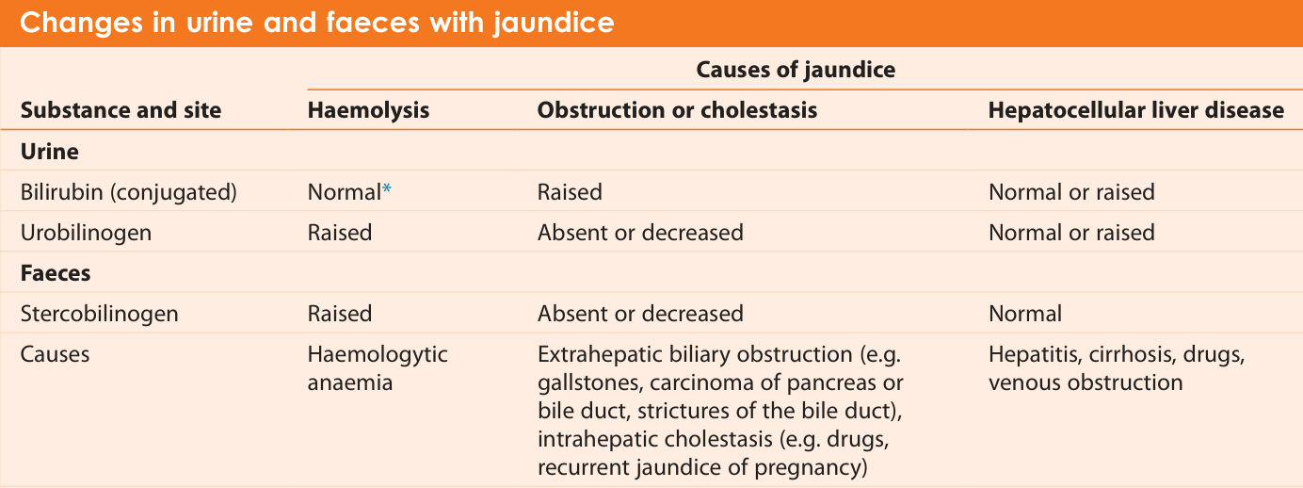 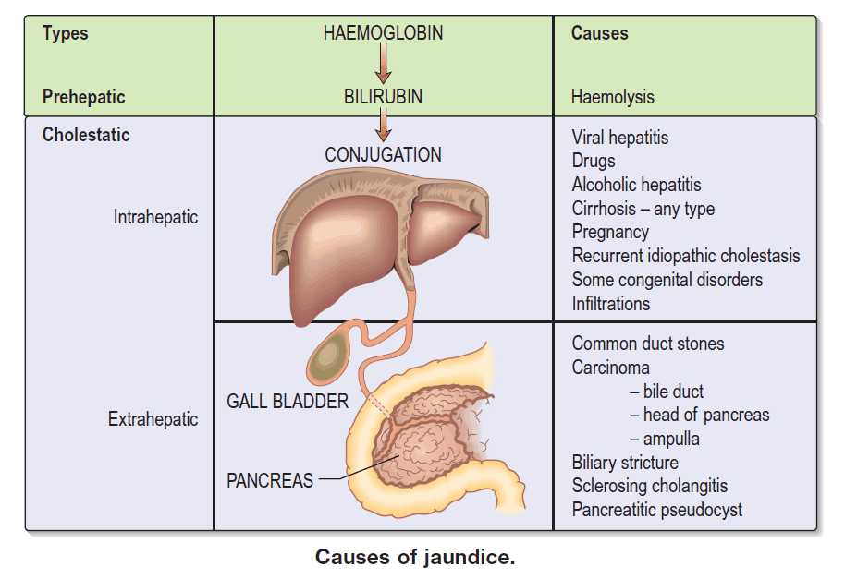

* Abdominal pain: gallstones = biliary pain + jaundice
* Pruritic: Cholestatic liver disease

### 4.0.1 Approach to Portal Hypertension

**Definition**

* Increase pressure gradient between portal vein and hepatic vein >5mmHg
  + 10mmHg - get complications
  + 12mmHg - start bleeding

**Signs**

* Splenomegaly
* Collateral veins: haematemesis (from oesophageal or gastric varices)
* Ascites

**Causes**

|  |  |  |
| --- | --- | --- |
| **Prehepatic**   * Portal vein thrombosis:   + Malignancy   + Coagulopathy   + Trauma   + Pancreatitis * Splenic vein thrombosis   Portal vein anatomy, function, embolization, thrombosis & hypertension | **Intrahepatic**   * **Pre-sinusoidal**:   + Bilharzia - ova deposited in space of Disse * **Sinusoidal**:   + Cirrhosis   + Alcohol   + Hepatitis   + NAFLD/NASH   + Autoimmune   + Wilson’s disease * **Post-sinusoidal**:   + Veno-occlusive disease     - Platinum-based chemotherapy | **Post-hepatic**   * Right-sided heart failure * Constrictive pericarditis * Obstruction of IVC:   + Tumour   + Thrombosis   + IVC webs   + Lymph node compression * IVC malformation * Budd-Chiari malformation |

### 4.0.2 Approach to Clubbing

|  |  |  |
| --- | --- | --- |
| **Common**  **CARDIOVASCULAR**   * Cyanotic congenital HD * Infective Endocarditis   **RESPIRATORY**   * Lung ca (not small cell ca) * Chronic pulmonary supp.   + Bronchiectasis   + Lung abscess   + Empyema * Idiopathic pulmonary fibrosis | **Uncommon**  **RESPIRATORY**   * Cystic fibrosis * Asbestosis * Pleural mesothelioma (benign fibrous type) or pleural fibroma   **GASTROINTESTINAL**   * Cirrhosis (especially biliary cirrhosis) * Inflammatory bowel disease * Coeliac disease   **THYROTOXICOSIS**  Familial (usually before puberty) or idiopathic | **Rare**   * Neurogenic diaphragmatic tumours * Pregnancy * Secondary parathyroidism   **UNILATERAL CLUBBING**   * Bronchial arteriovenous aneurysm * Axillary artery aneurysm |

### 4.0.3 Virchow’s Node (Left supraclavicular lymph node)

* Drains abdominal cavity. Cancer is painless, infection is painful
* Enlarged, hard painless Virchow’s node (Troisier’s sign): Gastric/pancreatic ca., ovarian ca, testicular, lung breast ca.
* Enlarged painful Virchow’s node: Infectious: TB, sarcoidosis, toxoplasmosis.
* Enlarged Virchow’s node & enlarged Sister-Mary-joseph Node simultaneous🡪 abdominal malignancy (gastric/pancreatic… etc.)

## 4.1 Ascites***

|  |  |  |  |  |  |  |  |  |  |  |  |  |  |  |  |
| --- | --- | --- | --- | --- | --- | --- | --- | --- | --- | --- | --- | --- | --- | --- | --- |
| Classified by SAAG (11g/L = 1.1g/dL). Excess fluid accumulation in peritoneal cavity  **Commonest cause**: portal hypertension, malignancy and heart failure  **History**   * Duration (acute, chronic, trauma) * Dyspnoea * Frothy urine (nephrotic syndrome) * Risk factors for liver disease:   + Alcohol intake, Diabetes   + Tattoos   + Intravenous drug use (IVDU)   + Medication (Acetaminophen)   + Toxins   + Family history * Other causes of oedema need to be ruled out:   + Cardiac, Cirrhosis, Hypoalbuminemia   **Exam**  Rule out specific reasons   * **General**:   + Features of chronic liver disease (pruritic/excoriations, hepatic flap, spider n.)   + Fetor hepaticus   + Asterixis   + Encephalopathy * **CVS** (Cardiovascular system) - rule out cardiac cause:   + Jugular venous pressure (JVP)   + Cardiomegaly   + S3 heart sound   + Murmur   + Pulmonary oedema (pink frothy sputum & coarse crackles) * **TB**:   + Retroviral disease (RVD) stigmata   + Lymphadenopathy (LAD)   + Respiratory signs of TB * **Constitutional symptoms/malignancy**:   + Wasting, fever, night sweats   + Mass   + Virchow’s node (Abdominal malignancy)   + Sister Mary Joseph node (malignant ca. pelvis/abdomen) | * **Nephrotic syndrome**:   + Anasarca, pitting oedema   + Periorbital & facial oedema * **Abdomen**:   + Distention   + Features of portal hypertension (varices, haemorrhoids, ascites) * **Ascites is present when**:   + Positive shifting dullness   + Fluid thrill   **Investigations**   * **Labs**:   + Full blood count (FBC)- inflamm. Markers (infx)   + Urea & electrolytes (U&E) - renal dysfunction (hepato-renal syndrome, nephrotic syndrome)   + C-reactive protein (CRP) – infection (serositis)   + Liver function tests (LFT) – cirrhosis (AST, ALT)   + SAAG: Albumin   + Cardiac: BNP and Troponin   + Blood culture (serositis)   + TB: workup   + Pancreatitis: Amylase and lipase * **Radiology**:   + Chest X-ray (CXR) - cardiomegaly   + Abdominal ultrasound (Abdo US) - confirm presence of ascites, exclude cirrhosis & malignancy   + CT scan - can confirm ascites, exclude other pathology * **Paracentesis**:   + In the left iliac fossa (LIF)   + Send fluid for cell count, albumin, & culture &     - GeneXpert (GXP)     - LDH, amylase, lipase     - Triglycerides (Tg) (chylous ascites)     - Bilirubin     - Cytology (if positive: peritoneal carcinomatosis; if negative: solid organ malignancy)     - Flow cytometry   + **Cell count >500 lymphocytes and >250/mm3 neutrophils: bacterial peritonitis**   + If cell count >1000: secondary cause of ascites | **Management** (Rx Na+, water restriction & diuretics)   * Treat underlying cause * **Supportive**:   + Bed rest: avoid (SNS) and (RAAS) activation (avoid NSAIDs, ACE-I🡪 renal impairment & ++BP)   + Fluid restriction and salt restriction     - If Na+ <130 mEq/L: 1–1.5 L/day     - If Na+ >130 mEq/L: cautious intake   + Nutritional support:     - Cirrhosis: watch protein intake     - Chylous ascites: high-protein, low-fat diet: Hepatic cirrhosis or lymphoma * **Specific**   + **Pharmaceutical**:     - Diuretics:       * Spironolactone **100**🡪400 mg o.d. (titrate up over 3 days)       * Furosemide (Lasix) **40**🡪160 mg IV (titrate up over 3 days)   + **Non-pharmaceutical**:     - **Therapeutic paracentesis**:       * 5L removed: albumin required (6–8 g/L of fluid drained)     - **Transjugular intrahepatic portosystemic shunt (TIPS)**       * Indications: refractory, diuretic-resistant, or diuretic-intolerant ascites     - **Liver transplant:** Refractory ascites  |  |  |  |  | | --- | --- | --- | --- | | **ASCITES** | | **SAAG** | | | **<1.1 g/dL (Non-Portal HTN)** | **>1.1g/dL (Portal HTN)** | | **Ascitic Total Protein** | **<2.5** **g/dL** (Pre & Intra hepatic) | Nephrotic syndrome,  Severe malnutrition | **Presinusoidal**: Splenic or Portal Vein thrombosis, schistosomiasis **Sinusoidal**: Cirrhosis  Hepatitis (alcoholic, acute), hepatic mets  **Ascitic Neutrophil >250🡪** spontaneousbacterial peritonitis | | **>2.5 g/dL** (Post-hepatic) | TB, Malignancy,  Pancreatitis Peritoneal carcinomatosis (e.g ovarian cancer) Serositis | **Post Sinusoidal**: RHF, Constrictive pericarditis, IVC obstruction,  Early Budd-Chiari syndrome = hepatic vein thrombosis |   **Grading**:   * **Grade 1: Mild**: only visible on U/S and CT * **Grade 2: Moderate**: flank bulging, shifting dullness * **Grade 3: Severe**: directly visible marked abdominal distension, Fluid thrill |

## 4.2 Hepatomegaly

|  |  |  |
| --- | --- | --- |
| **What is it?** A liver span of more than 13 cm.   * Distance below costal margin in MCL:   + **Mild**: 4-8 cm   + **Moderate**: 8-12 cm   + **Massive**: > 12 cm * **Massive**:   + Metastases - from colon, stomach, ovary, lungs   + Alcoholic liver disease with fatty infiltration   + Myeloproliferative disease   + Right heart failure - DCMO, TR, constrictive pericarditis   + Primary malignancy - hepatocellular cancer * **Moderate**:   + Above causes   + Haemochromatosis   + Haematological disease - chronic leukaemia, lymphoma   + Fatty liver - secondary to diabetes, obesity, toxins   + Infiltration - amyloid, sarcoid * **Mild**:   + Above causes   + Hepatitis   + Biliary obstruction   + Hydatid disease   + HIV | **Differential Diagnosis**   * **Firm and irregular liver**:   + Hepatocellular carcinoma   + Metastatic disease   + Cirrhosis   + Hydatid disease, granuloma (sarcoid), amyloid, cysts, lipidoses * **Tender liver**:   + Hepatitis   + Rapid liver enlargement - RHF, Budd-Chiari syndrome (hepatic vein thrombosis)   + Hepatocellular cancer   + Hepatic abscess   + Biliary obstruction cholangitis * **Pulsatile liver**:   + Tricuspid regurgitation   + Hepatocellular cancer   + Vascular abnormalities   **Causes of hepatosplenomegaly**   * Chronic liver disease with portal hypertension * **Haematological disease**:   + Myeloproliferative disease   + Lymphoma or leukaemia   + Pernicious anaemia   + Sickle cell anaemia * **Infection**:   + Acute viral hepatitis   + Infectious mononucleosis   + CMV * **Infiltration**:   + Amyloid or sarcoid * **Connective tissue disease**:   + SLE * Acromegaly * Thyrotoxicosis | **History Features**   * RUQ pain & distension * Fever - infective cause * Weight loss - malignant cause * Risk factors for liver disease:   + Significant alcohol consumption → cirrhosis   + Medications   + Multiple sexual partners   + Swimming in dams/rivers   **Exam Findings**   * Liver span > 13 cm * Dullness on percussion * Liver tenderness * Pulsatile liver * Irregular border * Stigmata of chronic liver disease (see below) * ↑ JVP - sign of right heart failure * +/- splenomegaly * +/- ascites   **Investigations**   * **Lab**:   + **LFTs**:     - Total bilirubin     - Serum albumin     - Serum aminotransferases - AST, ALT     - Ductal enzymes - ALP, GGT   + INR or prothrombin time   + Hepatitis serology * **Imaging**:   + Abdominal ultrasound   + CT Abdo   + MRI   **Management**   * Based on cause |

## 4.3 Splenomegaly

|  |  |  |
| --- | --- | --- |
| * **Mild** = <8 cm * **Moderate** = 8-12 cm * **Severe** = >12 cm or crosses the midline   2) **Causes** (*cause a MASSIVE splenomegaly - >12 cm or crosses the midline*)   * **Congestive**:   + Cirrhosis   + Heart failure   + Thrombosis of portal/hepatic/splenic veins   + Portal HPT * **Malignancy/Non-Benign Lesion**:   + Lymphoma   + CML/CLL   + Myelofibrosis   + Primary splenic tumours   + Secondary metastatic tumours * **Infection**:   + Viral - Hepatitis + EBV (mononucleosis) + CMV   + Bacterial - TB + Salmonella   + Parasitic - **Malaria** + Schistosomiasis   + IE * **Inflammation**:   + Sarcoid   + SLE   + RA (Felty syndrome) * **Infiltrative (benign)**:   + Amyloid   + Gaucher's * **Haematological**:   + Sickle cell disease   + Thalassaemia   **Massive**   * Common   + CML, CLL   + Idiopathic myelofibrosis * Rare   + Malaria   + Primary lymphoma of spleen | **Moderate**   * Portal hypertension * NHL * Leukaemia (acute or chronic) * Thalassaemia * Storage diseases, eg. Gaucher’s disease   **Mild**   * Other myeloproliferative causes   + Polycythaemia rubra vera   + Essential thrombocythemia * Haemolytic anaemia * Megaloblastic anaemia * Infection   + Viral     - EBV     - Hepatitis   + Bac 🡪 Infective endocarditis   + Malaria * Connective tissue diseases   + Rheumatoid arthritis   + Systemic lupus erythematosus   + Polyarteritis nodosa * Infiltration   + Amyloid   + Sarcoid   3) **History**   * Early satiety * Abdominal distension * Pain w/ +ve referral to the chest or left shoulder * Hx of recent pharyngitis - think of EBV as cause * +ve Constitutional symptoms - think of NBL cause * Significant alcohol intake - think of cirrhosis and portal hypertension | 4) **Exam**   * Fever - think of NBL * Splenic tenderness - think of splenic infarction or rupture * Ascites or peripheral oedema - think of possible cirrhosis or vascular obstruction * **ENSURE TO DIFF SPLEEN FROM KIDNEY**:   + Can't get above a spleen   + Spleen dull to percussion (esp in Traube's space)   + W/ inspiration a spleen will move towards the RIF   + +/- Palpable notch on medial side of the spleen   5) **Investigations**   * **FBC and Smear**   + Immature WCC - Myeloproliferative disorder   + Cytopaenia - Hypersplenism   + Tear drop cells - Myelofibrosis or Thalassemia   + Spherocytes - hereditary spherocytosis   + Sickles - SCD   + Malaria parasites on smear * **Other**:   + Blood cultures   + LFTs to confirm liver disease   + Hepatitis studies   + HIV testing if no other explanation fits   + BMAT (especially if there is a leukocytosis, abn lymphocytes or left shift of WCC, or is there is a thrombocytosis or erythrocytosis)   + LN biopsy is ass LAD   + POCUS w/ dopplers if suspecting a venous thromboembolism affecting hepatic or splenic circulation (+ve ascites/ peripheral oedema)   6) **Management**   * Treat the underlying cause   7) **Note**   * The following encapsulated organisms can cause a splenomegaly but cause hyposplenism and thus decreased functioning:   + S. Pneumonia   + N. Meningitides   + H. Influenza B   + S. Typhi |

|  |  |  |  |  |  |  |  |  |
| --- | --- | --- | --- | --- | --- | --- | --- | --- |
| **Exam 🡪 spleen**   * Size, Surface, Consistency, Tender * Notch * Rub 🡪 splenic infarct   **DDx: 🡪 splenomegaly (massive)**   * Myeloproliferative   + CML   + Polycythaemia vera   + Primary myelofibrosis   + Essential thrombocytopenia * Lymphoproliferative   + Hodgkin   + Non-Hodgkin (diffuse large B cell)   + CLL * Infective   + HIV +TB   + schistosomiasis (bilharzia)   + Chronic malaria (tropical splenomegaly syndrome)   **How to know its spleen**   * Correct anatomical position * Enlarges inferior-oblique * Moves with reparation * Dull to percussion * Feel notch * Cannot get above it   **Spleen span class**   * Mild 🡪 0-4cm * Mod. 🡪 4-8cm * Mod-massive 🡪 8-12cm * Massive 🡪 >12cm / past umbilicus   **Small spleen**   * Acute malaria * Viral infections | **Hepatomegaly**   |  |  |  | | --- | --- | --- | | **Massive**   * Metastases (colon stomach, ovary lungs) * Alcoholic liver disease w/ fatty infiltration * Myeloproliferative ds * RHF-DCMO,TR, constrictive peric. * HCC | **Moderate**   * Haemochromatosis * Haematological disease (e.g. CLL, lymphoma) * Fatty liver (secondary to diabetes mellitus, obesity, toxins) * Infiltration: amyloid, sarcoid | **Mild**   * Hepatitis * Biliary obstruction * Hydatid ds. * HIV |  |  |  |  | | --- | --- | --- | | **Firm & irregular liver**   * HCC * Metastatic ds. * Cirrhosis * Hydatid ds., granuloma (e.g. sarcoid), amyloid, cysts | **Tender liver**   * Hepatitis * Rapid liver enlargement (e.g. **RHF**, Budd–Chiari* syndrome [hepatic vein thrombosis]) * HCC * Hepatic abscess * Biliary obstruction cholangitis | **Pulsatile liver**   * Tricuspid regurgitation * HCC * Vascular abnormalities | | **Hepatosplenomegaly**   * **Chronic liver disease** w/ portal hypertension * Haematological disease (e.g.   + Myeloproliferative disease,   + lymphoma,   + leukaemia,   + pernicious anaemia,   + sickle cell anaemia * Infection   + acute viral hepatitis,   + EBV, CMV   + TB, Infective Endocarditis   + Schistosomiasis * **Infiltration** (e.g. amyloid, sarcoid) * Connective tissue disease   + SLE * Acromegaly * Thyrotoxicosis |

## 4.4 Jaundice

|  |  |  |  |
| --- | --- | --- | --- |
| **Unconjugated Hyperbilirubinaemia**   * Water insoluble * Does not enter urine   **Causes**:   * **Overproduction**:   + Hemolysis   + Ineffective erythropoiesis * **Impaired hepatic uptake**:   + Drugs - rifampicin and paracetamol   + Ischemic hepatitis * **Impaired conjugation**:   + **Gilbert’s**:     - Benign     - Decreased UGT-1 activity     - 5-15% of the population     - Positive family history     - Presents in adolescence     - Intermittent jaundice during illness, exercise, fasting     - Mild raised bilirubin, normal FBC, normal reticulocytes   + **Crigler Najar**:     - Present on the first day of life     - Jaundice and CNS signs     - Mutation in the UGT enzyme causing absent (Type 1) or impaired (Type 2) function     - **Treatment**:       * Phototherapy       * Plasmapheresis       * Liver transplant       * Type 2 doesn’t need any treatment   + Physiological NN-jaundice | **Conjugated Hyperbilirubinaemia**   * Water soluble * Excreted in the urine - making it dark * Less conjugated bilirubin enters the stool - acholic stools * Pruritus * **Causes**:  |  |  | | --- | --- | | * **Hepatocellular dysfunction**:   + Viruses - hepatitis, EBV   + Syphilis   + Drugs   + Alcohol   + Cirrhosis   + Liver mets   + Liver abscess   + Hemochromatosis   + Autoimmune hepatitis   + Alpha 1 antitrypsin   + Budd-Chiari   + Wilson's   + **Dubin Johnson syndrome**:     - Defective hepatocyte excretion     - Presents in adolescents with intermittent jaundice and hepatosplenomegaly     - Raised bili, AST/ALT normal     - Bilirubin on dipstick     - Liver biopsy - pigment granules     - No treatment needed   + **Rotor syndrome**:     - Benign     - AR     - Normal hepatic histology     - Presents in childhood with jaundice and cholescintigraphy reveals an “absent” liver | * **Right heart failure** * **Toxins** * **Cholestasis**:   + Primary biliary cholangitis   + Primary sclerosing cholangitis   + Drugs   + Gallstones   + Pancreatic cancer   + Compression of bile duct - LN, cholangiosarcoma, choledochal cyst, Caroli’s disease, Mirizzi syndrome | |

|  |  |  |
| --- | --- | --- |
| **Definition**  Yellowing of the eyes and skin due to raised bilirubin levels (> 60 micromoles/l)  **Classified in 2 ways**:   * According to the site of the problem:   + Prehepatic, Intrahepatic, Obstructive * Type of bilirubin:   + Conjugated, Unconjugated   **History**   * Blood transfusions * IVDU * Body piercings * Tattoos * Sexual activity * Travel * Jaundiced contacts * Family history * Alcohol use * Medications * Pale stools * Dark urine * LOW, LOA * Symptoms related to the underlying cause | **Exam**   * Signs of chronic liver disease * Hepatic encephalopathy * LAD * Hepatosplenomegaly * Ascites * Palpable gallbladder   **Investigations**   * **Urine**:   + Bilirubin is absent in prehepatic causes   + Obstructive causes - urobilin is absent * **Bloods**:   + FBC, reticulocytes, smear   + U and E   + INR   + Coombs test   + Malaria parasites   + LFT   + Total protein   + Albumin   + Paracetamol levels   + Blood cultures   + Hepatitis serology | * **Radiology**:   + **US** - if bile ducts dilated → surgical cause     - Look for gallstones, hepatic mets, pancreatic mass   + **ERCP** - if bile dilated and LFT not improving   + **MRCP**   + **CT/MRI**   + Liver biopsy   **Treatment**   * Treat the cause * **Supportive**:   + Hydration   + Broad spectrum antibiotics if there is an obstruction   + Monitor for ascites, encephalopathy * Refer |

## 

## 4.5 Acute Liver Failure (fulminant liver failure)

|  |  |  |  |  |  |  |  |  |  |  |  |  |
| --- | --- | --- | --- | --- | --- | --- | --- | --- | --- | --- | --- | --- |
| **ACUTE LIVER FAILURE (Fulminant Liver Failure)**  **Definitions**   * Development of a severely acute impaired liver synthetic dysfunction in a patient w/o pre-existing liver damage or cirrhosis causing:   + **JAUNDICE**   + **COAGULOPATHY**: INR > 1.5   + **ENCEPHALOPATHY**: Altered mental status * **Hyper Acute**: <7d * **Acute**: 8-21d   **Approach to Causes**   * **Infection**:   + Hepatitis A, B, C & D   + Herpes   + CMV * **Infiltrative**:   + Malignancy   + Haemochromatosis   + Wilson's * **Vascular**:   + Budd-Chiari   + Veno-occlusive disease   + Ischemia * **Lifestyle**:   + Alcohol   + Fatty liver of pregnancy (causes HELLP syndrome) * **Toxin**:   + Aflatoxins   + **Drugs**:     - Paracetamol     - TB meds (RH) | **History**   * Jaundice, Confusion * Depends on the cause of acute liver failure, so ask about:   + Alcohol intake   + Drug intake   + Chronic meds   + Paracetamol OD   + Flu-like symptoms (precedes Hepatitis infection)   + Immunisation status for hepatitis   **Exam**   * **Encephalopathy** (caused by cerebral oedema)  |  |  | | --- | --- | | Hepatic encephalopathy type | Manifestations | | I | Changes in behavior, mild confusion, slurred speech, disordered sleep | | II | Lethargy, moderate confusion | | III | Marked confusion (stupor), incoherent speech, sleeping but arousable | | IV | Coma, unresponsive to pain |  * Jaundice * Fetor hepaticus (evidently it smells like pear??) * Asterixis * RUQ Pain * +/- Hepatomegaly * Bruising * Brisk reflexes | **Investigations**   * **Blood**:   + FBC and CRP - rule out infectious cause   + U+E - urea made in liver   + LFT (synthetic functioning) - INR, Albumin, and Bilirubin levels   + Parenchymal and Ductal enzyme levels   + Paracetamol levels   + Hep studies   + Culture * **Special investigations**:   POCUS w/ dopplers to assess for Budd-Chiari  **Management**   * ABCs and close monitoring of all vitals * Supportive - catheter and protect airway * Treat the underlying cause * Prevent or treat complications:   + Cerebral oedema - IV mannitol   + Ascites - fluid restrict and weight monitoring and diuretics   + Bleeding - vit K   + Infection - IV Ceftriaxone   + Low glucose - monitor and give dextrose if necessary   + Encephalopathy - avoid sedatives + correct any electrolyte imbalances   + Hepatorenal syndrome (cirrhosis + ascites + renal failure) * Consider liver transplantation according to the King’s College criteria   **Criteria for Acetaminophen and Non-acetaminophen acute liver failure requiring liver transplantation**:   * **Acetaminophen**:   + pH < 7.3 or   + PT >100s (INR > 6.5)   + Creatinine > 300 mmol/l with grade 3 or 4 encephalopathy * **Non-acetaminophen**:   + INR > 6.5 or any 3 of the following:     - Age < 10 or > 40     - Aetiology: non-A, non-B hepatitis, drug reaction, Wilson disease     - PT > 50s (INR > 3.5)     - Bilirubin > 300 micromol |

## 

## 4.6 Chronic Liver Disease (Cirrhosis)

|  |  |  |
| --- | --- | --- |
| **Signs and Symptoms**   * Leukonychia - from hypoalbuminemia * Terry’s nail - white proximally but distal ¼ is red * Clubbing, Palmar erythema, Jaundice, Asterixis * Fetor hepaticus * Constructional apraxia - can’t draw 5 pointed star, subtract 7 from 100, register and recall an object, draw clock face, draw interlinking squares * Dupuytren’s contractures, Spider naevi * Xanthelasma. Gynecomastia * Testicular atrophy * Loss of body hair, Excoriations * Parotid enlargement. Hepatomegaly initially with cirrhotic liver later * Ascites, Portal hypertension   **Portal hypertension signs**   * Ascites   + Decrease Capillary Oncotic Pressure   + Increase Capillary Hydrostatic Pressure   + Activation of RAAS - fluid accumulates in splanchnic vessels → dec. blood flow to the kidney * Splenomegaly * Varices +/- bleeds * Caput medusa   **Decompensated liver failure signs**   * Coagulopathy/hematemesis/melena * Encephalopathy * Oedema * Sepsis * Spontaneous bacterial peritonitis * Severe hypoglycemia not responding to treatment | **Precipitants for decompensation**   * Alcohol binge * Infections - hepatitis, SBP * TIPS, Surgery * Dehydration * Upper GI bleed * Hypokalaemia: Kidney retains K in exchange for H → cause ammonia production * Constipation * Rifampicin   **Investigations**   * **Bloods**:   + FBC with diff:     - Anaemia due to bleeds     - WCC raised if infection     - Decreased WCC and platelets in hypersplenism   + LFT: Raised AST, ALT, ALP, and GGT   + Raised bilirubin   + INR elevated   + Low albumin   + Glucose   + Blood and urine culture   + Find the cause:     - Iron studies     - Hepatitis studies     - AFB     - Ceruloplasmin if < 40 years     - Alpha 1 antitrypsin * **Radiology**:   + CXR   + Liver US   + MRI * **Ascitic tap**:   + Send for MC&S, cell count (neutrophils>250) * **Liver biopsy** - confirm the diagnosis | **Differential diagnosis**   * Malignancy * Budd-Chiari * Constrictive pericarditis * Portal vein thrombosis * Splenic vein thrombosis   **Management**   * **General**:   + Good nutrition   + Alcohol abstinence   + Avoid NSAIDs, sedatives, and opioids   + Cholestyramine to help with pruritus   + US and alpha 1 antitrypsin every 6 months to screen for HCC   + Monitor glucose and vitals   + Treat seizures with phenytoin * **Ascites**:   + Fluid and salt restriction   + Good nutrition   + Diuretics:     - Spironolactone 100 mg - 400 mg PO OD     - Lasix 40-160 mg PO OD   + Chart daily weight:     - If only ascites - 0.5 kg lost per day     - If ascites and pedal oedema - 1 kg lost per day   + **Large volume paracentesis**:     - Drain > 5 kg     - Give albumin at the same time to maintain COP (6-8g/litre drained)     - Complications - post paracentesis circulatory dysfunction (hypotension and tachycardia)   + **TIPS** - transjugular intrahepatic portosystemic shunts   + **Transplant** * **Spontaneous Bacterial Peritonitis**:   + Ceftriaxone 1g BD 7/7   + Or 3rd gen ceph OR piperacillin tazobactam   + Prevent with norfloxacin if have a recurrent episode   + Neutrophils > 250, WCC > 500 and/or GNB - E. coli, klebsiella * **Encephalopathy**:   + Lactulose and rifaximin   + Nutrition   + Vit B12 supplements |

## 

## 4.7 Hepatocellular Carcinoma

|  |  |  |
| --- | --- | --- |
| **Aetiology (ask about these on history)**   * Hepatitis B virus (++) * Hepatitis C virus * Cirrhosis (secondary to hepatitis, alcoholic liver disease, non-alcoholic fatty liver disease, hemochromatosis) * Aflatoxin (fungus found in maize) * Anabolic steroid use * Oral contraceptive pill (OCP) (weak association)   **Symptoms (rapid development of these features in a cirrhotic patient is highly suggestive of HCC)**   * Unintended weight loss * Anorexia/reduced appetite * Fever * Fatigue * Right upper quadrant pain * Abdominal swelling * Symptoms of chronic liver disease (e.g. jaundice, bruising, testicular atrophy, gynecomastia, amenorrhoea, impotence, distended abdominal veins) * Symptoms of complicated liver disease, i.e. varices (e.g. haematemesis, rectal bleeding) or hepatic encephalopathy (altered mental status)   **Signs on examination**   * Jaundice * Abdominal distension * Hepatomegaly – tender, irregular liver border +- hepatic bruit * Ascites * Wasting * Signs of chronic liver disease (e.g. Dupuytren's contractures, axillary hair loss, alopecia, gynecomastia, caput medusae, spider naevi, palmar erythema, splenomegaly, testicular atrophy, asterixis) | **Investigations**   * FBC (may see one or more cytopenias; anemia, leukopenia, thrombocytopenia) * LFTs: albumin, bilirubin, INR/PTT * Liver enzymes: AST/ALT; ALP/GGT * U&E * Serum alpha-fetoprotein (raised in ~60% of HCCs), especially if >400 or progressively rising. Also useful for monitoring disease response to treatment. * US – showing focal liver lesions as small as 2-3 cm +- features of portal vein involvement and features of coexistent cirrhosis. * Contrast-enhanced CT scan (+- MRI for very small lesions <1-2 cm) is diagnostic. * Liver biopsy, especially in large tumors where patients do not have typical risk factors (e.g. cirrhosis/Hep B). Helps exclude metastatic tumors but increases the risk of seeding along the biopsy tract (thus do not use in liver transplant or surgical resection candidates).   **Management**   * **Surgical**: Treatment of choice for non-cirrhotic patients with small tumors (<3 cm) and good liver function (Child-Pugh A). * **Liver transplantation**: Can be curative in patients with a small primary tumor (depending on eligibility in a very resource-constrained setting). * **Percutaneous ablation or Transarterial chemoembolization (TACE)** with absorbable gelatin powder and doxorubicin (in decompensated cirrhosis). * **Antiangiogenic chemotherapy** (e.g. sorafenib (multikinase inhibitor against RAF, VEGF, and PDGF)) for advanced disease. | **Prevention of HCC**   * HBV vaccination * Reduce needle sharing * Screen blood * Reduce aflatoxin exposure (sun-dry maize) * For those at high risk (e.g. with cirrhosis or chronic HBV) – 6-monthly AFP and ultrasound screening.   **Differentials for a liver mass**   * **Benign solid tumors**: Liver adenoma, hemangioma (most common liver tumors), fibroma * **Malignant tumour’s**: HCC, cholangiocarcinoma, angiosarcoma, hepatoblastoma, fibrosarcoma, hepatic GIST * **Metastatic liver tumors**: From stomach, lung, breast, or colon cancer * **Cystic lesions**: Cystadenoma, cystadenocarcinoma, hydatid cyst, polycystic liver disease * **Pyogenic lesion**: Bacterial abscess or *Entamoeba histolytica* abscess |

## 4.8 Crohn’s Disease

**Definition**

* IBD can affect any part of GI tract, affinity for terminal ileum & ascending colon. i.e. ileocolonic disease (vs UC which affects only the colon).
* May involve multiple, differentiated parts of the gut, i.e. skip lesions through to the entire colon (total colitis).
* Associated with the development of perianal fistulae and fissures.
* Aetiology: genetic susceptibility, environment (smoking, NSAIDs, poor hygiene, chronic stress), intestinal microbiota (dysbiosis + increased E. coli)
* Disease course is recurrent +- progression from inflammatory to structuring and penetrating disease.

|  |  |  |
| --- | --- | --- |
| **Demographics**  Typically >60y, <25y  **Presentation**   * Diarrhoea +- bleeding * Abdominal pain * Weight loss * +- Constitutional sx: malaise, anorexia, nausea, vomiting, low grade fever * Anal/ perianal disease   + May be complicated by enteric fistulae e.g. with bladder, vagina, abdominal wall. * +- extraintestinal manifestations:   + Eyes: uveitis, episcleritis, conjunctivitis   + Joints: arthralgia, inflammatory back pain, ankylosing spondylitis   + Skin: erythema nodosum, pyoderma gangrenosum   + Liver: fatty liver, chronic hepatitis, cirrhosis, gallstones   + Urinary tract: nephrolithiasis   **Examination findings** (few signs usually)   * +- chronic wasting * Pallor from anaemia * Aphthous ulceration of the mouth * Abdominal tenderness * +- RIF mass (from inflamed loops of bowel matted or abscess or psoas muscle irritation) * Always examine anus for: oedematous anal tags, fissures or perianal abscesses * +- DRE for blood. * Look for extraintestinal manifestations | **Differential diagnosis**   * Acute: rule out small bowel obstruction (symptoms can mimic appendicitis) * Infective gastroenteritis * Ulcerative colitis * Ileocolonic TB * Lymphomas involving ileum and caecum (rare in this patient group)   **Investigations**   * **Blood tests**   + FBC (normochromic, normocytic anemia; megaloblastic anemia if ileal involvement)   + CRP, ESR   + LFT (hypoalbuminaemia as acute phase response to inflammation and deranged LFTs)   + +- Blood cultures (if septicemia suspected)   + ASCA * **Stool tests**   + Stool cultures (C. difficile toxin assay, microscopy for parasites)   + Faecal calprotectin (useful for disease monitoring in IBD)   + Faecal lactoferrin * **Endoscopy**   + Colonoscopy + 2 biopsies in 5 areas (incl. rectum and terminal ileum)   + Upper GI endoscopy determine inform prognosis * **Imaging**   + Small bowel US   + Barium with follow through   + CT with oral contrast (asymmetrical alteration in the mucosal pattern with deep ulceration + areas of narrowing or structuring; but ds commonly confined to terminal ileum)   + Capsule endoscopy if radiological exams appear normal | **Medical management**   * Induction of remission with **glucocorticosteroids**:   + In moderate to severe attacks – oral prednisolone 30-60 mg/day   + Ileocaecal disease can be treated with controlled release steroids e.g. budesonide * For secondary complications of CD, antibiotics (ciprofloxacin or metronidazole) can be used * +- exclusive enteral nutrition for severe attacks of CD * **Maintenance of remission** (+- induction of remission in refractory disease):   + **Immunosuppressant** e.g. azathioprine/ methotrexate/ mercaptopurine   + + **Anti-TNF antibodies** e.g. infliximab, adalimumab * **General measures**:   + Stop smoking   + Treat anaemia (d/t vit B12 or iron deficiency) orally (or IV if oral treatment is not tolerated)   + Dietician consult to help manage nutrition   + For inpatients: prophylaxis for thromboembolism   **Surgical management**   * Indications: failed medical therapy, complication (strictures with obstruction, perforation, enterocutaneous fistula), growth failure in children, perianal sepsis * Options: resection of affected bowel, subtotal colectomy + ileocecal anastomosis or panproctocolectomy with end ileostomy |

# 

# 5. Rheumatology

## 5.1 Rheumatoid Arthritis

|  |  |  |
| --- | --- | --- |
| A chronic systemic inflammatory disease of unknown aetiology that characteristically involves the joints.  **History Features**   * Symmetrical soft tissue swelling of small joints - hands, feet, wrist, elbow, ankles * Flexion and hyperextension abnormalities of fingers * Pain * Erythema * Stiffness * Rheumatoid nodules on extensor surfaces around joints   **Exam Findings**  **General appearance**:   * Look for cushingoid appearance from prolonged steroid treatment * Weight loss - sign of active disease * Rheumatoid nodules on extensor surfaces   **Hands**:   * Symmetrical joint synovitis * Ulnar deviation of fingers * Radial deviation of wrist * Volar subluxation of MCP joints * Z deformity of thumb = hyperextension of the PIP joint, fixed flexion and subluxation of the MCP joint * Swan neck deformity of fingers = PIP hyperextension and DIP flexion * Boutonniere deformities of fingers = flexion of PIP and hyperextension at DIP * Splinter-like vasculitic changes of fingernails * Wasting of thenar muscles - "bow stringing" * Palmar erythema * Palmar tendon crepitus * Ulnar nerve palsy - from ulnar nerve entrapment at the elbow * Carpal tunnel (median nerve palsy) | **Wrists**:   * Synovial thickening of wrist * Phalen's sign - pain when pressing back of hands together (wrist flexion) with fingers facing down = c-tunnel syndrome   **Parotids**:   * Enlarged parotid gland - Sjogren’s syndrome   **Mouth**:   * Dryness & dental caries - Sjogren's syndrome * Ulcers - from drug treatment (methotrexate)   **Temporomandibular joints**:   * Crepitus as open and close mouth   **Neck**:   * Examine cervical spine for tenderness, muscle spasm and reduction of rotational movement * Cervical lymphadenopathy   **Chest**:   * Signs of pleural effusion - stony dullness, reduced/absent breath sounds, bronchial breathing/crackles above fluid level * Signs of pulmonary fibrosis - fine bibasilar inspiratory crackles * Caplan's syndrome = presence of rheumatoid lung nodules with pneumoconiosis   **Heart**:   * Pericardial rub * Murmurs indicating valvular regurgitation - nodular involvement of heart valves   **Abdomen**:   * Splenomegaly - Felty’s syndrome * Hepatomegaly   **Eyes**:   * Redness/dryness = Sjogren's syndrome * Nodular scleritis (elevated white or purple-red lesion) surrounded by intense redness of injected sclera * Scleromalacia = scleral thinning exposing underlying choroid * Cataracts - from steroid treatment * Conjunctival pallor - anaemia due to iron deficiency | **Lower limbs**:   * Limitation of joint movement * Knees more affected - note quadricep wasting, synovial effusions and flexion contractures * Valgus deformity * Ligamentous instability * Baker's cysts in popliteal fossa * Ulceration on lower aspect - vasculitic complication of Felty’s syndrome * Peripheral neuropathy - glove and stocking distribution * Mononeuritis multiplex   Signs of spinal cord compression - anterior dislocation of first vertebra or vertical subluxation of the odontoid process  **Ankles & feet**:   * Foot drop - peroneal nerve entrapment or vasculitis * Ankle joint limitation of movement * Metatarsophalangeal joints for swelling and subluxation * Lateral deviation and clawing of the toes * Achilles tendon for nodules   **Lower limbs**:   * Limitation of joint movement * Knees more affected - note quadricep wasting, synovial effusions, and flexion contractures * Valgus deformity * Ligamentous instability * Baker’s cysts in popliteal fossa * Ulceration on lower aspect - vasculitic complication of Felty’s syndrome * Peripheral neuropathy - glove and stocking distribution * Mononeuritis multiplex * Signs of spinal cord compression - anterior dislocation of first vertebra or vertical subluxation of the odontoid process   **MSK exam** for each joint with look, feel, move - active and passive movement, and special tests. |

|  |  |  |
| --- | --- | --- |
| **Assessment of disease activity**:   * NB to assess adequacy of treatment * Includes duration of morning stiffness, joint pain and tenderness, fatigue, soft tissue swelling, and the presence of extra-articular manifestation * **Criteria**:   + Tender joint count   + Swollen joint count   + Patient global score   + ESR/CRP * **Score**:   + Remission = < 2.8   + Low disease activity = 2.0 - 10   + Moderate disease activity = 10.1 - 22   + High disease activity = > 22 * In OSCE - can just eyeball based on history and examination findings   A diagram of the human body  Description automatically generated | **Differential Diagnosis**:   * Rheumatoid arthritis * Polymyalgia rheumatica * Sjogren's syndrome * Fibromyalgia * SLE * Reactive arthritis * Gout   **Criteria**    **Investigations**   * **Beside**:   + Urine dipstick - if worried about an associated glomerulonephritis   + ECG - if worried about an associated pericarditis * **Lab**:   + FBC + diff - check Hb if concerned about anaemia, differential to check WCC for an infection   + U&E - check for any electrolyte abnormalities   + CRP - part of criteria if initial diagnosis, otherwise checking for associated infections   + RF - part of criteria for initial diagnosis * **Imaging**:   + CXR - associated infections, pericarditis, etc.   + Specific joint x-ray - if the patient needs a joint replacement | **Management**   * **Lifestyle modification**:   + Smoking cessation   + Low load-bearing exercise   + Healthy diet = healthy weight * **Pharmacological**:   + NSAIDs, corticosteroids, immunosuppressive/immunomodulatory drugs (DMARDs)   + **1st line**:     - Methotrexate, sulfasalazine, chloroquine   + **2nd line**:     - Gold salts, penicillamine (high toxicity)     - Adjuncts: azathioprine, leflunomide, cyclosporine, cyclophosphamide   + **Monoclonal antibodies**:     - Anti-TNF - infliximab, adalimumab, etanercept     - Rituximab (anti-CD20)   + Biologics - injections every 6 months, 2 weeks apart * **Surgical**:   + Joint replacement if severe deformity and loss of function   **Complications**   * **Localised to the joint**:   + Severe deformity, loss of movement and function * **Systemic involvement**:   + Vasculitis, secondary ischaemia, nail bed changes, cutaneous ulceration, gangrene   + Amyloid deposition - heart, valves, myocardium, lungs, spleen   + GI bleeding   + Infections - prolonged steroid use and immunosuppression |

## 5.2 Systemic Lupus Erythematosus

|  |  |  |
| --- | --- | --- |
| **1. Definition**   * SLE is a chronic autoimmune disease that can affect multiple organ systems. * Due to the production of so many ab & the lack of their clearance, it results in multi-system damage. * EULAR/ACR Criteria for diagnosis.   **2. History**   * Constitutional symptoms. * Rashes predominant in sun-exposed regions. * Painless oral/nasal ulcers. * Raynaud’s phenomenon - changing colors of fingers and toes with white tips. * Patchy hair loss. * Joint pain and swelling (may be symmetrical). * Chest pain (if pericarditis). * LL (lower limb) oedema. * Neuropsych symptoms of seizures or psychosis. * Recurrent miscarriages.   + APLS screen: Lupus anticoagulant, anticardiolipin, anti-B2-glycoprotein + anti-B2-antibodies.   **3. Exam**  These are relapsing and remitting features; there are SO many, so I put a pneumonic (MD SOAP BRAIN) on core things to look out for and then a few others:   * Malar rash. * Discoid rash (usually more on extensor surfaces) - NB look in ears. * Serositis (pericardial + pleural effusions). * Oral + genital ulcers. * Antibodies (ANA, Anti-Smith, Anti-dsDNA, Anti-Ro + Anti-La). * Photosensitivity - rashes in sun-exposed areas - face and shawl sign. * Blood (anaemia, thrombosis + vasculitis). * Renal (haematuria, HPT + Lupus Nephritis). * Arthritis (Symmetrical + incl Jaccoud’s arthritis + Myalgias). * Immune system suppressed. * Neurological (H/a, depression, seizures + psychosis). | * **Other**:   + SICCA symptoms - Dry eyes, mouth, and vagina.   + SJS with mucosal involvement.   + Libman-Sachs (non-bacterial endocarditis).   + Raynaud’s.   + Myocarditis.   + Mitral valve prolapse.   **4. Investigations**   * Rule out other possible causes for presenting issues. * Dx according to above criteria. * **Antibody testing**:   + ANA (++sensitive but not as specific).   + Anti-Smith.   + Anti-dsDNA.   + Anti-Ro.   + Anti-La. * **Monitor for complications**:   + CXR - effusions.   + Renal sonar.   + Echo.   + U+E. * **Monitor treatment response**:   + Anti-dsDNA.   + C3+C4 (decrease with time).   + ESR (NOT CRP).   + Antiphospholipid.   **5. Major complications**   * Lupus nephritis inducing nephrotic syndrome. * AKI. * Pleural and pericardial effusions. * Accelerated HPT. * High risk of TB.   **6. Management**   * MDT. * Counselling to look out for flares and when to come in. * Sunblock and avoid UV light - Skin. * Topical and systemic steroids (prednisone). * IV Cyclophosphamide (x6 cycles) - lupus nephritis. | * **Chloroquine**:   + For maintenance because not a severe immunosuppressant.   + Keeps lupus stable.   + Less A/E than systemic steroids.   + A/E: Bull's eye maculopathy. * **For acute/severe flares**:   + **Skin + Joints** = Methotrexate.   + **Skin + Joints + Blood** = Azathioprine.   + **Skin + Joints + Heart + Lungs + Renal** = MMF (mycophenolate mofetil).   A close-up of a survey  Description automatically generated |

## 5.3 Gout

|  |  |  |
| --- | --- | --- |
| **DEFINITION**   * Acute crystal monoarthropathy with severe joint inflammation. * Secondary to a derangement in purine metabolism causing hyperuricaemia and deposition of monosodium urate crystals in and near joints. * Metatarsal joint of the big toe is affected in > 50% of cases (podagra). * Other common joints: ankle, foot, small joints of the hand, wrist, elbow, or knee. May be polyarticular. * Longer term:   + Urate deposits accumulate to form gouty tophi.   + Deposited on cartilage, tendons, bursae, soft tissues, and synovial membranes.   + Common sites = 1st MTP joint, helix of ear, olecranon, tendon insertions (e.g. Achilles).   **RISK FACTORS**   * **Non-modifiable**:   + Gender: M > F but postmenopausal women at risk.   + Age.   + Renal failure.   + Myelo- or lymphoproliferative disorders.   + Psoriasis.   + Tumour lysis syndrome. * **Modifiable**:   + Alcohol use.   + Dietary: esp. purine-rich red meat (esp. liver, kidneys), seafood, fructose/sugary drinks.   + Hypertension.   + Obesity.   + Drugs: diuretics, aspirin, anti-hypertensives, warfarin, cytotoxic drugs.   + Dehydration. * **Associations** (must ask on history!):   + Hypertension.   + Diabetes mellitus.   + Dyslipidaemia.   + Metabolic syndrome.   + Chronic kidney disease. | **CLINICAL FEATURES** (NB: ask about and look for both acute and chronic features in patient presenting with suspected gout)   * **Acute gouty arthritis** (often precipitated by a alcohol binge - remember to ask; attacks tend to subside spontaneously in 5-10 days; often recur):   + Acute onset, severe joint pain (usually a monoarthritis, usually a lower limb joint, often podagra).   + Redness.   + Swelling.   + Reduced joint mobility. * **Chronic/Tophaceous gout**:   + One or more chalky deposits of urate on cartilage, tendons, synovial membranes.   + Especially on: 1st MTP joint, helix of ear, olecranon, tendon insertions (e.g. Achilles).   + Examine for ulceration and complications of infection, poor wound healing, etc.   **INVESTIGATIONS**   * **Synovial fluid aspirate** for polarized light microscopy: will show negatively birefringent urate crystals = diagnostic. * **Bloods**:   + Serum urate: usually raised- may be normal.   + WBC & CRP: usually raised. * **X-ray of affected joint/s**:   + Erosions of joint with overhanging edge.   + +- punched-out lesions.   + +- show tophi as soft tissue swelling around affected bone/joints.   **MANAGEMENT**   * **Acute gout episodes**:   + **NSAIDS** (high dose then taper).   + **Colchicine** (1 mg initially then 0.5 mg after 1 hour then 0.5 mg TDS up to a max of 6 mg per course; then wait at least 3 days before the next course).   + +- Corticosteroids (IA, oral, or IM).   + Rest and elevate joints +- ice packs. | * NB: Do **not** use allopurinol for an acute attack – it may worsen the presentation. * **Chronic gout**:   + Start anti-hyperuricaemics if:     - > 1 attack in 12 months.     - Tophaceous gout.     - Urate renal stones.     - Bone erosions.     - Renal dysfunction with very high urate load.   + Anti-hyperuricaemics, i.e. **Allopurinol** or **Febuxostat** (Xanthine Oxidase inhibitor):     - Do not initiate within 3 weeks of an acute episode.     - Cover with regular NSAID (for up to 6 weeks) or Colchicine (for up to 6 months).     - Titrate dose from 100 mg / 24 hours, increasing every 4 weeks until plasma urate < 0.3 mmol/L (up to max 300 mg / 8 hours).     - Once established on Allopurinol, avoid stopping it if acute attacks occur.     - Can use Febuxostat if Allopurinol is contraindicated or not tolerated. * OR   + **Probenecid** (Uricosuric):     - Don’t use together with an anti-hyperuricaemic (e.g. Allopurinol).   **Prevention/prophylaxis**   * Lose weight. * Avoid prolonged fasts. * Reduce alcohol intake/avoid binges. * Avoid purine-rich meats. * Avoid aspirin, diuretics. * NB: manage associated metabolic conditions e.g. HPT, DM, hyperlipidaemia. * Initiate chronic treatment prophylactically if indicated. |

# 6. Haematology/Oncology

**Features of bleeding abnormalities**

|  |  |  |
| --- | --- | --- |
| Feature | Platelet abnormalities | Coagulation abnormalities |
| Examples | Aspirin, thrombocytopoenia autoimmune (ITP), splenectomy (thrombocytosis) | Haemophilia A (F8), B(F9)- XL-Recessive |
| Family or medication history | Sometimes | Often |
| Sex | Females > males | Males > females |
| Petechiae | Usual | Unusual |
| Superficial ecchymoses (bruises) | Small, numerous | Large, single |
| Bleeding into joints (haemarthrosis) | Rare | Common |
| Delayed bleeding after trauma | Rare | Common |
| Haematoma (deeper bruises) | Rare | Common |

Recurrent infection (e.g pneumonia) may be the first symptom of a disorder of the immune system,

including

* leukaemia (due to low neutrophils),
* multiple myeloma (due to low-normal immunoglobulin levels),
* HIV infection (lymphopenia) or
* inherited or acquired immunoglobulin deficiency.

The patient may have noticed lymph node enlargement, which can occur with lymphoma or leukaemia

## 6.0.1 Haematological Malignancies

1. Leukemia: ALL, AML, CLL, CML

2. Lymphoma: Hodgkins, Non-Hodgkins

3. Myeloma: Multiple Myeloma

## 6.1 Leukaemia

|  |  |
| --- | --- |
| **Acute Leukaemia**  **Definition:**   * Neoplastic proliferation of immature white blood cells (in marrow and blood). * Rapidly fatal w/o treatment * Acute Leukaemia divided into:   + **ALL: Acute lymphoblastic leukaemia** (rare in adults - childhood RFs incl radiation exposure during preg and T21)   + **AML: Acute myeloid leukaemia** (most common leukaemia in adults)   **Signs of Acute Leukaemia**   * Pallor (low RBCs) * Fever/Infxn (low WCCs) * Petechiae (d/t thrombocytopenia) (low Plts) * Weight loss and muscle wasting (hypercatabolic state) * Localised infections (mouth ulcers etc)   **Signs of infiltration**   * **Haemopoietic infiltration**   + Bony tenderness   + Lymphadenopathy (esp in ALL)   + Splenomegaly   + Hepatomegaly * **Systemic infiltration**   + Tonsillar enlargement   + Swelling/bleeding of gums (esp in AML)   + Nerve palsies   + Meningism (esp in ALL) | **Chronic Leukaemia**  **Definition:**   * Initially the leukemic cells are **mature and well differentiated** * Better prognosis than the acute leukaemia’s * Two types of Chronic Leukaemia:   + **Chronic myeloid leukaemia** (undergoes transformation into Acute leukaemia and has a poor prognosis)   + **Chronic lymphocytic leukaemia** (usually low-grade and may not require treatment for many years) |

## 

## 6.2 Chronic Myeloid Leukaemia

|  |  |  |
| --- | --- | --- |
| **What is it?**  A myeloproliferative disorder characterised by ++ proliferation of the granulocytic cell line (expanded granulocytic mass in the bone marrow) with the loss of their capacity to differentiate. It is associated with the **BCR-ABL oncogene** (molecular counterpart of the Philadelphia chr.).  **3 Clinical Phases**   * **Chronic phase:** 85% are diagnosed here   + Few blasts (< 10%) in peripheral film   + +/- slightly elevated eosinophils and basophils   + No significant symptoms * **Accelerated phase:** impaired neutrophil differentiation   + Circulating blasts (10-19%) w/ ++ peripheral basophils (pruritus)   + **Worsening constitutional symptoms and splenomegaly** (extramedullary haemopoiesis)   + FBC: thrombocytopenia < 100 x 10^9/L   + Leukocyte counts are more difficult to control with treatment * **Blast crisis:** more aggressive course - blasts fail to differentiate   + Blasts (> 20%) in peripheral blood or bone marrow   + Resembles acute leukaemia in which myeloid or lymphoid blasts proliferate uncontrollably   **History Features**   * **Risk factors:**   + Adult age (> 40 years)   + Radiation exposure   + Benzene exposure * **Asymptomatic:** 20-50% (disease suspected from routine blood tests) * **Non-specific symptoms:**   + Fatigue   + Malaise   + Weight loss   + Reduced energy   + Fever   + Excessive sweating * **Secondary to splenic involvement:**   + Early satiety   + LUQ pain or abdominal fullness   + Left shoulder pain (referred pain) * **Recurrent infections** - cough, dyspnoea etc * **Bleeding, petechiae, ecchymoses** | **Signs of anaemia:**   * Dizziness * Syncopal episodes * Palpitations * **Pruritus**   **Exam Findings**   * **General signs:**   + Palmar/conjunctival pallor (anaemia due to bone marrow infiltration)   + Acute secondary gouty arthritis (common - due to overproduction of uric acid)   + Petechiae, ecchymoses   + Lymphadenopathy - limited to patients with blast crisis * **Chest:**   + Signs of recurrent infections * **Abdomen:**   + Massive splenomegaly (crosses the midline)   + Moderate hepatomegaly   **Investigations**   * **Bedside:**   + ABG - if patient presents in distress/hypoxic, check Hb if pallor present * **Lab:**   + FBC + diff - would see ↑ granulocytes (basophils, eosinophils, neutrophils)   + U&E - to check for any electrolyte abnormalities and baseline renal function   + CRP - to check/monitor for infection (if presenting with recurrent infections) * **Imaging:**   + CXR - to check for infection (present with recurrent infections)   + CT neck & chest - to assess for lymph node involvement * **Diagnostic:**   + **Bone marrow biopsy:**     - Hypercellularity (cells of myeloid cell line/precursors)     - Granulocytic hyperplasia     - Karyotypic analysis:       * Fluorescent in situ hybridization (FISH)       * PCR: **BCR-ABL1 gene mapping**     - Mild fibrosis | **Differential Diagnosis**   * Leukemoid reaction - high leukocyte count with neutrophilia and prominent left shift usually in response to an infection * Other leukaemias:   + Juvenile myelomonocytic leukaemia   + Chronic myelomonocytic leukaemia   + Chronic eosinophilic leukaemia   + Chronic neutrophilic leukaemia   **Management**   * **Stabilise the patient** * **Medical:**   + **Tyrosine kinase inhibitors** (mainstay)   + Other agents: provide symptomatic relief if can’t take TKI     - Interferon alfa     - Hydroxyurea     - Cytotoxic agents   + **Allogeneic hematopoietic cell transplantation (HCT):**     - Intensive chemotherapy and/or radiation therapy to reduce the burden of CML cells followed by restoration of blood cell formation by infusion of haematopoietic stem/progenitor cells from a donor * **Surgery:**   + Bone marrow transplantation |

## 6.3 Generalised Lymphadenopathy

The enlargement of more than two non-contiguous lymph node groups (cervical, supraclavicular, axillary, epitrochlear, inguinal, popliteal)

|  |  |  |
| --- | --- | --- |
| **Differential Diagnosis of suspected Lymphadenopathy**   * Lipoma: usually large/soft * Abscess: tender, erythematous +/- fluctuant * Sebaceous cyst: intradermal location * Secondary to immunisation, or cellulitis   **Causes**   * Lymphoma - rubbery and firm * Leukaemia - CLL, ALL * Infections:   + Viral - infectious mononucleosis, CMV, HIV   + Bacterial - TB, brucellosis, syphilis   + Protozoal - toxoplasmosis * Connective tissue diseases - RA, SLE * Infiltration - Sarcoid * Drugs - phenytoin (causes pseudo-lymphoma)   **History Features**   * Lump(s) in lymph node regions - cervical, supraclavicular, axillary, epitrochlear, inguinal, popliteal * Fever and pharyngitis - EBV * Constitutional symptoms (fever, weight loss, night sweats) - lymphoma, TB * Past medical history:   + RVD positive   + TB exposure or previous TB   + Known autoimmune disease   **Exam Findings**   * Describe nodes according to: site, size, consistency, tenderness, fixation/mobility, overlying skin changes * General:   + Pallor or oedema   + +/- splenomegaly - lymphoma, leukaemia   + +/- hepatomegaly | **Investigations**   * **Lab**:   + FBC + diff - to rule out infection/inflammation   + U&E - baseline, look for any electrolyte abnormalities   + CRP - rule out or monitor infection/inflammation   + Blood culture - rule out infection   + TB workup - GXP, smear, bactec if suspect TB   + HIV testing - if status is unknown   + ANA   + LFTs - if suspect hepatic involvement   + LDH - raised in malignancy like Hodgkin Lymphoma   + Uric Acid - tumour lysis syndrome * **Imaging**:   + CXR - check for mediastinal mass (Hodgkin lymphoma), para-aortic lymph nodes   + CT - of involved area   + PET scan - investigation of choice in hodgkin lymphoma * **Lymph node biopsy** - core needle biopsy to confirm diagnosis and classify * **Fine needle aspiration** - for cytology, when looking for recurrence of cancer   **Management**  Based on cause identified |  |

## 6.4.1 Hodgkin’s Lymphoma****

Local, adenopathy, not extra-nodal but contiguous spread, Reed S cells & better prognosis (> Non-Hodgkins)

|  |  |  |  |  |  |
| --- | --- | --- | --- | --- | --- |
| **Classification:**   * Classic H-Lymphoma (90-95% of cases; characterized by Reed-Sternberg cells with mirror image nuclei). * 5 sub-types:   + Nodular sclerosing (70%)   + Mixed cellularity (20%)   + Lymphocyte-rich (5%)   + Lymphocyte-depleted (rare)   + Nodular-lymphocyte predominant HL (5%)   **Incidence:**   * Twin peaks:   + Young adults (15-25 years)   + Elderly * Risk factors:   + Female > Male (2:1)   + An affected sibling   + EBV   + SLE * Post-transplantation   **Symptoms:**   * Typically starts cervical LNs🡪 supraclav 🡪 axillary🡪 inguinal * Enlarged, painless, ‘rubbery’ superficial lymph nodes (60-70% cervical, also axillary, inguinal). * Constitutional symptoms: fever, weight loss, night sweats, * Other: lethargy, pruritic (hyperbilirubinemia). * +/- alcohol-induced LN pain. * Mediastinal LN involvement: +/- mass effect e.g. bronchial/SVC obstruction or direct extension to lung = pleural effusions.   **Signs:**   * Lymphadenopathy – non-tender, rubbery, fixed, +/- matting. * Wasting/cachexia. * Anaemia of chronic disease * Splenomegaly or hepatomegaly. | **Investigations:**   * **Bone Marrow biopsy** * **Node biopsy: Tissue diagnosis** required:   + Lymph node excision biopsy is preferable.   + Alternatively, a core needle biopsy.   + **Not** a fine needle aspiration. * **Bloods:**   + FBC + differential + peripheral smear. (Bone marrow involvement- anaemia (or ACD), eosinophilia, thrombocyto.(or hypersplenism)   + CRP. ESR (high = worse prognosis).   + LDH (released in cell turnover). * **Imaging:**   + CXR (look for mediastinal widening/lymphaden.)   + CT or CT-PET scan of chest/abdo/pelvis +/- neck (staging) * **Thoracocentesis** for cytology if pleural effusion. * **LP** for CSF cytology if CNS signs.   **Treatment**   |  |  | | --- | --- | | **Early-stage disease** (IA and IIA with 3 or less areas involved).   * Radiation + DBDV * **Chemotherapy** comprising 2-4 cycles of **ABDV**:   + Adriamycin (Doxorubicin).   + Bleomycin.   + Vinblastine.   + Dacarbazine. * +**Radiotherapy** for involved fields. | **Advanced-stage disease** (IIA with >3 areas involved through to IVB):  2 cycles of ABVD then interim PET scan to determine response-adjusted further chemotherapy thereafter.   * If interim PET shows complete metabolic remission, Bleomycin can be dropped from future cycles to minimize pulmonary toxicity. * If interim PET shows residual disease (or for primary refractory/relapsed disease), therapy is escalated to **R-ACOP-BPE**:   + Bleomycin.   + Etoposide.   + Adriamycin.   + Cyclophosphamide.   + Oncovin (Vincristine).   + Procarbazine.   + Prednisolone.   Involved-field radiation of initial bulky sites can be considered on completion of chemotherapy. | | **Complications/AEs of Rx to counsel patients about:**   * **Radiotherapy** increases the risk of:   + Solid tumors (secondary malignancies), esp. of breast, lung, melanoma, sarcoma, stomach, and thyroid cancers.   + IHD.   + Hypothyroidism.   + Lung fibrosis.   + Infertility. * **Chemotherapy** AEs:   + Myelosuppression.   + Nausea.   + Alopecia.   + Infection.   + AML.   + Non-Hodgkin Lymphoma.   + Infertility  |  | | --- | | **Staging (Ann-Arbor system):**   * Stage I = confined to single lymph node region. * Stage II = Involvement of 2+ lymph node areas on the same side of the diaphragm. * Stage III = Involvement of nodes on both sides of the diaphragm. * Stage IV = Spread beyond the lymph nodes e.g. bone marrow.   + **A** – no systemic involvement other than pruritus.   + **B** – presence of one or more ‘B’ symptoms (worse prognosis), i.e.:     - weight loss > 10% in the last 6 months.     - unexplained fever > 38°C.     - night sweats (needing a change of clothes). * Localized extra-nodal extension is indicated by a subscripted ‘E’ after the stage. | |

## 6.4.2 Non-Hodgkin’s Lymphoma****

**Diverse group; all without Reed-Sternberg cells on histology.**

Multiple LN involved, non-contiguous extra nodal spread with worse (>Hodgkins) prognosis and prevalence.

|  |  |  |  |  |  |  |  |  |  |  |  |  |  |  |  |  |  |  |  |  |  |  |  |  |  |  |  |  |  |  |  |  |  |  |  |
| --- | --- | --- | --- | --- | --- | --- | --- | --- | --- | --- | --- | --- | --- | --- | --- | --- | --- | --- | --- | --- | --- | --- | --- | --- | --- | --- | --- | --- | --- | --- | --- | --- | --- | --- | --- |
| **Classification:**   * **B-Cell origin** (c. 80% of cases), e.g.   + (H) Diffuse large B-cell lymphoma (most common)   + (H) Burkitt lymphoma (endemic or sporadic)   + (H) Mantle cell lymphoma   + (I) Follicular lymphoma   + (I) MALT lymphoma * **T-Cell origin** (c. 20% of cases), e.g.   + Peripheral T-cell lymphoma   + Angio-immunoblastic T-cell lymphoma   + Mycosis fungoides (cutaneous lymphoma)   + Sezary’s syndrome (leukemic variant of mycosis fungoides)   **Risk factors:**   * Immunosuppression (e.g., HIV, immunosuppressant drugs or inherited immunodeficiency syndromes e.g. Wiskott-Aldrich syndrome). * Family history (small increase in risk). * Age: 50+ yo * Infectious causes:   + EBV (associated with endemic but not sporadic Burkitt lymphoma).   + HIV.   + HTLV-1.   + H. Pylori in gastric MALT lymphoma.   + Chlamydia psittaci (pistachiosis!) in ocular MALT lymphoma.   **Symptoms:**   * Superficial, **painless** lymphadenopathy +/- local symptoms from lymph node mass. * +/- Extranodal features common, e.g.:   + **Stomach** – gastric MALT.   + **Small bowel lymphomas**.   + **Skin** – e.g., erythroderma seen in cutaneous T-cell lymphoma (e.g. Sezary syndrome).   + **Oropharynx** – obstructed breathing/sore throat from Waldeyer's ring lymphoma.   + Also: bone, CNS, lung involvement possible. * +/- Systemic features: fever, night sweats, weight loss (may indicate disseminated disease). * +/- Pancytopenia from marrow involvement – anaemia, infections, bleeding (low platelets). | **Investigations:**   * **Bone marrow and Node biopsy** (for classification). * **Blood**:   + FBC+diff (anaemia, thrombocyto.), U&E, LFT (liver infiltration or biliary obstruction d/t lymphadenopathy)   + CRP, ESR, LDH (increased cell turnover). * **Imaging:**   + CXR (look for mediastinal widening/lymphadenop.)   + CT or CT-PET scan of chest/abdo/pelvis +/- neck (for staging) * **Thoracocentesis** for cytology if pleural effusion. * **LP** for CSF cytology if CNS signs.   **Management:**   * **Low-grade lymphomas** are indolent, often incurable and widely disseminated (e.g., follicular lymphoma, MALT, lymphocytic lymphoma). * **High-grade lymphomas** are more aggressive but often curable (e.g., Burkitt's lymphoma, diffuse large B-cell lymphoma) with chemotherapy:   + **R-ACOP regimen**:     - Rituximab (anti-CD20 monoclonal antibody).     - Cyclophosphamide, Doxorubicin, Oncovin (Vincristine), Prednisone.  |  | | --- | | **Staging (Ann-Arbor system):**   * Stage I = confined to single lymph node region. * Stage II = Involvement of 2+ lymph node areas on the same side of the diaphragm. * Stage III = Involvement of nodes on both sides of the diaphragm. * Stage IV = Spread beyond the lymph nodes e.g. bone marrow.   + **A** – no systemic involvement other than pruritus.   + **B** – presence of one or more ‘B’ symptoms (worse prognosis), i.e.:     - weight loss > 10% in the last 6 months.     - unexplained fever > 38°C.     - night sweats (needing a change of clothes). * Localized extra-nodal extension is indicated by a subscripted ‘E’ after the stage. | | |  |  | | --- | --- | | **Signs of Hodgkin’s Lymphoma**   1. **Lymph Node Enlargement**: Discrete, rubbery, painless, large, and superficial nodes, often confined to one side & one lymph node group 2. **Splenomegaly and Hepatomegaly**: Although splenomegaly does not always indicate extensive disease. 3. **Organ Infiltration**: Occurs seldom and typically in advanced stage disease. Look for signs of:  * Lung disease (e.g., pleural effusion), * Bone pain or pathological fractures (rare), * Spinal cord or nerve compression (rare), * Nodular skin infiltrates  1. **Profuse Night Sweats, Weight Loss, and Fever**: With or without infection (reduced cell-mediated immunity) suggest a poorer prognosis or more advanced disease. | **Signs of Non-Hodgkin’s Lymphoma**   1. **Lymph Node Enlargement**: Often involves more than one site, and Waldeyer’s ring is more commonly affected than in HL 2. **Hepatosplenomegaly**: May occur. 3. **Systemic ‘B’ Signs**: Profuse night sweats, weight loss, or fever. 4. **Signs of Extranodal Spread**: More common than in HL. 5. **Disease May Sometimes Arise at an Extranodal Site**: Such as the gastrointestinal tract |  |  |  |  | | --- | --- | --- | | Early HL | Advanced HL | High Grade NHL | | R-ABDV | **R-ACOP-BPE** | **R-ACOP** | | Radiotherapy | Radiotherapy | Rituximab | | Doxorubicin | Doxorubicin | Doxorubicin | |  | Cyclophosphamide | Cyclophosphamide | |  | Oncovin (vincristine) | Oncovin | |  | Prednisolone | Prednisolone | | Bleomycin | Bleomycin |  | | Dacarbazine | Procarbazine |  | | Vinblastine | Etoposide |  | |

## 6.5 Kaposi Sarcoma****

|  |  |
| --- | --- |
| **Definition/ Aetiology**   * Tumour of the vascular and lymphatic endothelium. * Caused by HHV-8. * **AIDS-defining illness** (classifies as WHO clinical stage 4 HIV); usually presents with low CD4 and may indicate HAART failure (but can present at normal CD4 and LDL viral load). * KS can be a manifestation of IRIS (rapid immune constitution). * Metastatic to nodes. * Four types:   + **Classic** – rare disease of the elderly, esp. male, Jewish. Presents as slow-growing macules, plaques or nodules on the foot/ lower limb.   + **Endemic** – central Africa, males and children, more widespread skin and lymph node involvement, oedema ++.   + **Iatrogenic** – d/t immunosuppression, e.g., in organ transplant patients.   + **AIDS-associated** – related to immunosuppression in HIV-positive (especially males); widespread lesions with additional involvement of the oral cavity, bowel, and lungs more likely than in other types. | **Presentation**   * Presents as multiple violaceous/ purple macules, papules, or plaques on the skin and mucosa (incl. mouth). * **Lung KS** – may present as dyspnoea and haemoptysis. * **Bowel KS** – nausea, abdominal pain. * **+/- Oedema** – may block lymphatic drainage causing significant lymphoedema (non-pitting), e.g., in the legs. * Rare sites: CNS, larynx, eye, heart, wounds.   **Differential Diagnosis:**   * Bacillary angiomatosis. * Hemosiderotic haemangioma. * AV malformation. * Fibrous histiocytoma.   **Diagnosis:**   * Punch biopsy + histology.   **Management:**   * Optimize HAART (ensure adherence, escalate to 2nd line, etc.). * Treatment options include:   + Local radiotherapy.   + Surgical excision.   + Intralesional chemotherapy (vincristine, bleomycin).   + Topical retinoids.   + New treatments:     - Interferon alpha or interleukin 12.     - VEGF monoclonal antibodies. |

# 

# #Clinical Exams

## Cardiovascular examination | Checklist

**Introduction**

* Wash your hands and don PPE if appropriate
* Introduce yourself to the patient including your name and role
* Confirm the patient's name and date of birth
* Briefly explain what the examination will involve using patient-friendly language
* Gain consent to proceed with the examination
* Adjust the head of the bed to a 45° angle
* Adequately expose the patient
* Ask if the patient has any pain before proceeding

**General inspection**

* Inspect for clinical signs suggestive of underlying pathology (e.g. cyanosis, shortness of breath, pallor)
* Look for objects or equipment on or around the patient (e.g. walking aids, medical equipment)

**Hands**

* Inspect the hands (colour, tar staining, xanthomata, finger clubbing)
* Assess and compare the temperature of the hands
* Assess capillary refill time (CRT)

**Pulses and blood pressure**

* Palpate the radial pulse, assessing the heart rate and rhythm
* Assess for radio-radial delay
* Assess for a collapsing pulse
* Palpate the brachial pulse, assessing volume and character
* Offer to measure the patient’s blood pressure in both arms
* Auscultate the carotid pulse
* Palpate the carotid pulse

**Jugular venous pressure (JVP)**

* Measure the JVP with the patient positioned correctly
* Elicit hepatojugular reflux if appropriate

**Face**

* Inspect the eyes for signs relevant to the cardiovascular system (e.g. conjunctival pallor, corneal arcus, xanthelasma)
* Inspect the mouth for signs relevant to the cardiovascular system (e.g. central cyanosis, angular stomatitis, high-arched palate, dental hygiene)

**Close inspection of the chest**

* Inspect for scars, chest wall deformities and pulsations

**Palpation**

* Palpate the apex beat and assess position
* Assess for a parasternal heave
* Assess for thrills

**Auscultation**

* Auscultate the mitral, tricuspid, pulmonary and aortic valve with the diaphragm of the stethoscope, whilst palpating the carotid pulse
* Repeat auscultation of all 4 valves using the bell of the stethoscope
* Auscultate the carotid arteries using the diaphragm of the stethoscope whilst the patient holds their breath to identify radiation of an aortic murmur
* Sit the patient forwards and auscultate over the aortic area with the diaphragm of the stethoscope during expiration to listen for an early diastolic murmur caused by aortic regurgitation
* Roll the patient onto their left side and listen over the mitral area with the diaphragm of the stethoscope during expiration to listen for a pansystolic murmur caused by mitral regurgitation. Continue to auscultate into the axilla to identify radiation of this murmur
* With the patient still on their left side, listen again over the mitral area using the bell of the stethoscope during expiration for a mid-diastolic murmur caused by mitral stenosis

**Final steps**

* Inspect the posterior chest wall for any deformities or scars
* Auscultate the posterior lung fields
* Palpate for sacral oedema
* Palpate the patient’s ankles for evidence of pitting oedema
* Inspect the patient’s legs for evidence of saphenous vein harvesting sites

**To complete the examination...**

* Explain to the patient that the examination is now finished
* Thank the patient for their time
* Dispose of PPE appropriately and wash your hands
* Summarise your findings
* Suggest further assessments and investigations (e.g. peripheral vascular examination, 12-lead ECG, urine dipstick, capillary blood glucose, fundoscopy)

# #Trauma Manual (Trauma Rotation)

## T.03 Trauma Induced Coagulopathy

**I.M. Joubert**

Trauma remains a leading cause of death and disability in adults. Hemorrhage is the most common cause of preventable death after traumatic injury. Twenty-five to thirty-five percent of injured civilian trauma patients develop biochemically evident coagulopathy upon arrival in the emergency department. This may result from physiological derangements such as acidosis, hypothermia, or hemodilution. However, acute coagulopathy can also occur in severely injured patients independently, proven to be present on admission prior to significant fluid administration.

This condition significantly impacts patient outcomes:

* Higher transfusion requirements
* Longer ICU and hospital stays
* More days requiring mechanical ventilation
* Greater incidence of multiorgan dysfunction
* 3-4x greater mortality
* Up to 8x more likely to die within the first 24 hours following injury

**Coagulation Pathway - Normal Mechanism**

The pathophysiology of trauma-induced coagulopathy must be understood through the normal coagulation pathway, which involves three overlapping stages:

1. **Initiation**
2. **Amplification**
3. **Propagation**

These stages are regulated by properties of cell surfaces and their receptors.

**Initiation Phase**:

* Exposed subendothelial collagen localizes circulating platelets at the injury site by binding to platelet glycoprotein receptor GP-VI.
* Von Willebrand factor (vWF) binds to collagen, adhering the platelet via the GP-Ib-V-IX receptor, further localizing platelets.
* Tissue factor (TF) expressed on fibroblasts and smooth muscle cells binds circulating factor VII, rapidly activating factor VII (VIIa). This catalyzes activation of factors IX and X, generating thrombin. However, the initial thrombin level is insufficient for fibrin generation but activates platelets and factors V and VIII.

**Amplification Phase**:

* Activated factors V and VIII form prothrombinase (Va/Xa) and tenase (VIIIa/IXa) complexes, assembling on activated platelet surfaces. Multiple feedback loops amplify this process.

**Propagation Phase**:

* Thrombin cleaves fibrinogen into fibrin, maintaining positive feedback for further thrombin generation. Fibrin forms a clot by binding platelets via the GP-IIb-IIIa receptor.

**Endogenous Anticoagulant Proteins**

These proteins, including Protein C, Protein S, thrombomodulin, tissue factor pathway inhibitor (TFPI), and antithrombin (AT), prevent excessive clotting. Imbalance during physiologic extremis can lead to pathologic clotting.

* Thrombin is inhibited by circulating antithrombin and binding to thrombomodulin.
* Activated Protein C inactivates factors Va and VIIIa and enhances fibrinolysis by depleting plasminogen inhibitors.

**Mechanism of Trauma-Induced Coagulopathy**

Sustained hypoperfusion increases circulating soluble thrombomodulin levels, enhancing Protein C activation. This leads to:

* Inhibition of thrombin generation
* Impaired clot formation
* Enhanced fibrinolysis (unopposed tPA-mediated plasminogen conversion to plasmin)

**Other Causes of Coagulopathy in Trauma**

* **Acidosis**: Inadequate tissue perfusion in shock leads to lactic acidosis. Clotting dysfunction occurs at pH < 7.2.
* **Hypothermia**: Impairs platelet function and enzymatic activity. Thrombin generation is preserved at temperatures as low as 33°C.
* **Dilutional Coagulopathy**: Induced by large-volume IV fluids or unbalanced blood component administration. It can be prevented by balanced component resuscitation (1:1:1 ratio of packed RBCs, FFP, and platelets).

**Treatment**

Balanced blood product transfusion is key, with a 1:1:1 ratio of FFP, PRBC, and platelets given early and aggressively. Limiting crystalloid administration (<1 liter, max 2 liters) is essential. Thromboelastography (TEG) can guide targeted blood product administration. Surgical cessation of hemorrhage is critical.

**Pharmaceutical Agents**:

* Recombinant factor VIIa (rFVIIa)
* Prothrombin complex concentrate (PCC) (e.g., Haemosolvex)
* Antifibrinolytics (e.g., tranexamic acid)
* Desmopressin
* Fibrinogen concentrate (Cryoprecipitate)

Low admission fibrinogen levels are predictive of trauma-induced coagulopathy. Cryoprecipitate is commonly used to replete low fibrinogen levels.

## T.04 ABCs of Trauma Resuscitation

**Chapter 4: The ABC’s of trauma resuscitation**

* A patient should be handed over by the EMS with the **AT-MIST** handover:
  + Age
  + Time of injury
  + Mechanism of injury
  + Injuries sustained
  + Symptoms and signs
  + Treatment given

**Primary survey**

* **Aim:** Assess immediate threats to life and treat them in order of priority.

|  |  |  |
| --- | --- | --- |
|  | Management | Emergency Management |
| Massive C (bleeding) | Massive haem. w/ direct pressure, indirect pressure, tourniquets, foley catheters, compression bandage. |  |
| Airway (with cervical spine protection) | * Assess for an open, patent, and safe airway (obstructions, blood, fractures). Listen stridor, gurgling. * GCS<8🡪can’t maintain airway * Ask name🡪 airway is patent, they’re breathing, & GCS is adequate to maintain an airway. | * Open airway (jaw thrust or lateral position), suction or clear debris and intubate if necessary. **NB:** remember c-spine control when turning lateral. * If the patient had a threatened airway **DO NOT** move onto the next step until securing a patent airway, i.e., a cuffed tube in the trachea. |
| Breathing (requires adequate function of the chest wall, lungs, and diaphragm) | * distressed, using accessory muscles, or flaring at the nostrils? Are they breathing rapidly or slowly? * Trachea central: a massive haemothorax or tension pneumothorax * Equal chest rise – flail chest, or large haemo/ pneumothorax. * Listen for equal air entry bilaterally. It is often difficult to percuss in a noisy environment. | * Give supplemental oxygen. * Ventilator if intubated. * Sucking chest wound 🡪 3-way occlusive dressing. * Decompress🡪 place a drain in any pneumo or haemothorax. * If tension pneumothorax, perform urgent needle decompression while the ICD is being prepared. |
| Circulation | * Assess haemodynamic status: Feel for central and peripheral pulses, assess blood pressure, assess HR * LOOK: active source of bleeding externally. * Assess: internal source of bleeding – tender, distended abdomen, massive haemothorax, pelvic or long bone fractures (may be visible on e-FAST, x-rays). | * Stop active bleed – direct pressure, compression bandage, or haemostatic suture. * Reduce long bone fractures. * Stabilise pelvis with a pelvic binder. * Obtain IV access with 2 large-bore IV lines. * Consider intraosseous line or central venous catheter if IV access cannot be obtained. * Give 1 litre or less bolus of crystalloids. * Take blood to cross-match for blood products. **NB:** crystalloids do not replace blood. If the patient requires fluid resuscitation of >1 litre, switch to blood products. * Avoid aggressive resuscitation while the patient is actively bleeding as a higher BP may make the patient bleed more. |
| Disability | * Assess the patient’s GCS. * Assess the size and reactivity of pupils. * Look for any focal neurological deficit. | * If the GCS is 8/15 or below, they will require intubation to protect their airway |
| Exposure | * Undress the patient to ensure no injuries are missed. * **Logroll patient with inline c-spine immobilisation** to assess for other injuries, palpate spine & do a rectal exam to assess for bleeding & anal tone. * A rectal exam not always needed. There should be a specific indication for the exam (e.g., GSW buttock or other need to assess for blood in the rectum, to assess for anal tone in spinal injuries, etc). * Check temperature and **prevent hypothermia** with passive and active warming measures e.g. blankets and warm fluid. Hypothermia can worsen coagulopathy. |  |

**Note:** this is a dynamic process with assessment and management happening simultaneously. If the patient deteriorates at any point, restart the primary survey to try to identify the problem.

* **Adjuncts to primary survey**
  + Attach monitors: ECG, blood pressure, and oxygen saturation.
  + Place a urine catheter and nasogastric tube when appropriate.
  + Lodox if available else a chest and pelvic x-ray.
  + Do an e-FAST (an extended focused assessment with sonography for trauma) to look for
    - intraabdominal bleeding,
    - haemo or pneumothorax,
    - and pericardial fluid.
  + ABG and send off blood tests as appropriate to the type of trauma.
    - If blood products will be required, take a cross-match.
* **History**
* Obtain a history surrounding events:
  + **A** – allergies
  + **M** – medications currently used
  + **P** – past illnesses or current pregnancy
  + **L** – last meal
  + **E** – events leading up to the injury

**Secondary survey**

* Perform a detailed examination, head to toe, front to back to ensure all injuries are noted.
* Do a comprehensive neurological exam.
* Document all injuries and procedures appropriately.
* Only perform non-lifesaving x-rays in stable patients.

**Definitive care**

* Provide definitive care for the patient’s injuries: suture wounds, stabilize fractures, etc.
* Transfer patient to the point of definitive care asap: theatre, ICU, the ward, or another hospital if required.
* Repeat the primary survey at each new point of care – things change!

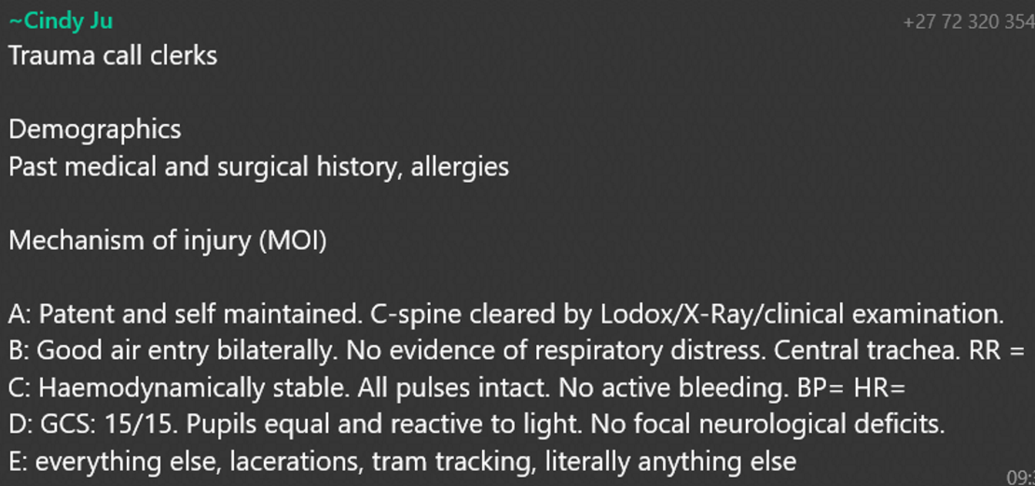

## T.05 Damage Control Resuscitation and IV Fluids in Trauma

*M. Lubout*

* Damage control was initially described in the 1960s by the US navy to keep ships afloat and fighting long enough to reach port where definitive repairs could be carried out. The approach was then extrapolated to resuscitation efforts in the military setting and carried forward to urban trauma centres. The aim is to identify severely ill patients early and institute DCR to achieve physiological optimization. This has been shown to improve morbidity and mortality. The key is early recognition of at-risk patients to avoid the lethal triad, namely:
* Hypothermia
* Coagulopathy
* Acidosis
* **Damage Control Team:**
* Pre-hospital staff
* ED staff
* Trauma surgeon
* Anaesthetists
* Intensivists
* ICU staff
* Nursing Staff
* **What is Damage Control Resuscitation?**
* **Rapid recognition of shock and trauma-induced coagulopathy**  
  Coagulopathy involves a disturbed balance between the haemostatic and fibrinolytic systems, which leads to decreased clot formation and increased clot breakdown.
* **Permissive hypotension**
  + SBP ≈ 90 mmHg
  + Maintains perfusion to vital organs without dislodging clots.
  + Avoids excessive crystalloid infusion.
  + Challenges arise with concomitant TBI (higher MAP required for adequate brain perfusion).
* **Control of bleeding and contamination**
  + Damage control surgery aims to stop the bleeding and decrease potential for contamination (e.g., clip and drop, temporary abdominal closure using negative pressure wound therapy like vacuum dressings).
  + In vascular injuries, shunting is considered damage control.
* **Prevention/treatment of hypothermia, metabolic acidosis, and hypocalcaemia**
  + **Hypothermia:** Use of warm resuscitative fluids, temperature-regulating blankets, pleural and bladder lavage, and increased ambient room temperature.
  + **Hypocalcaemia:** Citrate in transfused blood binds calcium, forming calcium citrate complexes that reduce free calcium levels. Maintain ionized calcium > 0.9 mmol/L.
  + **Metabolic acidosis:** Corrected with adequate resuscitation and rewarming.
* **Minimize the use of crystalloids**  
  Limit low-volume crystalloid resuscitation to less than 2 liters, favoring early use of blood products.
* **Early activation of the massive transfusion protocol**  
  Transfuse in balanced 1:1:1 ratio (Packed Red Cells: Fresh Frozen Plasma: Platelets). Employ TEG-guided transfusion for better outcomes.
* **Early and appropriate use of coagulation adjuncts**
  + **Cryoprecipitate:** Used based on TEG evidence when more than 6 packed cells are administered.
  + **Cyclokapron (Tranexamic Acid/TXA):** Should be administered within 3 hours of injury.
* **Transfer to ICU without delay to continue resuscitation and warming.**
* **Stages of Damage Control:**

1. Stage I: Patient selection and implementation of DCR.
2. Stage II: Stop the bleeding and contamination (damage control surgery).
3. Stage III: Further resuscitation (ICU).
4. Stage IV: Definitive surgery (e.g., bowel anastomoses, definitive vascular repair).
5. Stage V: Abdominal wall reconstruction.

* **Damage Control Surgery: Patient selection criteria**
* Haemodynamic instability (P > 120 bpm, SBP < 90 mmHg).
* Metabolic instability (Acidosis).
* Coagulopathy.
* Hypothermia (< 34°C).
* Massive blood loss, multiple hollow viscus injuries with contamination.
* Intra-operative inotropic requirement.
* Need to address extra-abdominal life-threatening injury.
* 10 units of blood required in <6 hrs.
* **Fluids**
* **Goals in Trauma Patients:**
* Minimize crystalloid administration.
* Avoid significant hypotension.
* Stop the bleeding.
* Replace what is being lost (i.e., blood).
* Balanced transfusion (1:1:1 RBC:FFP:PLT).
* **Isotonic Crystalloids:**  
  Best options include Ringer’s lactate or Balsol; restrict use to ≤2L as excess use is harmful and associated with increased mortality.
* **Complications of Isotonic Crystalloids:**
* Intracellular oedema disrupting vital biochemical processes.
* Wound complications, ARDS, MODS, compartment syndrome, coagulopathy, hypothermia, increased mortality.
* **Hypertonic Saline:**  
  May benefit osmotic movement of interstitial fluid into the vascular compartment; potentially modulates inflammatory responses to injury.
* **Colloids:**  
  Hydroxyethyl Starch (HES) (e.g., Voluven) is not recommended due to risks of acute kidney injury, coagulopathy, and increased mortality.
* **Blood Products:**
* **Red Cell Concentrate (RBC/RCC)**
* **Whole Blood:** Rarely used except in massive transfusions.
* **Fresh Frozen Plasma:** Contains all coagulation proteins.
* **Cryoprecipitate:** Contains Factor VIII, fibrinogen, fibronectin, and Factor XIII.
* **Platelets.**
* **Administration:**  
  Balanced blood product transfusion (1:1:1) is key. Massive Transfusion Protocol (MTP) should be used proactively to manage massive blood loss and prevent the lethal triad of acidosis, hypothermia, and coagulopathy.
* **Adverse Transfusion Reactions:**
* **Acute Hemolytic Reactions:** Rare but life-threatening, often due to ABO-incompatible blood.
* **Delayed Hemolytic Reactions:** Usually result from undetected antibodies; typically non-life-threatening.
* **Bacterial Contamination:** Rare, but potentially severe.
* **Anaphylactic Reactions:** Rare, linked to IgA antibodies.
* **Transfusion-Related Acute Lung Injury (TRALI):** Under-recognized and under-reported, mostly associated with plasma-containing products.
* **Febrile Reactions:** Not life-threatening.
* **Allergic Reactions:** Usually mild.

## T.06 Emergency Room Thoracotomy & REBOA

D. Wineberg

* **Emergency Room Thoracotomy (ERT)** is a damage control, resuscitative thoracotomy performed in the emergency room and, if the patient survives, it is completed in theatre. It is a controversial procedure as it exposes the healthcare providers to high risk and has a low probability of survival; about 1-5% in blunt trauma and 10-15% in penetrating trauma.
* **Indications:**
* Penetrating injuries with a witnessed arrest in a patient who had signs of life
* A patient with a blood pressure of 70mmHg or below despite resuscitation
* May consider in blunt injuries with previous signs of life under very specific conditions as outcome is very poor
* **Aim:**
* Alleviate cardiac tamponade by opening the pericardium
* Haemorrhage control of the heart, lungs, or great vessels with clamps or haemostatic sutures
* Performing open cardiac massage
* Cross clamping the descending thoracic aorta to prevent exsanguination from catastrophic intra-abdominal or pelvic bleeding
* **Contraindications for Emergency Room Thoracotomy:**
* Blunt injuries with no prehospital signs of life
* Blunt injuries with CPR of >10 minutes
* Penetrating injuries with CPR >15 minutes
* Non-traumatic arrest
* Severe head injury
* Improperly trained team
* Non-survivable injuries
* **Method:**
* The patient should be intubated, and resuscitative efforts should continue.
* Theatre should be notified.
* A left lateral thoracotomy is performed in the emergency department in the 5th intercostal space with the patient on the stretcher.
* The pericardium should be opened to relieve a pericardial tamponade.
* Any active bleeding should be controlled with a vascular clamp. A haemostatic suture may be placed to control bleeding.
* If cardiac massage is required, a 2-handed technique should be utilized.
* Internal cardiac defibrillation can be performed.
* If clamping is required, the descending thoracic aorta should be identified and clamped with a vascular clamp.
* Should the patient respond, they should be immediately moved to theatre where a definitive procedure can be performed.

## T.07 Radiology in Trauma

|  |  |  |
| --- | --- | --- |
| **CXR** | Primary Survey:   * All Blunt, * Chest penetrating trauma | **High specificity, low sensitivity: pneumothorax**,  Haemothorax, pulomonary contusion/aspiration, abnormal mediastinal width or contour (i.e. aortic injury), abnormal diaphragm contour, sustained bullets, rib fractures |
| **C-Spine XR** | Unreliable | If not cleared clinically, then need CT whilst restricting C-spine movement |
| **PXR** | Primary Survey: **Blunt hip/pelvic** | PXR IDs signicant fractures, pelvic diastasis, hip fractrures and dislocations.  **Rx pelvic binder for open book pelvic fracture, reduction of hip dislocation**. |
| **Ultra sonography FAST** | Abdominal: **Blunt & Penetrating** precordial/transthoracic injuries | **Four views** a) subxiphoid pericardial b) RUQ c) LUQ d) Pelvic views  **AIM**: Determine haemo-peritoneum  **Detects**: free fluid/ abdominal fluid >225ml  **Limitations**: solid organ injuries, retroperitoneal injuries, hollow visceral injuries (bc. Haemoperit. might not be present in these cases)  **Grossly ++FAST + haemodynam. unstable + blunt trauma 🡪 indication for laparotomy** (fluid assumed blood and intra-abdominal bleeding the cause of instability) |
| **Ultra sonography eFAST** | eFAST = FAST+additional view (pleural spaces). Rule out pneumothorax | **High sensitivity, High specificity: Pneumothorax**  Posterior pleural space assess haemothorax |
| **CT Scan** | Stable patients with **Blunt & Penetrating** | **ID**: Organ injuries, active bleeding, retroperitoneal injuries  Must not delay surgery in unstable pt. |
| **Pan-CT** | Multiply injured blunt trauma (above & below diaphragm) or high energy blunt trauma |  |
| **CTA** | Dx & ruling out **peripheral vascular injuries & cervical vascular injuries** | High sens, High spec. 🡪 preferred over conventional angiography |

## T.08 Analgesia in Trauma

**Opioids**

|  |  |  |  |  |  |  |  |
| --- | --- | --- | --- | --- | --- | --- | --- |
| Opioid | Onset | Peak | DOA | Admin | Dose | Prep | S/E |
| Morphine | 3-5min | 10-20min | 3-4h | IV | 0.1-0.3mg/kg | 1mg/1ml (10mg 1ml, 9ml sterile water) | Hypotension  Resp. Depression |
| Pethidine | Anticholinergic properties (mild chronotropic) |  | 2-3h | IV | 1-1.5mg/kg |  | * C/I: confusion in elderly * Renal Impaired (convulsion risk) * Dysphoria in some |
| Tilidine | Moderate to moderately severe |  | 4-6h | Sublingual Intranasal | 50-100mg 4-6hourly |  | C/I: <1y paeds |
| Tramadol | Moderate to moderately severe, LOW RESP DEPRESSION | Opiod of choice: Spontaneously breathing head injury pt. |  |  | 100mg 6-8hourly |  | CI: <14y paeds  Caution w/ pethidine🡪 seritoninergic syndrome |
| Sufentanyl | Quicker onset  More cardiovascular stable |  | 1-2h |  | 0.02-0.04mcg/kg every 2-5min |  |  |
| Codeine | Poor analgesic  LOW RESP DEPRESSION (tramadol better) |  |  |  |  |  |  |

|  |  |
| --- | --- |
| **NSAIDS**   * PERIPHERAL anti-prostaglandin effect * Aspirin, COX1-COX2-I: Diclofenac, Ibuprofen, Naproxen, Ketorolac * COX2-I: Celocoxib, Mefloxicam, Valdercoxib, Etoxicoxib * Moderate/Musculoskeletal pain * Not for severely injured pts (risk of renal impairment, bleeding tendencies, gastric mucosal erosion) * Onset = 30mins. * Good synergism with paracetamol and opiods (but after 5h for opioids) * Preferred oral (IV/IM/Rectal available) | **Paracetamol**   * CENTRAL anti-prostaglandin effect * Mild to moderate pain * C/I: intoxicated patients (liver damage) * Synergistic with NSAIDS * IV Prep (Perfalgan) > oral: Dose 60-90mg/kg/day in 4 divided doses |
| **Ketamine**   * Anaesthetic induction agent * IV preferred: * IV dose: 0.2-0.4mg/kg * IM dose: 0.8-1.5mg/kg * Onset = 5min, DOA = 15-20min * Low Resp depression * Direct sympathomimetic effect = ++HR, ++ CO, ++Peripheral Resistance * S/E = Restlessness, dreams/hallucinations | **Local Anaesthetics**   * Never use local anaesthetic with adrenaline in end organs (nose, penis, toes, fingers)- vasoconstriction🡪 necrosis. * Preparation w/ 0.9% saline NEVER sterile water |

**Nerve Blocks**

|  |  |
| --- | --- |
| **Intercostal Block** | * **Indications**: Used for **rib fractures** and during the **insertion of an intercostal drain**. * **Procedure**:   + **The intercostal nerve is blocked at the costal angle**, approximately one hand’s breadth lateral to the spinous processes or in the midaxillary line.   + After palpating the rib of the selected intercostal nerve, pull the skin taut in a cranial direction and insert the needle perpendicular to the skin.   + Contact the rib and then "walk" the needle tip caudally until it slides underneath the rib.   + **After confirming that the pleura has not been breached, inject 3-5 ml of long-acting local anesthetic with adrenaline.** * **Duration**: 4-8 hours. * **Risks**: Local anesthetic toxicity due to rapid absorption in the vascular area, and the risk of pneumothorax (1 in 1000 cases may require drainage). |
| **Intrapleural Block** | * **Indications**: Instillation of local anesthetic **between the visceral and parietal pleura**. * **Procedure**:   + A 23G butterfly needle is inserted into the intercostal drain, secured with adhesive dressing.   + A mixture of **10 ml Bupivacaine 0.5%, 10 ml Lignocaine 1%, and 40 ml sterile** water is injected through the butterfly needle.   + The IC drain is clamped for 15 minutes, and the patient is encouraged to move side to side to distribute the anaesthetic.   + After 15 minutes, the drain is unclamped. * **Duration**: 2-4 hours. * **Caution**: This procedure should not be performed if the intercostal drain is still bubbling (indicating a persistent pneumothorax), as clamping could lead to tension pneumothorax. |

## T.09 Traumatic Brain Injury

**Scalp injuries**

Laceration of scalp associated with significant bleeding. Control with compression dressing and follow with deep sutures if necessary. Debride and repair properly **later** (**haemostasis before cosmesis**). Haematomas under the galea can attain considerable size. It is best to evacuate the haematoma and control the source of bleeding. Remember that there is danger of infection as scalp infections may spread intra-cranially via the emissary veins.

**Skull injuries**

* A skull fracture = possibility of underlying brain bleed or injury. Clinical skull fracture should undergo a CT scan.
* Skull fractures may be open or closed and may be depressed or undisplaced.
* Open skull fractures 🡪 broad-spectrum antibiotic prophylaxis.
* Base of skull fractures: suspected clinically & confirmed on CT. No routine prophylactic antibiotics. Clinical features include:

1. CSF leaking from the nose or ear (**otorrhea, rhinorrhea**).
2. Peri-orbital ecchymosis (**Racoon eyes**).
3. Ecchymosis behind the ear (**Battle's sign**).
4. Blood in external canal of ear 🡪 basilar fracture till proven otherwise.
5. CN 7 or 8 fallout. Should these exist, consult ENT for further management.

**Brain injuries**

Brain injuries = **focal** (a discrete bleed or contusion) or **diffuse** (hypoxic-ischemic injuries).

* **Primary brain injury** = occurs at the time of the trauma + irreversible, i.e., **lacerations, contusions, axonal**. (35% of brain injury mortalities).
* **Secondary brain injury** = occurs later may be preventable and reversible (65% of mortality due to brain injury). It may manifest as **cerebral oedema, microscopic haemorrhages**, or no macroscopic change but ultimately leads to degeneration of axons.
* **Extra-cranial causes**: shock, hypoxia, hyperglycaemia, hypoglycaemia.
* **Intra-cranial causes**: haematoma, brain oedema, infection, hydrocephalus.

*Prevent secondary brain injuries as these lead to worse outcomes🡪 accomplished by measures described below in the management of brain injuries. Aim: to protect the brain from further insult and limit the metabolic activity of the brain to allow for healing.*

**Types of brain injuries**

|  |  |
| --- | --- |
|  | |
| **Concussion**: No gross pathology is noted. There is a reported transient loss of consciousness (mild concussions may present with symptoms only and no loss of consciousness). Most patients make an uneventful recovery. These patients, however, may have mild symptoms including headaches, memory loss, dizziness, and other neurological symptoms. They should be followed up at the neurosurgical outpatient clinic and may require medication or therapy to assist with their symptoms. |  |
| **Contusion**: Bruising of the brain surface. May be due to an overlying fracture, a direct blow, or due to an acceleration or deceleration injury (coup/contre-coup) where the brain hits the overlying skull. |  |
| **Intra-cerebral haematoma**: Usually in the centre of cerebral contusion. May have secondary haemorrhage. A repeat CT after 24-48 hours is recommended to assess for any enlargement or mass effect. |  |
| **Extradural haematoma**:   * Generally temporo-parietal regions and are usually * associated overlying fracture which results in a tear of the middle meningeal artery but may be a disruption of the venous sinuses. * Classically, patients present with a lucid interval between the injury and subsequent neurological deterioration. * On imaging, the haematoma is convex as it pushes the dura away from the inner table of the skull. |  |
| **Subdural haematoma**: Occurs due to shearing of small surface or bridging blood vessels of the cortex.   * On CT the bleed conforms to the shape of the brain. * SA chronic subdural may present weeks after the injury. |  |
| **Subarachnoid Haemorrhage**: Occurs with   * bleeding in the subarachnoid space between the arachnoid and the pia mater. * It may present with signs of meningism * may complicate with hydrocephalus due to obstruction of the arachnoid space or the basal cisterns. |  |
| **Cerebral oedema**: may be   * due to the underlying bleed or tissue response to trauma. It * causes secondary brain injury by ++ICP & --cerebral perfusion. * Severe oedema without decompression will result in cerebral herniation. |  |
| **Diffuse axonal injury**:   * damage of neurons from deceleration injury. * Suspected in GCS that remains low. * MRI is a better means of diagnosis than CT scan however the CT may show a loss of grey white interface or petechial haemorrhages |  |

**Management of head injuries**

Management of a head injury requires good resuscitation and management of associated injuries **to prevent secondary injury:**

* **Airway**:
  + GCS of 8/15 gag reflex lost 🡪 indication for a definitive airway (i.e., intubation).
  + GCS 9-12/15 ~ inability to control the patient, especially during CT scan.

**We prefer to sedate, intubate, and ventilate restless patients**. Maintain spinal control until the spine is cleared as there is a strong association between brain and cervical spine trauma.

* **Breathing**: Maintain normocapnia (PCO2 35-45 mmHg, and PO2 80 -100 mmHg).
* **Circulation**: Head injuries alone do not produce hypotension, except in terminal stages.
  + 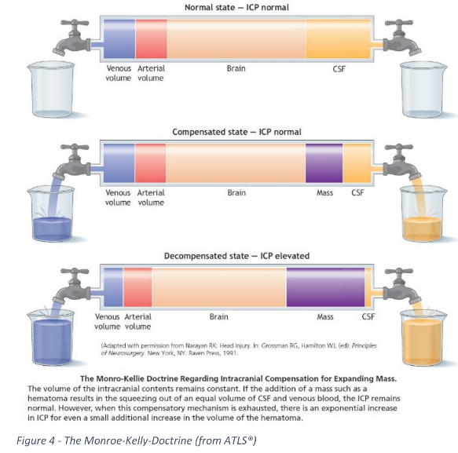Look for Cushing’s triad (bradycardia, hypertension, irregular breathing), as it’s a sign of impending brain herniation.
  + Stop bleeding from scalp or other wounds
  + Avoid hypotension!!
    - **Maintain MAP > 70 mmHg to ensure adequate cerebral perfusion (CPP = MAP – ICP).**
    - **sBP >100mgHg** & **CPP >60mmhg**
    - **NB: Munroe-Kellie doctrine**: The skull is a hard box that doesn’t allow for expansion. It contains 3 things: blood , brain and CSF. If there is an increase in any of these or the presence of a mass, it results in raised intracranial pressure. The body tries to resolve this by decreasing the blood or CSF. This continues until no further decrease is possible and results in herniation of the brain through the foramen magnum (tonsillar herniation) and brain death.
* **Disability**: GCS, pupil size and reaction, localizing signs.
* **Exposure**: Maintain normothermia. Avoid hyperthermia.
* **Imaging**:
  + Decide on the need for a CT scan and consider CT of the cervical spine if indicated.
* **Mannitol**: A temporizing measure used for transtentorial herniation as evidenced by a rapid decline in GCS, unequal pupils, or other localizing signs, all signs of rising intracranial pressure. Mannitol is a potent osmotic diuretic and should not be used in hypotensive patients. The dose is 1 g/kg and should ideally be given through a central line.
* **Anti-epileptic prophylaxis**: Initiate seizure prophylaxis for 7 days post-injury. Load with phenytoin 1g IV and continue maintenance doses of 300 mg daily, or 100 mg every 8 hours.

**Secondary Survey**

* **Look**: Assess for facial asymmetry, proptosis, enophthalmos, lacerations, bruises, eye injuries (and contact lenses), ears and nose for bleeding or CSF leakage.
* **Feel**: Palpate from the chin over the vault of the skull back to the chin. Look for lacerations, bruises hidden by hair. Feel for fractures, crepitus, deformity, asymmetry, and bruises along the C-spine, carotid pulses, surgical emphysema of the neck, etc.
* **Listen**: For carotid bruit (to assess for blunt carotid injury).
* **Neurological examination**: A full neurological exam to detect any deficits.

**Diagnostic tests**:

* **Skull X-rays**: Although plain X-rays of the skull are a valuable adjunct when CT scanning isn't available, a normal skull X-ray does not exclude intracranial injury. Skull fractures, air in the ventricles, subarachnoid space, and shifting of calcified midline structures should be noted. A linear fracture increases the risk of intracranial hematoma by 400 times.

**CT scan**:

* Mild brain injury (GCS 13-15): Use the **Canadian head CT rule**.
* Moderate brain injury (GCS 9-12): Always perform a CT scan.
* Severe brain injury (GCS 3-8): Always perform a CT scan.

**Consults**:

* Neurosurgeon: Consult for all patients with brain injuries and complex skull fractures.
* Ophthalmologist, Maxillofacial Surgeon, or ENT: If there are associated eye, nose, or facial fractures.

**Management: Ward**

* **Avoid secondary brain injury**: Prevent further harm by managing intracranial pressure and avoiding factors like hypoxia and hypotension.
* **Seizure prophylaxis**: Continue for 7 days post-injury.
* **Early nutrition**: Essential for recovery, supported by a multidisciplinary team (Speech Therapy, OT, Physiotherapy, Dietician).
* **Prevent pressure sores**: Especially in patients with prolonged immobility.

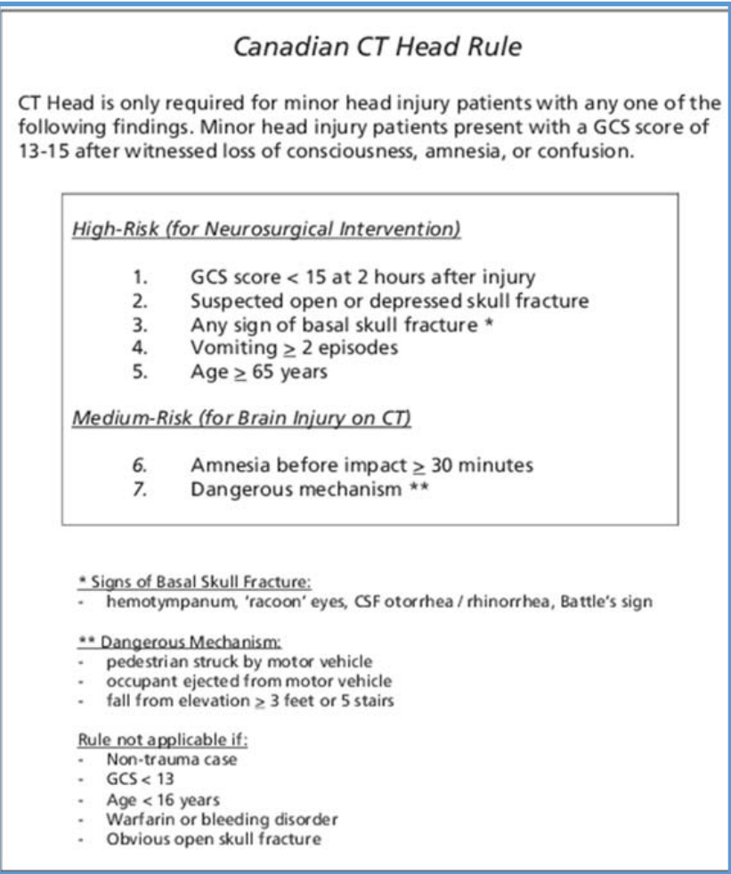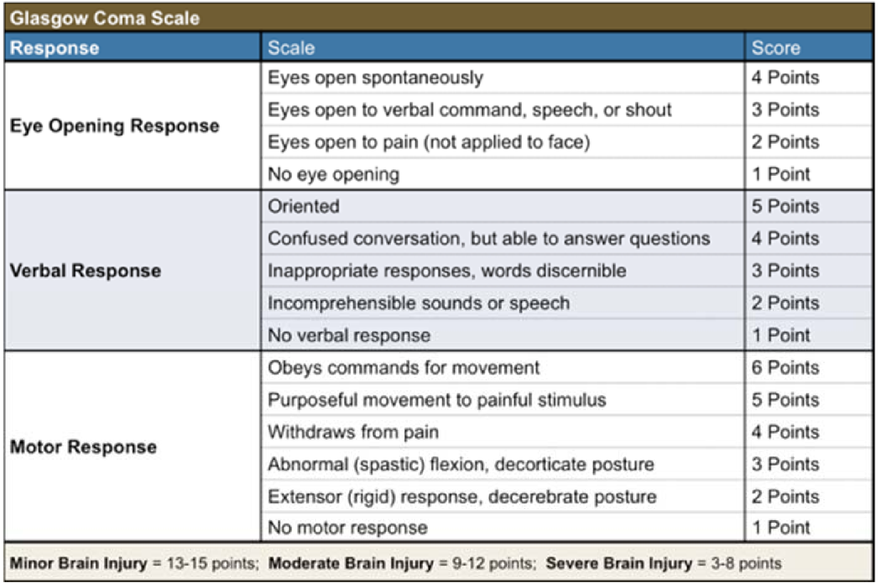

## T.22 Burns

**Pathophysiology**

Immediate shift of intravascular fluid into the surrounding interstitial space. This occurs in burned tissues and, to a lesser extent, in unburned tissues 🡪 significant oedema

* As the burn size approaches 15-20% TBSA shock develops if the patient doesn’t undergo fluid resuscitation.
* The capillary barrier begins to regain its integrity after about 24 – 48 hours. Failure to aggressively treat the volume deficit properly leads to eventual cell death.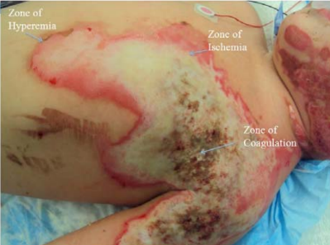
* Zones radiating from primarily burned tissues;

1. **Zone of coagulation** - A nonviable area of tissue at epicentre of burn.
2. **Zone of ischemia or stasis** - Surrounding tissues (both deep and peripheral) to the coagulated areas, can progress irreversibly to necrosis over several days if not resuscitated properly.
3. **Zone of hyperaemia** - Peripheral tissues that undergo vasodilatory changes due to neighbouring inflammatory mediator release but are not injured thermally and remain viable.

**Determining level of care**

* Suggested patient populations that need treatment at a specialist Burn Centre:
* Partial-thickness burns: <10y, >50y w/ >10% TBSA
* Partial-thickness burns: >10y, <50y w/ >20% TBSA
* Burns that involve the face, hands, feet, genitalia, perineum, or major joints
* Third-degree burns in any age group
* Electrical burns, including lightning injury
* Chemical burns
* Inhalation injury
* Burns in patients with pre-existing medical disorders that could complicate management, prolong recovery, or affect mortality rate
* Any patients with burns and concomitant trauma (such as fractures) in which the burn injury poses the greatest risk of morbidity or death

**Initial evaluation and treatment**

* Evaluation of a burn patient is similar to that of any trauma patient – ATLS principles:
* Primary survey
* Secondary survey

**Airway management**

* It is critical to assess whether inhalation injury is present
* If there is any suspicion of inhalation injury the patient requires prompt intubation.
* Remember that oedema formation does not spare the airway – oedema from facial burns or inhalation injury will lead to airway compromise.
* The following patients require intubation:
* Suspicion of inhalation injury
* Facial burns
* Burns in an enclosed area
* >40% burns
* Deep circumferential burns to the neck

**Inhalation injury**

* Includes 3 distinct types of injury that often but not always occur together:
* Heat injury to upper airway
* Smoke inhalation injury
* Injury due to inhalation of toxic compounds
* Inhalation injury is a greater contributor to morbidity and mortality than %TBSA or age.
* **Generally, 15% is added** to the external TBSA burn in patients with inhalation injury to assist with the calculation of fluid requirements.

**Carbon monoxide:**

* The affinity of CO for Hb is 240x greater than that of O2. COHb (Carboxy-Haemoglobin) is inactive in O2 transport and leads to reduction of O2 carrying capacity of blood. The severity of reduction is dependent on concentration of inhaled CO and duration of exposure.
* **Diagnosis:**
* Suspected in all cases of exposure to combustion products in enclosed spaces
* Symptoms:
  + Throbbing headache in mild exposure (10-25% COHb)
  + Weakness, dizziness, confusion, nausea (25-40% COHb)
  + Collapse, unconsciousness, convulsions (40-60% COHb)
  + Death (>60% COHb)
  + May have signs of cardiac instability
* Cerebral irritability may persist for days to weeks after recovery

**Diagnosis of inhalation injury:**

* No definitive diagnostic criteria or special investigations except for bronchoscopy (which generally requires intubation). The safest is to maintain a high index of suspicion. Any of the following risk factors indicate a high likelihood of inhalation injury:
* History of exposure in enclosed space
* Facial burns
* Burnt lips and nasal hair
* Singed facial hair
* Soot particles in pharynx/sputum
* Coughing, wheeze, stridor, hoarseness
* Dyspnoea
* Hypoxaemia/cyanosis
* Neurological – unconscious, vertigo, nausea, vomiting

**Treatment of inhalation injury:**

Early intubation before oedema develops.

* **Intravenous access**
  + Prompt establishment of large-bore (IV) access and rapid initiation of fluid resuscitation is important in outcome of patients with significant thermal injuries. **No factor other than airway protection is as critical in the early period after a burn.**
  + Place a central line early before burn oedema makes assessing landmarks difficult. Ultrasound guidance can be used to gain vascular access.
* **Additional evaluation:**
* Foley catheter placed early so that urine output can be monitored as a guide for volume status.
* Nasogastric tube to decompress the stomach and to begin early enteral feeding.
* Assess peripheral pulses immediately and evaluate all extremities and the chest wall for potential compartment syndromes.

**Secondary survey**

* Burn-specific secondary survey:
* Evaluation for the presence or absence of inhalation injury
* Evaluate for carbon monoxide intoxication
* Examination for corneal burns
* Consideration of the possibility of abuse
* Detailed assessment of the burn wound
* Another important thing to evaluate is whether or not full thickness burns of extremities or the torso are circumferential. If this is the case then the burn eschar will constrict the affected area. In the case of limb burns this leads to a compartment syndrome of the affected limb and interferes with the blood supply to the limb. In the case of torso burns this prevents chest wall expansion and leads to significant difficulty in ventilating these patients.
* Escharotomies of these areas are both life and limb saving.

**Estimation of Burn Size:**

* Only second-degree burns or greater should be included in the TBSA determination for burn fluid calculations. A standard Lund-Browder chart can be used. If a Lund-Browder chart is not available, the "rule of nines" is fairly accurate
* The palmar surface area of the hand is ~1% TBSA and can be used for estimating patchy areas of burns.

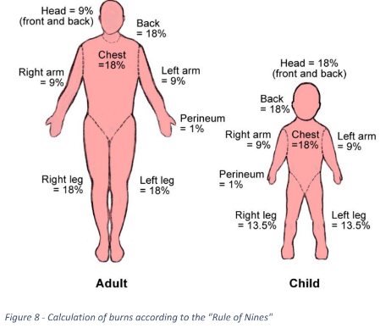

**Resuscitative Fluid Management:**

* The Parkland formula is most widely used:
* First 24h of resuscitation with Ringer’s lactate at 4 mL/kg body weight x percentage burn
* Half the volume in the first 8h post burn, remaining volume over 16h
* Add 15% to TBSA if inhalation burns is suspected
* The goal for fluid resuscitation: is a urine output of
  + 0.5 mL/kg body weight/hour in adults and
  + 1 mL/kg body weight/hour in paediatric patients.
* Paediatric patients have lower hepatic glycogen reserves they become hypoglycaemic very quickly and all paediatric patients should receive glucose-containing maintenance fluids.

**Other considerations**

* Opioid analgesia is generally used as burns are extremely painful.
* Burn patients have a hypermetabolic response and early enteral nutrition should be given in these patients.
  + In intubated patients, feeds should be started as soon as the patient is stable enough to tolerate feeds.
  + In non-intubated patients, oral food with protein supplements should be started as soon as possible.
* Burns patients are at very high risk of hypothermia; maintain body heat in these patients including:
* Only administering warmed fluids
* Use of heating blankets like “Bair Huggers”
* Covering all exposed areas of the patient while busy exposing and dressing other areas.

**Special Situations:**

* **Electrical burns**
  + High voltage current passing through muscle could lead to compartment syndrome or myoglobinuria.
  + High-voltage injuries are commonly associated with loss of consciousness, falls, fractures, myoglobinuria, compartment syndrome, and arrhythmias, and these individuals should be treated as polytrauma patients.
* **Chemical burns**
* Treatment begins with immediate removal of clothing and chemicals. Health care workers must protect themselves from contact with the chemical.
* The following steps need to be taken:
* Copious irrigation with tap water should be performed for at least 30 minutes
* Do not forget that eyes also need to be rinsed if involved
* Adequate ocular irrigation can be facilitated by topical ocular anaesthetics
* With larger injuries, fluid resuscitation may be required

**Excision and grafting of burn wounds:**

* Early excision and closure of full-thickness wounds avoids wound sepsis as it reduces the presence of potentially necrotic and infected tissue.
* One of the single greatest advancements in the treatment of patients with severe thermal injuries and a mainstay of therapy is the early excision and grafting of burns. Full thickness and most deep partial thickness burns will need excision and grafting.
* If wounds cover more than 40% TBSA, staged procedures are often needed as it’s generally only possible to graft up to 30% at a time. If the wounds involve more than 50% of the body surface, achieving immediate autograft closure is often impossible. When autograft material is exhausted, temporary biologic closure is achieved with human allograft (i.e., cadaver skin) or other temporary wound closure material (e.g., Xenograft or synthetic materials). Wounds are later resurfaced with autograft when donor sites have healed and can thus be re-used as donor sites.